8-bit AVR® Device Reset Sources

Last modified by Microchip on 2023/11/09 09:02

**Contents**

* [MCU Status Register (MCUSR)](https://developerhelp.microchip.com/xwiki/bin/view/products/mcu-mpu/8-bit-avr/peripherals/reset-sources/#HMCUStatusRegister28MCUSR29)
* [Power-on Reset (POR)](https://developerhelp.microchip.com/xwiki/bin/view/products/mcu-mpu/8-bit-avr/peripherals/reset-sources/#HPower-onReset28POR29)
* [Brown-out Detection (BOD) and Brown-out Reset (BOR)](https://developerhelp.microchip.com/xwiki/bin/view/products/mcu-mpu/8-bit-avr/peripherals/reset-sources/#HBrown-outDetection28BOD29andBrown-outReset28BOR29)
* [Watchdog Timer (WDT)](https://developerhelp.microchip.com/xwiki/bin/view/products/mcu-mpu/8-bit-avr/peripherals/reset-sources/#HWatchdogTimer28WDT29)
* [Clock Failure Detection (CFD)](https://developerhelp.microchip.com/xwiki/bin/view/products/mcu-mpu/8-bit-avr/peripherals/reset-sources/#HClockFailureDetection28CFD29)

The AVR® device has four sources of reset:

* Power-on Reset (POR) - The microcontroller unit (MCU) is reset when the supply voltage is less than the Power-on Reset threshold (VPOT).
* External Reset - The MCU is reset when a low level is present on the RESET pin for longer than the minimum pulse length.
* Watchdog System Reset - The MCU is reset when the Watchdog Timer period expires and the Watchdog System Reset mode is enabled.
* Brown-out Reset (BOR) - The MCU is reset when the supply voltage VCC is less than the Brown-out Reset.

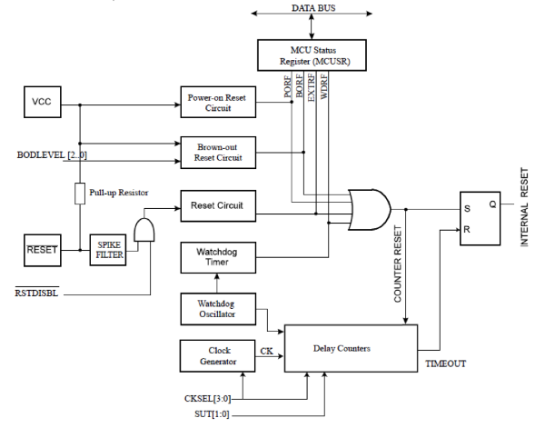

[Back to top](https://developerhelp.microchip.com/xwiki/bin/view/products/mcu-mpu/8-bit-avr/peripherals/reset-sources/)

MCU Status Register (MCUSR)

To make use of the reset flags to identify a reset condition, the user should read and then reset the MCUSR as early as possible in the program. If the register is cleared before another reset occurs, the source of the reset can be found by examining the reset flags.

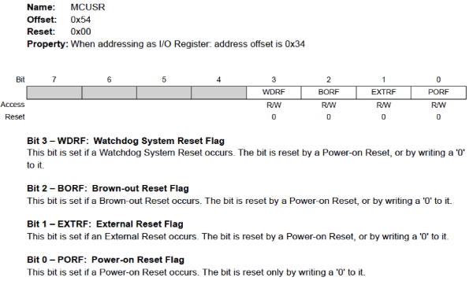

[Back to top](https://developerhelp.microchip.com/xwiki/bin/view/products/mcu-mpu/8-bit-avr/peripherals/reset-sources/)

Power-on Reset (POR)

A POR pulse is generated by an On-chip detection circuit. The POR is activated whenever VCC is below the detection level. The POR circuit can be used to trigger the start-up Reset, as well as to detect a failure in supply voltage.

A POR circuit ensures that the device is reset from Power-on. Reaching the Power-on Reset threshold voltage invokes the delay counter, which determines how long the device is kept in Reset after VCC rise.

The Reset signal is activated again, without any delay, when VCC decreases below the detection level.

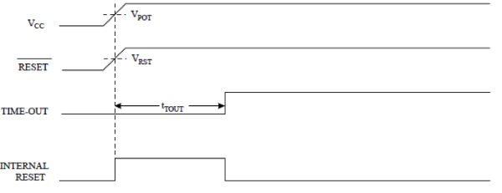

[Back to top](https://developerhelp.microchip.com/xwiki/bin/view/products/mcu-mpu/8-bit-avr/peripherals/reset-sources/)

Brown-out Detection (BOD) and Brown-out Reset (BOR)

The device has an On-chip BOD circuit for monitoring the VCC level during operation by comparing it to a fixed trigger level. The trigger level for the BOD can be selected by the BODLEVEL Fuses.

The BOR circuitry has hysteresis on the detection level. The BOD circuit will only detect a drop in VCC if the voltage stays below the trigger level (VBOT-) for longer than tBOD. When that occurs, the BOR is immediately activated.

When VCC increases above the trigger level (VBOT+ in the following figure), the delay counter starts the MCU after the Time-out period tTOUT has expired.

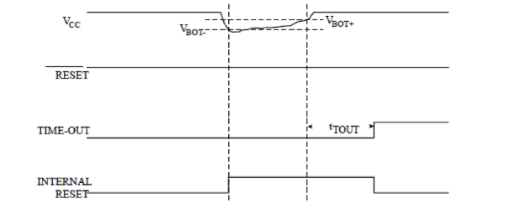

[Back to top](https://developerhelp.microchip.com/xwiki/bin/view/products/mcu-mpu/8-bit-avr/peripherals/reset-sources/)

Watchdog Timer (WDT)

The WDT runs independent of the rest of the system, causing system resets whenever it times out. However, the application software should ensure that the timeout never occurs by resetting the WDT periodically as long as the software is in a known healthy state. If the system hangs or program execution is corrupted, the WDT will not receive its periodic reset, and will eventually time out and cause a system reset.

The Enhanced WDT in some AVR devices also has the ability to generate interrupts instead of resetting the device. Since the WDT runs from its own independent clock, it can be used to wake up the AVR from all sleep modes. This makes it an ideal wake-up timer, easily combined with ordinary operation as a system reset source. The interrupt can also be used to get an early warning of an upcoming Watchdog System Reset so that vital parameters can be backed up to non-volatile memory.

[Back to top](https://developerhelp.microchip.com/xwiki/bin/view/products/mcu-mpu/8-bit-avr/peripherals/reset-sources/)

Clock Failure Detection (CFD)

The CFD allows the user to monitor the low-power crystal oscillator or external clock signal (XOSC). The XOSC is monitored by the CFD circuit operating with the internal 128 kHz oscillator. CFD monitors XOSC clock and if it fails, it will automatically switch to a safe internal RC clock. When a Power-On or External Reset occurs, the device will switch back to XOSC clock and continue monitoring XOSC clock for failures.

The safe clock is derived from the 8 MHz internal RC system clock. This allows the safe clock to be configured to meet the fail-safe needs of the application.

# 8-bit AVR Microcontrollers Reset Sources Example Project

Last modified by Microchip on 2023/11/10 11:09

**Contents**

* [Objective](https://developerhelp.microchip.com/xwiki/bin/view/products/mcu-mpu/8-bit-avr/peripherals/reset-sources/8-bit-avr-resetexample/#HObjective)
  + [Reference Materials](https://developerhelp.microchip.com/xwiki/bin/view/products/mcu-mpu/8-bit-avr/peripherals/reset-sources/8-bit-avr-resetexample/#HReferenceMaterials)
  + [Required Materials](https://developerhelp.microchip.com/xwiki/bin/view/products/mcu-mpu/8-bit-avr/peripherals/reset-sources/8-bit-avr-resetexample/#HRequiredMaterials)
* [Connection Diagram](https://developerhelp.microchip.com/xwiki/bin/view/products/mcu-mpu/8-bit-avr/peripherals/reset-sources/8-bit-avr-resetexample/#HConnectionDiagram)
* [Procedure](https://developerhelp.microchip.com/xwiki/bin/view/products/mcu-mpu/8-bit-avr/peripherals/reset-sources/8-bit-avr-resetexample/#HProcedure)
* [Analysis](https://developerhelp.microchip.com/xwiki/bin/view/products/mcu-mpu/8-bit-avr/peripherals/reset-sources/8-bit-avr-resetexample/#HAnalysis)
* [Conclusions](https://developerhelp.microchip.com/xwiki/bin/view/products/mcu-mpu/8-bit-avr/peripherals/reset-sources/8-bit-avr-resetexample/#HConclusions)

## Objective

This project goes through several different reset conditions, Power On Reset (POR), Brown Out Reset (BOR) and Watch Dog Timer (WDT) timeout, and shows how each one works on anATmega328PB Xplained board. Some external circuitry is shown to produce a variable voltage input but an adjustable power supply will also work.

For more details on the AVR® reset sources visit the "[*AVR Reset Sources*](https://developerhelp.microchip.com/xwiki/bin/view/products/mcu-mpu/8-bit-avr/peripherals/reset-sources/)" page.

### Reference Materials

* [MPLAB X IDE](https://www.microchip.com/en-us/tools-resources/develop/mplab-x-ide)
* [ATmega328PB Xplained Mini](https://www.microchipdirect.com/dev-tools/ATMEGA328PB-XMINI?productLoaded=true&allDevTools=true)
* [Project Source Code](https://microchiptechnology.sharepoint.com/sites/DeveloperHelp/Shared%20Documents/Forms/AllItems.aspx?id=%2Fsites%2FDeveloperHelp%2FShared%20Documents%2FWiki%20file%20sharing%20folder%2FMCU%208%2Dbit%2FAVR%20Projects%2FATMEGA328PB%5FHFO%5FWDT%5FFinal%2Ezip&parent=%2Fsites%2FDeveloperHelp%2FShared%20Documents%2FWiki%20file%20sharing%20folder%2FMCU%208%2Dbit%2FAVR%20Projects&p=true&ga=1)

### Required Materials

* Perfboard
* Switch
* 2 AA Batteries
* 2SC2655L IC
* AA Battery Holder
* 3.9Ω Resistor
* Test Leads
* LED
* 22 AWG Hook-Up Wire

[Back to top](https://developerhelp.microchip.com/xwiki/bin/view/products/mcu-mpu/8-bit-avr/peripherals/reset-sources/8-bit-avr-resetexample/)

## Connection Diagram

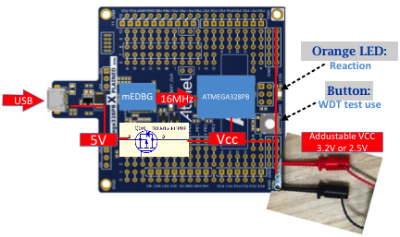

## Procedure

##### **Attach the ATmega328PB Xplained Mini Board**

Using a USB-A-male-to-Micro-B-male cable, attach the Xplained Mini to your computer. Start MPLAB X IDE. If the board has been successfully enumerated, you should see the board image come up in MPLAB X IDE as shown.

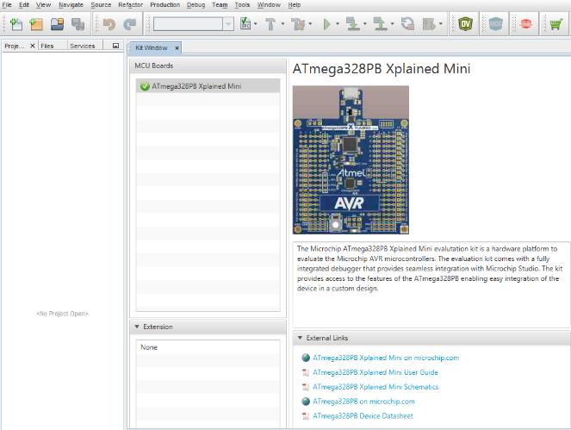

##### **Open the Project**

In MPLAB X IDE, select **File > Open Project**.

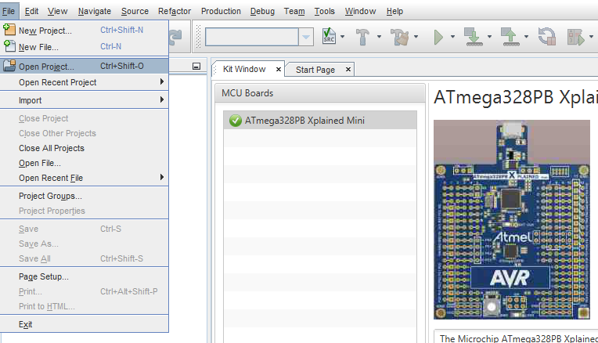

Navigate to the location where the project file was unzipped

Select the project folder indicated by the X in the folder name and the pressing the **Open Project**button.

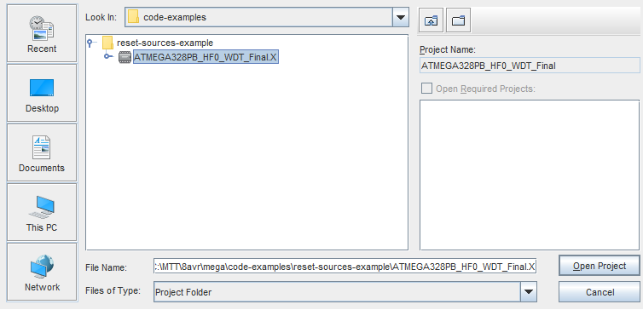

##### **Program the Device**

Select the **Make and Program Device** button at the top of the MPLAB X GUI.



##### **Build the Reset Test Circuit Shown in the Schematic**

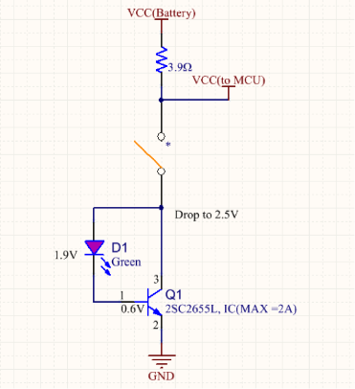

##### **POR Test**

* Pull out the USB Cable
* Make sure the External Adjustable VCC Cable’s switch is on the right side (3.2V)
* Clip The External adjustable VCC cable to the board

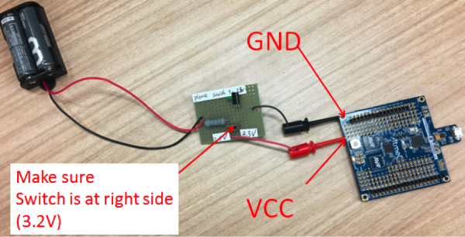

* Result: The orange LED will respond by flashing (0.3 ms, four times) based on the code section below because the POR reset is detected.

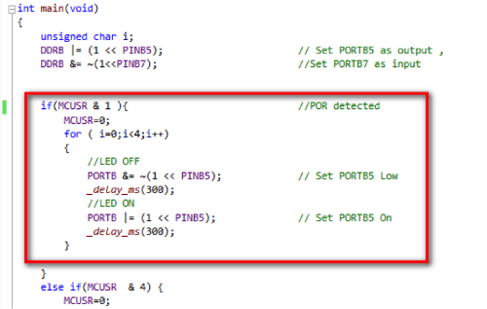

##### **BOR Test**

* After the POR test, slide the switch on the External Adjustable VCC Cable to the left side (2.5V)
* Slide the switch on the External Adjustable VCC Cable back to the right side (3.2V)
* Result: the orange LED will respond by flashing (0.1 ms, eight times) based on the code highlighted below because the BOR reset is detected.

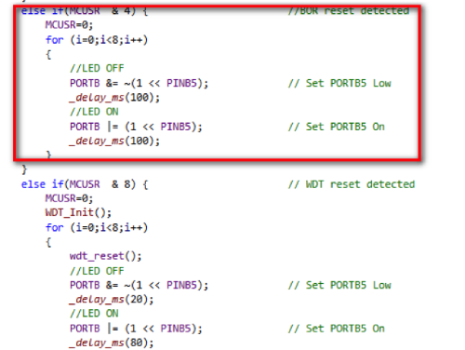

##### **WDT Test**

Push the **button**on the board for about 1 second and then release the button. Extended delays will be triggered in the main routine, which will cause a WDT timeout.

Note: The WDT timer is set to 2 seconds.

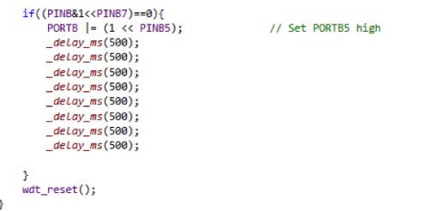

**Result:** The orange LED will respond by fast flashing (0.02 ms on, 0.08 ms off, four times) at first as the WDT interrupt ISR:

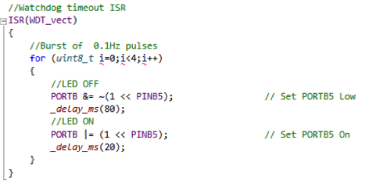

**Result:** The orange LED will again respond by fast flashing (0.02 ms on, 0.08 ms off, four times) as the WDT reset is detected:

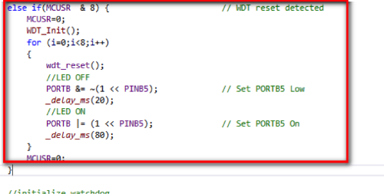

[Back to top](https://developerhelp.microchip.com/xwiki/bin/view/products/mcu-mpu/8-bit-avr/peripherals/reset-sources/8-bit-avr-resetexample/)

## Analysis

The project shows three ways that a reset can occur, POR, BOR, and WDT Timeout. Each has a unique application and can all run in the same application. The code examples are just a reference to how these types of resets can be set up and implemented.

[Back to top](https://developerhelp.microchip.com/xwiki/bin/view/products/mcu-mpu/8-bit-avr/peripherals/reset-sources/8-bit-avr-resetexample/)

## Conclusions

The project helps explain how the reset circuitry within the AVR functions and how to implement it. The code section can be reused in future applications that may require a similar reset structure. By no means is this the only way to design resets in the AVR device, this is just a simple sample project that helps explain the operation and allows you to apply your knowledge and understanding of the reset structure to a specific application.

8-bit AVR® MCU Low Power Overview

Last modified by Microchip on 2023/11/09 09:02

The 8-bit AVR® microcontroller provides various sleep modes and software-controlled clock gating to tailor the power consumption to the application's requirements. Sleep modes enable the microcontroller to shut down unused modules to save power. When the device enters sleep mode, program execution is stopped and interrupts or reset is used to wake the device again. The individual clock to unused peripherals can be stopped during normal operation or in sleep, enabling a much more fine-tuned power management than sleep modes alone.

If you want to achieve the lowest possible power figures, there are a few things to keep in mind. It is not only the sleep mode that defines the power consumption but also the state of the I/O pins, the quantity of enabled peripheral modules, and so on.

Power consumption is proportional to operating voltage. To conserve power you should consider using the lowest system voltage possible. Additionally, consumption is also directly proportional to clock frequency, and if sleep modes are not utilized, the device should be running as low a frequency as possible.

Tips and Tricks for Lowering Power on an AVR®MCU

* Use the Power Reduction Register (PRR0) to stop the clock to unused individual peripherals reducing power consumption.

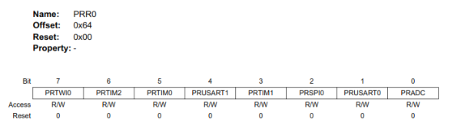

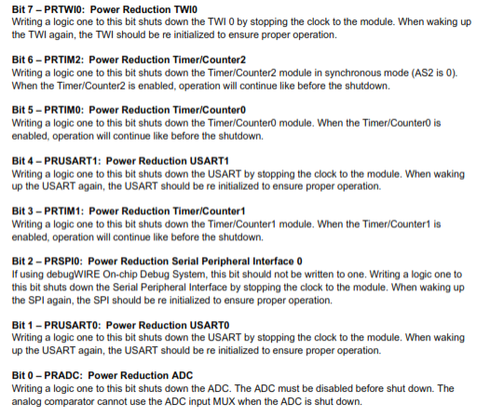

* Use the Digital Input Disable Register (DIDR) to shut off unused digital input buffers and stop leakage current.

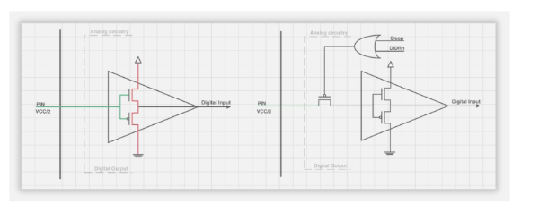

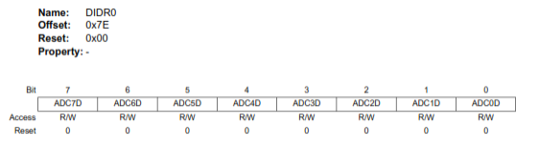

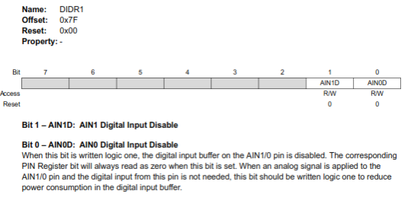

ADC and Power Optimization Training for tinyAVR® and megaAVR® MCUs

Last modified by Microchip on 2023/11/09 09:02

**Contents**

* [Introduction](https://developerhelp.microchip.com/xwiki/bin/view/products/mcu-mpu/8-bit-avr/peripherals/low-power/8-bit-avr-adc-and-power-optimization/#HIntroduction)
  + [Reference Materials](https://developerhelp.microchip.com/xwiki/bin/view/products/mcu-mpu/8-bit-avr/peripherals/low-power/8-bit-avr-adc-and-power-optimization/#HReferenceMaterials)
* [Assignment 1: ADC Conversion with USART Print Application](https://developerhelp.microchip.com/xwiki/bin/view/products/mcu-mpu/8-bit-avr/peripherals/low-power/8-bit-avr-adc-and-power-optimization/#HAssignment1:ADCConversionwithUSARTPrintApplication)
* [Assignment 2: RTC Interrupts Triggers ADC and USART Print](https://developerhelp.microchip.com/xwiki/bin/view/products/mcu-mpu/8-bit-avr/peripherals/low-power/8-bit-avr-adc-and-power-optimization/#HAssignment2:RTCInterruptsTriggersADCandUSARTPrint)
* [Assignment 3: Power Optimization on I/O Pins](https://developerhelp.microchip.com/xwiki/bin/view/products/mcu-mpu/8-bit-avr/peripherals/low-power/8-bit-avr-adc-and-power-optimization/#HAssignment3:PowerOptimizationonI2FOPins)
* [Assignment 4: ADC Conversion Using Window Compare Mode](https://developerhelp.microchip.com/xwiki/bin/view/products/mcu-mpu/8-bit-avr/peripherals/low-power/8-bit-avr-adc-and-power-optimization/#HAssignment4:ADCConversionUsingWindowCompareMode)
* [Assignment 5: Event System (EVSYS) Used to Replace the RTC Interrupt Handler](https://developerhelp.microchip.com/xwiki/bin/view/products/mcu-mpu/8-bit-avr/peripherals/low-power/8-bit-avr-adc-and-power-optimization/#HAssignment5:EventSystem28EVSYS29UsedtoReplacetheRTCInterruptHandler)
* [Summary](https://developerhelp.microchip.com/xwiki/bin/view/products/mcu-mpu/8-bit-avr/peripherals/low-power/8-bit-avr-adc-and-power-optimization/#HSummary)

Introduction

This tutorial contains five hands-on applications for ADC data conversion, with current consumption measured for each application. The tutorial starts with a simple ADC conversion application. In the following applications, different techniques are introduced in order to demonstrate how the current consumption can be reduced in tinyAVR® 0- and 1-series and megaAVR® 0-series MCUs.

This tutorial also demonstrates how to use Atmel START to get started with AVR® devices ADC applications development. The ADC applications have been developed step-by-step in Atmel Studio. This tutorial has been developed on the ATtiny817 Xplained Pro evaluation kit but should be applicable for all tinyAVR 0- and 1-series, and megaAVR 0-series devices.

Solution projects for each of the assignments are available in the Atmel [START Example Browser](http://start.atmel.com/#examples).  
In the Getting Started category, search for ADC and Power Optimization Solution (1-5).  
Direct links to the relevant example projects are provided in the assignment descriptions below.

* [ADC and Power Optimization: Hands-on Tutorial Manual](http://www.microchip.com/40002008)

Reference Materials

* ATtiny817 Xplained Pro evaluation kit
* Micro-USB cable (Type-A/Micro-B)
* A potentiometer
* Three male-to-female wires
* Atmel Studio 7.0
* Web browser. List of supported browsers can be found here: [START supported browsers](https://onlinedocs.microchip.com/pr/GUID-4E095027-601A-4343-844F-2034603B4C9C-en-US-4/index.html?GUID-51435BA6-0D59-4458-A413-08A066F6F7CA)

[Back to Top](https://developerhelp.microchip.com/xwiki/bin/view/products/mcu-mpu/8-bit-avr/peripherals/low-power/8-bit-avr-adc-and-power-optimization/#top)

Estimated Completion Time: 120 minutes

[Assignment 1: ADC Conversion with USART Print Application](https://onlinedocs.microchip.com/pr/GUID-C35EC6FB-C2A0-42FF-80EF-BF1E9A5B3EE8-en-US-2/index.html?GUID-E05908F0-47A0-4464-90E8-9F0E6636A86E)

In this assignment, Atmel Studio is used to develop an application using ADC and USART drivers from Atmel START. The ADC is configured to run in single conversion mode and a potentiometer is connected to the ADC input pin to study the ADC functionality. The ADC data is sent via USART to the embedded terminal in Atmel Studio's Data Visualizer. In Data Visualizer, the current consumption of the application is analyzed using the embedded Power Analyzer.

​

[Assignment 1 solution](http://start.atmel.com/#example/Atmel%3AADC_and_Power_Optimization%3A1.0.0%3A%3AApplication%3AADC_and_Power_Optimization_Solution_1_ADC_conversion%3A)

[Assignment 2: RTC Interrupts Triggers ADC and USART Print](https://onlinedocs.microchip.com/g/GUID-C35EC6FB-C2A0-42FF-80EF-BF1E9A5B3EE8-en-US-2/GUID-87616D7E-1CEE-4DD9-A525-4F221AEF5761.html)

In this assignment, the Real Time Counter (RTC) module is used. The RTC overflow interrupt is used to trigger an ADC conversion every half a second. ADC Result Ready (RESRDY) interrupt triggers a print of the ADC result to the USART terminal. When the RTC overflow interrupt is not triggered, the device is kept in Sleep Standby mode in order to reduce the power consumption. Atmel START is used to add the RTC module and to configure the RTC, ADC, CPUINIT, and SLEEPCTRL drivers. An Atmel Studio project is regenerated afterward.

​

[Assignment 2 solution](http://start.atmel.com/#example/Atmel%3AADC_and_Power_Optimization%3A1.0.0%3A%3AApplication%3AADC_and_Power_Optimization_Solution_2_RTC_SLPCTRL%3A)

[Assignment 3: Power Optimization on I/O Pins](https://onlinedocs.microchip.com/pr/GUID-C35EC6FB-C2A0-42FF-80EF-BF1E9A5B3EE8-en-US-2/GUID-EC8461C8-689A-4FF2-A949-48CCCD0E192A.html)

In this assignment, the digital input buffer on the I/O pins is disabled in order to reduce the current consumption. The current consumption is further reduced when the USART TX pin is configured as a high-impedance pin during the data transmission period. The same drivers and configurations from the previous assignment is used here. Atmel Studio is used to further develop the code.

[Assignment 3 solution](http://start.atmel.com/#example/Atmel%3AADC_and_Power_Optimization%3A1.0.0%3A%3AApplication%3AADC_and_Power_Optimization_Solution_3_IO_pin_optimize%3A)

[Back to Top](https://developerhelp.microchip.com/xwiki/bin/view/products/mcu-mpu/8-bit-avr/peripherals/low-power/8-bit-avr-adc-and-power-optimization/#top)

[Assignment 4: ADC Conversion Using Window Compare Mode](https://onlinedocs.microchip.com/pr/GUID-C35EC6FB-C2A0-42FF-80EF-BF1E9A5B3EE8-en-US-2/GUID-7F09571D-564A-4F76-AEE2-3236E099D521.html)

In this assignment, the ADC result ready interrupt is replaced by the ADC WCMP interrupt, to trigger a USART transmission. In this case, the ADC result, which is below the ADC window threshold value, triggers USART transmission. The ADC results, which are above the window threshold value, are ignored and do not trigger any USART transmission. Atmel START is used to reconfigure the ADC module and the Atmel Studio project is updated with the new configuration.

[Assignment 4 solution](http://start.atmel.com/#example/Atmel%3AADC_and_Power_Optimization%3A1.0.0%3A%3AApplication%3AADC_and_Power_Optimization_Solution_4_ADC_WCMP%3A)

[Assignment 5: Event System (EVSYS) Used to Replace the RTC Interrupt Handler](https://onlinedocs.microchip.com/pr/GUID-C35EC6FB-C2A0-42FF-80EF-BF1E9A5B3EE8-en-US-2/GUID-319E3FE3-511F-4DF5-97CB-0E26619EF7B7.html)

In this assignment, the event system with the RTC overflow event signal, instead of the RTC overflow interrupt, is used to trigger an ADC conversion. The Event System enables direct peripheral-to-peripheral signaling. It allows a change in one peripheral (the Event Generator) to trigger actions in other peripherals (the Event Users) through Event channels without using the CPU. A channel path can be either asynchronous or synchronous to the main clock.

[Assignment 5 solution](http://start.atmel.com/#example/Atmel%3AADC_and_Power_Optimization%3A1.0.0%3A%3AApplication%3AADC_and_Power_Optimization_Solution_5_EVSYS%3A)

Summary

This tutorial contains five hands-on applications doing ADC data conversion, with current consumption measured for each application. It starts with a simple ADC conversion application and different techniques are introduced in order to demonstrate how the current consumption can be reduced. This is a useful foundation for developing future ADC applications with specific current consumption requirements.

[Back to Top](https://developerhelp.microchip.com/xwiki/bin/view/products/mcu-mpu/8-bit-avr/peripherals/low-power/8-bit-avr-adc-and-power-optimization/#top)

# AVR Low Power Example Project

Last modified by Microchip on 2023/11/09 09:02

**Contents**

* [Objective](https://developerhelp.microchip.com/xwiki/bin/view/products/mcu-mpu/8-bit-avr/peripherals/low-power/8-bit-avr-low-power-example/#HObjective)
* [Reference Materials](https://developerhelp.microchip.com/xwiki/bin/view/products/mcu-mpu/8-bit-avr/peripherals/low-power/8-bit-avr-low-power-example/#HReferenceMaterials)
  + [ATmega328PB Xplained Board](https://developerhelp.microchip.com/xwiki/bin/view/products/mcu-mpu/8-bit-avr/peripherals/low-power/8-bit-avr-low-power-example/#HATmega328PBXplainedBoard)
  + [Power Debugger Kit](https://developerhelp.microchip.com/xwiki/bin/view/products/mcu-mpu/8-bit-avr/peripherals/low-power/8-bit-avr-low-power-example/#HPowerDebuggerKit)
  + [Hardware Setup](https://developerhelp.microchip.com/xwiki/bin/view/products/mcu-mpu/8-bit-avr/peripherals/low-power/8-bit-avr-low-power-example/#HHardwareSetup)
    - [Connecting the Power Debugger to the ATmega328PB Xplained Board](https://developerhelp.microchip.com/xwiki/bin/view/products/mcu-mpu/8-bit-avr/peripherals/low-power/8-bit-avr-low-power-example/#HConnectingthePowerDebuggertotheATmega328PBXplainedBoard)
    - [Hardware Configuration](https://developerhelp.microchip.com/xwiki/bin/view/products/mcu-mpu/8-bit-avr/peripherals/low-power/8-bit-avr-low-power-example/#HHardwareConfiguration)
* [Measuring the Current in Active Mode](https://developerhelp.microchip.com/xwiki/bin/view/products/mcu-mpu/8-bit-avr/peripherals/low-power/8-bit-avr-low-power-example/#HMeasuringtheCurrentinActiveMode)
* [Reducing the Power Consumption](https://developerhelp.microchip.com/xwiki/bin/view/products/mcu-mpu/8-bit-avr/peripherals/low-power/8-bit-avr-low-power-example/#HReducingthePowerConsumption)
* [Conclusions](https://developerhelp.microchip.com/xwiki/bin/view/products/mcu-mpu/8-bit-avr/peripherals/low-power/8-bit-avr-low-power-example/#HConclusions)

## Objective

This page illustrates several methods of configuring an 8-bit AVR® MCU to operate with low power consumption. With this exercise, you will:

* Create a project and add simple code to blink an LED
* Run the project and measure the power consumption
* Make modifications to the code to lower power
* Run the modified project and observe reduced power consumption

## Reference Materials

* [Microchip Studio](https://www.microchip.com/en-us/tools-resources/develop/microchip-studio)
* [ATmega328PB Xplained Mini](https://www.microchipdirect.com/dev-tools/ATMEGA328PB-XMINI?productLoaded=true&allDevTools=true)
* [Power Debugger Kit](https://www.microchip.com/en-us/development-tool/ATPOWERDEBUGGER)
* [Two micro USB Cables](https://en.wikipedia.org/wiki/USB_hardware)
* Three female to male wires
* One male to male wire

### ATmega328PB Xplained Board

The ATmega328PB Xplained Mini Evaluation Kit is a hardware platform for evaluating the Atmel ATmega328PB microcontroller. An external debugger is NOT needed to run these exercises. The ATmega328PB has a fully integrated embedded debugger on-board.

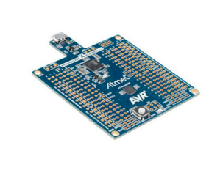

### Power Debugger Kit

The Power Debugger is a CMSIS-DAP compatible debugger that works with Atmel Studio v7.0 or later. The power Debugger sends runtime power measurement and application debug data to the Data Visualizer.

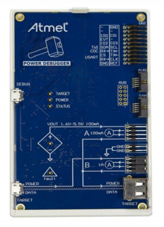

The Power Debugger has two independent current sensing channels for measuring and optimizing the power consumption of a design.  
The ‘A’ channel is the recommend channel for accurately measuring low currents.  
The ‘B’ channel is the recommended channel for measuring higher currents with lower resolution.

[Back to Top](https://developerhelp.microchip.com/xwiki/bin/view/products/mcu-mpu/8-bit-avr/peripherals/low-power/8-bit-avr-low-power-example/#top)

### Hardware Setup

#### **Connecting the Power Debugger to the ATmega328PB Xplained Board**

The ‘A’ and ‘B’ channel current measurement ports on the Power Debugger board are depicted with ammeter symbols on the silkscreen. The voltage supply is connected to the input of the ammeter, and the load (target) is connected to the output. With the following steps, the power debugger measures the consumption on the AVR core.

Table 1-1 Power Debugger and **ATmega328PB Xplained Mini** connection.

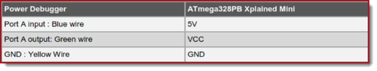

Figure 1-1 Power Debugger and **ATmega328PB Xplained Mini** connection.

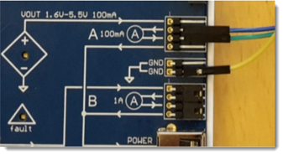

#### **Hardware Configuration**

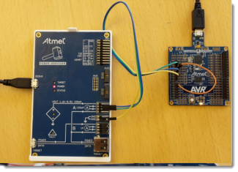

[Back to Top](https://developerhelp.microchip.com/xwiki/bin/view/products/mcu-mpu/8-bit-avr/peripherals/low-power/8-bit-avr-low-power-example/#top)

## Measuring the Current in Active Mode

Project Creation

Open Atmel Studio 7  
Select **File > New > Project**  
Select **GCC C Executable Project** and give it the name "LowPower".  
Choose a location to save the project on your computer.

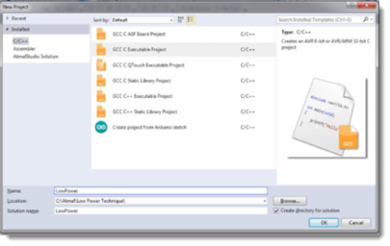

When the Device Selection window appears, enter "328P" into the search window and then select the **Atmega328PB**. Click **OK**.

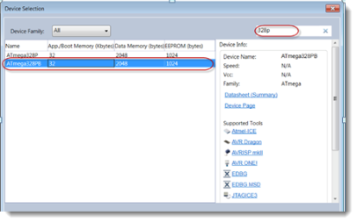

A project will be created containing an empty while(1) loop in main().

#**include** <avr/io.h>  
   
int main(void)  
{  
    */* Replace with your application code */*  
    **while** (1)   
    {  
    }  
}

Select **View > Solution Explorer** from the menu bar.

In the **Solution Explorer**, right click the project and select **Properties**.

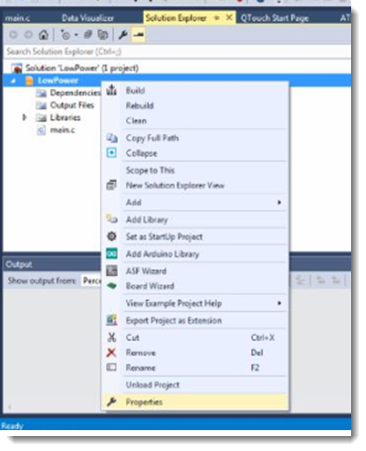

Under **Tool**, Select **mEDBG** and **debugWIRE**

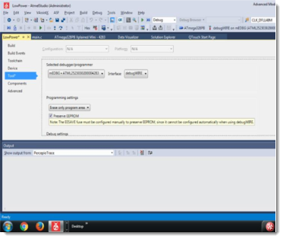

[Back to Top](https://developerhelp.microchip.com/xwiki/bin/view/products/mcu-mpu/8-bit-avr/peripherals/low-power/8-bit-avr-low-power-example/#top)

Add Code to the Project

Add the following two statements in main() to call TMR0_init and set an I/O pin as an output:

​​​​​

TMR0_init();  
   
DDRB |= 1<<DDRB5;   // Direction **of** pin PB5 **set** **as** **Output**

Add the Timer 0 initialization routine

​

*/********************************************************************************  
                                TMR 0 Initialization  
********************************************************************************/*  
void TMR0_init( void ){  
   
    // enable timer overflow interrupt **for** both Timer0 and Timer1  
    TIMSK0=(1<<TOIE0)   
    // set timer0 counter initial value to 0  
    TCNT0=0x00*;*  
    // start timer0 with /1024 prescaler  
    TCCR0B = (1<<CS02) | (1<<CS00)*;*  
   
    // enable interrupts  
    sei()*;*  
   
}

Provide the TMR0 interrupt service routine to the project, and make the LED blink at about 1 Hz.

​

uint8_t    count*;*  
ISR(TIMER0_OVF_vect){  
   
    count++*;*  
    **if**(count==20){  
        count=0*;*  
        // Toogle LED  
        PORTB=PORTB ^ 0x20*;*  
    }  
}

The complete program is as follows,

​

#**include** <avr/io.h>  
#**include** "avr/interrupt.h"  
   
    uint8_t    count*;*  
*/* Timer 0 Interrupt */*  
ISR(TIMER0_OVF_vect){  
   
    count++*;*  
    **if**(count==20){  
        count=0*;*  
        // Toogle LED  
        PORTB=PORTB ^ 0x20*;*  
    }  
}  
   
int main(void)  
{  
    TMR0_init()*;*  
   
    DDRB |= 1<<DDRB5*;   // Direction of pin PB5 set as Output*  
    */* Replace with your application code */*  
    **while** (1)   
    {  
    }  
}  
   
*/********************************************************************************  
                                TMR 0 Initialization  
********************************************************************************/*  
void TMR0_init( void ){  
   
    // enable timer overflow interrupt **for** both Timer0 and Timer1  
    TIMSK0=(1 <<TOIE0) *;*  
   
    // set timer0 counter initial value to 0  
    TCNT0=0x00*;*  
   
    // start timer0 with /1024 prescaler  
    TCCR0B = (1 <<CS02) | (1<<CS00)*;*  
   
    // enable interrupts  
    sei()*;*  
   
}

[Back to Top](https://developerhelp.microchip.com/xwiki/bin/view/products/mcu-mpu/8-bit-avr/peripherals/low-power/8-bit-avr-low-power-example/#top)

Verify the Project Runs

Build the project and program the device by selecting **Debug > Continue**.

The LED will blink if the project is working correctly

Ensure debugging for the project is terminated by selecting **Debug > Disable debugWire** then **Close**.

[Back to Top](https://developerhelp.microchip.com/xwiki/bin/view/products/mcu-mpu/8-bit-avr/peripherals/low-power/8-bit-avr-low-power-example/#top)

##### **Measure the Power Consumption in Active Mode**

In Atmel Studio 7, open the menu **Tools > Data Visualizer**

Power Debugger Data Gateway should be selected by default in the DGI Control Panel, select it if not. Click on **Connect**.

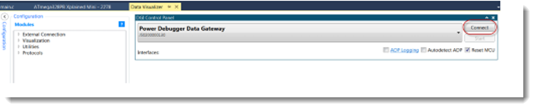

Select **Power** and **Start**

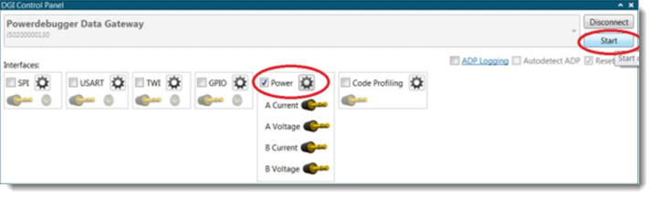

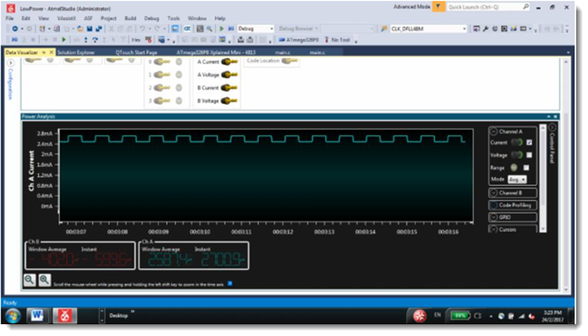

Turn off the target Power Supply to the Xplained board and enable power measurement

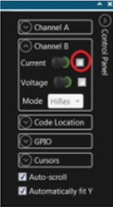

Close the Device Programming  
Verify that the average current consumption is about 2.6 mA

[Back to Top](https://developerhelp.microchip.com/xwiki/bin/view/products/mcu-mpu/8-bit-avr/peripherals/low-power/8-bit-avr-low-power-example/#top)

## Reducing the Power Consumption

There are several methods you can use to reduce the power consumption of an AVR® microcontroller. This example reduces power by:

* Turning off unused peripherals
* Stopping leakage current on the digital I/O pins
* Using Sleep mode. Power consumption optimization techniques are implemented in the function Optimize_power_consumption(), which is called from main().

##### **Disable digital input buffers and Analog comparator**

For analog input pins, the digital input buffer should be disabled.

The digital input buffer measures the voltage on the pin and represents the value as a logical one or zero. An analog signal level close to VCC/2 on an input pin can cause significant additional current consumption. If the pin is used as analog pin there is no need to know if the analog signal’s digital value would be a one or zero; these digital pins should be disabled.

[Back to Top](https://developerhelp.microchip.com/xwiki/bin/view/products/mcu-mpu/8-bit-avr/peripherals/low-power/8-bit-avr-low-power-example/#top)

##### **Turn off unused peripherals**

Disable the peripherals not used in the application. The **Power Reduction Register** (**PRR0**) and (**PRR1**) can stop the clock to individual peripherals to reduce power consumption. Resources used by the peripheral remain occupied when the clock is stopped. In most instances, peripherals should be disabled before the clock is halted.

Include the <power.h> file in the main program  
**#include <avr/power.h>**

Add accompanying code to optimize_power_consumption().

​

*/* Power shutdown to unused peripherals*/*  
PPR0 = 0xDF;  
PPR1 = 0x3F;

Add and #include for <wdt.h> to main.c.  
**#include <avr/wdt.h>**

Add the following code in optimize_power_consumption() to turn off watchdog timer.

​

*/* Disable interrupts*/*  
Cli();  
Wdt_reset();  
MCUSR&= ~(1<<WDRF);

[Back to Top](https://developerhelp.microchip.com/xwiki/bin/view/products/mcu-mpu/8-bit-avr/peripherals/low-power/8-bit-avr-low-power-example/#top)

##### **Apply pull-up resistors**

Unused and unconnected pins consume power. The unneeded power load of floating pins can be avoided by using the AVR's internal pull-up resistors on the unused pins. Port pins can be set to input pull-ups by setting the **DDxn** bit to 0 and **PORTxn** bit to 1. (where x is PORT B,C,D,E and n is 0 to 7)

​

*/* Unused pins set as input pull up*/*  
    DDRB  &= 0xE0;  
    DDRC &= 0xC9;  
    DDRD &= 0x03;  
    DDRE &= 0xF3;  
   
    PORTB |= ~(0xE0);  
    PORTC |= ~(0xC9);  
    PORTD |= ~(0x03);  
    PORTE |= ~(0xF3);

[Back to Top](https://developerhelp.microchip.com/xwiki/bin/view/products/mcu-mpu/8-bit-avr/peripherals/low-power/8-bit-avr-low-power-example/#top)

##### **Use Sleep function**

Sleep mode allows the application to save power by shutting down unused modules. The AVR provides various sleep modes allowing the user to tailor the power consumption to the application’s requirements.

**Include <avr/sleep.h>** header file from AVR library at the top of file.

Set the desired sleep mode in the optimize_power_consumption () function by configuring the microcontroller to use the sleep mode **SLEEP_MODE_PWR_DOWN** for minimum power consumption.

​

*/* Set sleep mode */*  
set_sleep_mode(SLEEP_MODE_PWR_DOWN);

Call the function sleep_mode() from main() to enter Sleep mode.

​

**while** (1)   
{  
sleep_mode()*;*  
}

[Back to Top](https://developerhelp.microchip.com/xwiki/bin/view/products/mcu-mpu/8-bit-avr/peripherals/low-power/8-bit-avr-low-power-example/#top)

##### **Using Pin Change Interrupt**

To wake up the microcontroller from SLEEP_MODE_PWR_DOWN the Pin Change Interrupt is used. The ATmega328PB Xplained Mini board's switch (SW0) is connected to PB7. Pin PB7 is the source for the pin change interrupt. Make the following additions to main():

**#include avr/interrupt.h**

Configuring bit PCINT7 and PCICR register:

PCMSK0 |= (1<<PCINT7)*; //Enable Pin Change Interrupt 7*  
   PCICR |= (1<<PCIE0)*; //Enable the interrupt enable bit for PCINT*  
   sei()*;*

**Add the interrupt service routine:**

In order to enable the ISR routines, the vector name for the PCINT7 is ISR (PCINT0_vect), defined in device header file.

ISR (PCINT0_vect)  
{  
     **if** (!(PINB & (1<<PINB7))) // **if** PINB7 is low (Switch pressed)  
    {  
        PORTB |= (1 <<PORTB5)*; // Turn ON LED*  
    }  
    **else**  
    {  
        PORTB &= ~(1<<PORTB5)*; // Turn OFF LED*  
    }   
}        }

**Completed Code**

After making the previous changes the complete code should like the following:

​

*/*  
 * lowpower2.c  
 */*  
   
//#**include** <avr/io.h>  
   
#**include** <avr/io.h>  
#**include** "avr/interrupt.h"  
#**include** "avr/wdt.h"  
#**include** "avr/sleep.h"  
   
#**include** <avr/power.h>  
#**include** <avr/interrupt.h>  
//#**include** <util/delay.h>  
   
void    optimize_power_consumption(void){  
   
    */* Disable digital input buffer on ADC pins */*  
    DIDR0 = (1 << ADC5D) | (1 << ADC4D) | (1 << ADC3D) | (1 << ADC2D) | (1 << ADC1D) | (1 << ADC0D)*;*  
    DIDR0 |= 0xC0 *;   /*ADC7D and ADC6D are undefined in header file so set bits this way*/*  
   
    */* Disable digital input buffer on Analog comparator pins */*  
    DIDR1 |= (1 << AIN1D) | (1 << AIN0D)*;*  
    */* Disable Analog Comparator */*  
    ACSR |= (1 << ACD)*;*  
   
    */*Power shutdown to unused peripherals*/*  
    PRR0 = 0xDF*;*  
    PRR1 = 0x3F*;*  
    */*Unused pins set as input pull up*/*  
    DDRB &= 0xE0*;*  
    DDRC &= 0xC9*;*  
    DDRD &= 0x03*;*  
    DDRE &=0xF3*;*  
   
    PORTB |=~(0xE0)*;*  
    PORTC |=~(0xC9)*;*  
    PORTD |=~(0x03)*;*  
    PORTE |=~(0xf3)*;*  
   
    */*Watchdog Timer OFF*/*  
   
    */* Disable interrupts */*  
    cli()*;*  
    */* Reset watchdog timer */*  
    wdt_reset()*;*  
    */* Clear WDRF in MCUSR */*  
    MCUSR &= ~(1<<WDRF)*;*  
    */* Turn off WDT */*  
    WDTCSR = 0x00*;*  
   
    */* Set sleep mode */*  
    set_sleep_mode(SLEEP_MODE_PWR_DOWN)*;*  
   
}  
   
*/********************************************************************************  
                                TMR 0 Initialization  
********************************************************************************/*  
 void TMR0_init( void ){  
   
    // enable timer overflow interrupt **for** both Timer0 and Timer1  
    TIMSK0=(1<<TOIE0) *;*  
   
    // set timer0 counter initial value to 0  
    TCNT0=0x00*;*  
   
    // start timer0 with /1024 prescaler  
    TCCR0B = (1<<CS02) | (1<<CS00)*;*  
   
    // enable interrupts  
    sei()*;*  
   
}    
     uint8_t    count*;*  
*/* Timer 0 Interrupt */*  
 ISR(TIMER0_OVF_vect){  
   
    count++*;*  
    **if**(count==20){  
        count=0*;*  
        // Toogle LED  
        PORTB=PORTB ^ 0x20*;*  
    }  
}  
   
ISR (PCINT0_vect)  
{  
     **if** (!(PINB & (1<<PINB7))) // **if** PINB7 is low (Switch pressed)  
    {  
        PORTB |= (1<<PORTB5)*; // Turn ON LED*  
    }  
    **else**  
    {  
        PORTB &= ~(1<<PORTB5)*; // Turn OFF LED*  
    }   
}  
   
int main(void)  
{  
    TMR0_init()*;*  
   
    DDRB |= 1<<DDRB5*;   // Direction of pin PB5 set as Output*  
    DDRB &= ~(1<<DDB7)*; //Set PORTB7 as input*  
   
    optimize_power_consumption()*;*  
   
    PCMSK0 |= (1<<PCINT7)*; //Enable Pin Change Interrupt 7*  
    PCICR |= (1<<PCIE0)*; //Enable the interrupt enable bit for PCINT*  
    sei()*;*  
   
    //set_sleep_mode(SLEEP_MODE_PWR_DOWN)*;*  
    //sleep_enable()*;*  
    //sleep_cpu()*;*  
   
    */* Replace with your application code */*  
    **while** (1)   
    {  
        sleep_mode()*;*  
    }  
}

[Back to Top](https://developerhelp.microchip.com/xwiki/bin/view/products/mcu-mpu/8-bit-avr/peripherals/low-power/8-bit-avr-low-power-example/#top)

##### **Program the application and measure power consumption**

Program the code by selecting **Debug > Continue**.

Wait until the application is programmed and the message at the bottom of the window appears as Running.

Exit the debugger by selecting **Debug > Disable debugWire** then **Close**.

Open the **DataVisualizer window** and check the power consumption as shown.

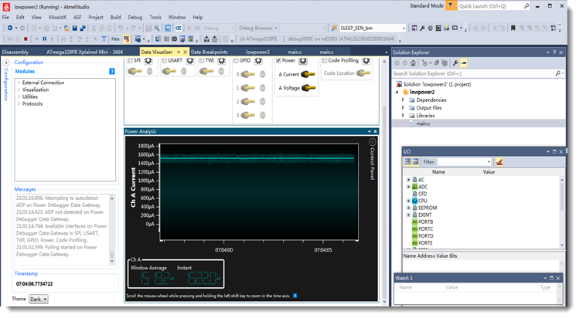

Current consumption observed should be down to around 1.52 mA.

Set target power switch off: **Tools > Device Programming > Tools** setting

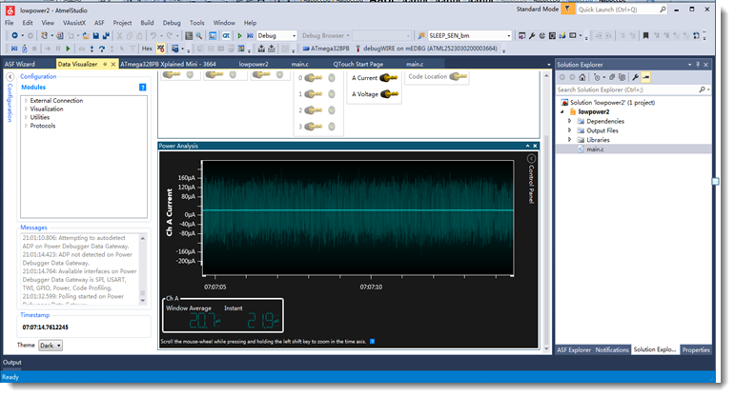

Current consumption should have been lowered to approximately 20.7 μA.

​

Note that the Timer does not wake the device from Sleep mode. The application is set to exit sleep mode when the Pin Change Interrupt occurs.

[Back to Top](https://developerhelp.microchip.com/xwiki/bin/view/products/mcu-mpu/8-bit-avr/peripherals/low-power/8-bit-avr-low-power-example/#top)

## Conclusions

This example demonstrated several different techniques to lower the power consumption of an AVR application. The power consumption can be significantly reduced by:

* Intelligent design
* Using sleep modes
* Switching off unused peripherals

This example used the Atmel Studio 7 Data Visualizer and the Power Debugger Board to measure the power.

# 8-bit AVR Interrupts Example

Last modified by Microchip on 2023/11/10 11:09

## Objective

This page provides a basic interrupt code example for the [ATmega328PB](http://www.microchip.com/wwwproducts/en/ATmega328PB) MCU. The project configures the Timer/Counter1 module to operate in Clear-Timer-On-Compare (CTC) mode, and, on a period match, generates an interrupt event every 100 mS. The ISR manipulates a "tick" signal variable that is used by the main loop to toggle LED0 every 100 mS.

## Resources

[ATmega328PB Xplained Mini](https://www.microchipdirect.com/product/ATMEGA328PB-XMINI?productLoaded=true)  
[MPLAB® X IDE](https://developerhelp.microchip.com/xwiki/bin/view/software-tools/x/)  
[MPLAB® X XC8](https://developerhelp.microchip.com/xwiki/bin/view/software-tools/xc8/)

## Connection Diagram

The USART0 module on the target ATmega328PB device is connected to the USART interface on the mEDBG chip. The mEDBG chip performs USB-serial conversion by enumerating as a CDC-class virtual COM port on the PC and presenting the target USART data on this interface. The mEDBG also controls the programming/debug interface on the target device, as well as supplying a 16MHz clock when the Xplained board is connected via USB cable to a PC. The LED0 is connected to port PB5 as shown:

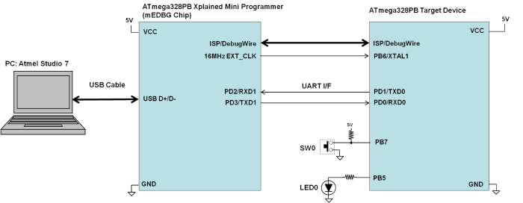

## Procedure

##### **Attach the ATmega328PB Xplained Mini board**

###### **Using a USB-A-male-to-Micro-B-male cable, attached the Xplained Mini to your computer. Start MPLAB X. If the board has been successfully enumerated, you should see the board image come up in Studio.**

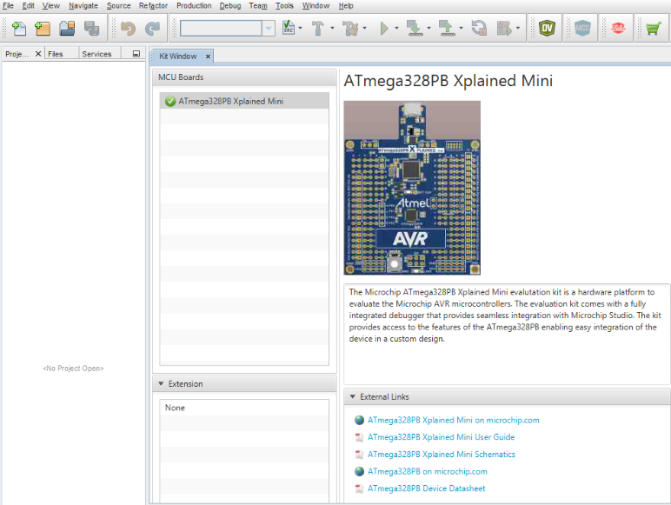

##### **Create a New Project**

###### **In MPLAB X IDE, select File > New Project.**

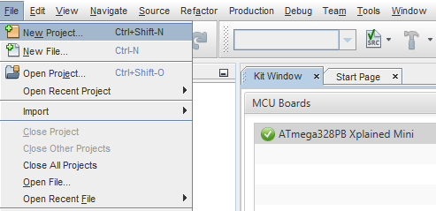​

##### **Choose Project**

###### **Select Microchip Embedded and then Standalone Project and then select Next.**

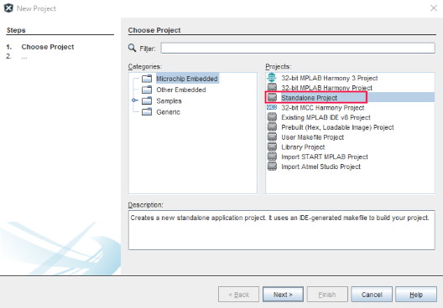

##### **Select Device**

###### **Use the pulldown or type into the boxes to indicate the Family,  ATmega328PB, and Tool. Then select Next.**

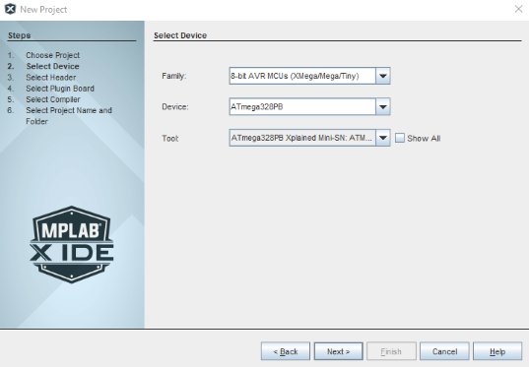

##### **Select Compiler**

###### **Select the XC8 Compiler and then Next.**

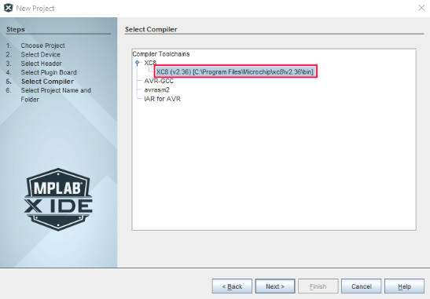

##### **Name the Project**

###### **Choose a name for the project, browse to a location to save it, and select Finish.**

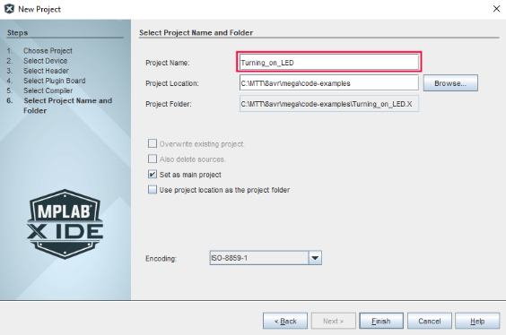

##### **Create a new main.c file**

###### **Right-click on Source Files in the file explorer window and select New > avr-main.c and rename the File Name to main.  Then select Finish.**

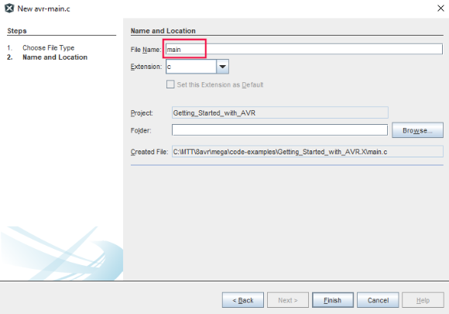

##### **Add the Code**

###### **Delete the contents of the newly created main.c file. Copy and paste the following code into it.**

*/*******************************************************************************  
 * File:  main.c  
 *  
 * Project:  8avr-mega-int-usage-complete  
 *  
 * Description: Timer1 ISR used to provide 100mS "tick" signal  
 *    Main loop toggles LED0 on every "tick" event  
 *   
 * Date:  31-May-2017   
 * Revision:  
 * Author:  
 *  
 * Hardware: ATmega328PB Xplained Mini PCB Rev 3  
 *  
 *    Clock:  16MHz (External - from EDBG IC)  
 *    LED0:  PB5  
 *    SW0:  PB7  
 *    UART_TX: TXD/PD1 (Connected to EDBG IC RXD)  
 *    UART_RX: RXD/PD0 (Connected to EDBG IC TXD)  
 *  
 * Fuses:  High:  0xDF  
 *    Low:  0xC0  
 *    Ext:  0xFC  
 ******************************************************************************/*   
  
#**include** <stdint.h>  
#**include** <avr/io.h>  
#**include** <avr/interrupt.h>  
  
// define shared variable used **for** signaling  
volatile uint8_t tick_signal = 0*;*  
  
// Define An Interrupt Handler **for** TIMER1_COMPA Interrupt (Nesting Disabled)  
ISR(TIMER1_COMPA_vect, ISR_BLOCK)  
{  
 tick_signal++*;     // signal "tick" event*  
         // Timer1 CTC flag auto-cleared by hardware  
}  
  
int main(void)  
{  
    // Initialization  
   
 // Set LED as output  
 DDRB |= (1<<PORTB5)*;   // Configure PB5 as digital output*  
 PORTB &= ~(1<<PORTB5)*;   // Set initial level for PB5*  
   
 // Set up Timer/Counter1  
 TCCR1B |= (1 << WGM12)*;   // Configure timer 1 for CTC mode*  
 OCR1A = 25000*;     // Set CTC compare value to 10Hz (100mS) at*  
         // 16MHz AVR clock , with a prescaler of 64  
 TIMSK1 |= (1 << OCIE1A)*;  // Enable CTC interrupt*  
 TCCR1B |= ((1 << CS10) | (1 << CS11))*; // Start Timer/Counter1 at F_CPU/64*  
   
 // Enable global interrupts   
 sei()*;*  
   
    **while**(1){  
  **if**(tick_signal){  
   PORTB ^= (1 << PORTB5)*; // Toggle LED0*  
   tick_signal = 0*;*  
  }  
 }  
}  
  
*/*******************************************************************************  
  
SOFTWARE AND DOCUMENTATION ARE PROVIDED "AS IS" WITHOUT WARRANTY OF ANY KIND,  
EITHER EXPRESS OR IMPLIED, INCLUDING WITHOUT LIMITATION, ANY WARRANTY OF  
MERCHANTABILITY, TITLE, NON-INFRINGEMENT AND FITNESS FOR A PARTICULAR PURPOSE.  
IN NO EVENT SHALL MICROCHIP TECHNOLOGY INC OR ITS LICENSORS BE LIABLE OR  
OBLIGATED UNDER CONTRACT, NEGLIGENCE, STRICT LIABILITY, CONTRIBUTION, BREACH OF  
WARRANTY, OR OTHER LEGAL EQUITABLE THEORY ANY DIRECT OR INDIRECT DAMAGES OR  
EXPENSES INCLUDING BUT NOT LIMITED TO ANY INCIDENTAL, SPECIAL, INDIRECT,  
PUNITIVE OR CONSEQUENTIAL DAMAGES, LOST PROFITS OR LOST DATA, COST OF  
PROCUREMENT OF SUBSTITUTE GOODS, TECHNOLOGY, SERVICES, OR ANY CLAIMS BY THIRD  
PARTIES (INCLUDING BUT NOT LIMITED TO ANY DEFENSE THEREOF), OR OTHER SIMILAR  
COSTS.  
  
*******************************************************************************/*

##### **Program the Device**

###### **At the top of the MPLAB X IDE, select the Make and Program device button.**



##### **Observe the Results**

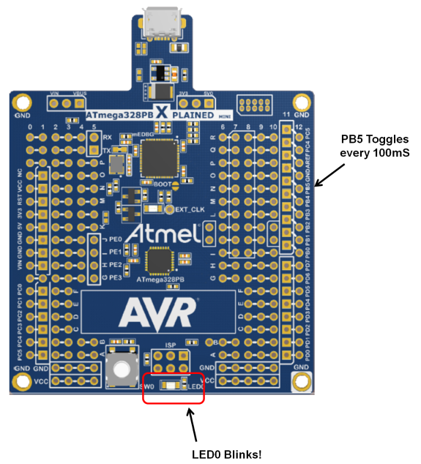

## Conclusions

This project has provided an example of how to set up and use interrupts on the megaAVR MCU.

8-bit AVR® Interrupts Special Considerations

Last modified by Microchip on 2023/11/09 09:02

**Contents**

* + - [Sharing Data with the ISR](https://developerhelp.microchip.com/xwiki/bin/view/products/mcu-mpu/8-bit-avr/peripherals/interrupts/special-considerations/#HSharingDatawiththeISR)
    - [Atomic Data Operations](https://developerhelp.microchip.com/xwiki/bin/view/products/mcu-mpu/8-bit-avr/peripherals/interrupts/special-considerations/#HAtomicDataOperations)
    - [Atomic Access Macros](https://developerhelp.microchip.com/xwiki/bin/view/products/mcu-mpu/8-bit-avr/peripherals/interrupts/special-considerations/#HAtomicAccessMacros)
    - [Learn More](https://developerhelp.microchip.com/xwiki/bin/view/products/mcu-mpu/8-bit-avr/peripherals/interrupts/special-considerations/#HLearnMore)

This page covers a few special considerations to keep in mind when working with interrupts on AVR® MCUs.

Sharing Data with the ISR

Variables shared between the ISR and the main program must be declared as volatile and be global in scope.  
  
When compiling using the optimizer, in a loop like the following one:

​uint8_t flag;  
...  
ISR(SOME_vect) {  
    flag = 1;  
}  
...  
**while**(flag == 0) {  
...  
}

the compiler will typically access "flag" only once, and optimize further accesses completely away since its code path analysis shows that nothing inside the loop could change the value of "flag" anyway.  
  
To tell the compiler that this variable could be changed outside the scope of its code path analysis (e.g., within an interrupt service routine), the variable needs to be declared like this:

​**volatile** uint8_t flag;  
...  
ISR(SOME_vect) {  
    flag = 1;  
}  
...  
**while**(flag == 0) {  
...  
}

When the variable is declared volatile as above, the compiler makes certain that wherever the variable is updated or read it will always write changes back to SRAM memory and read the variable from SRAM.

[Back to top](https://developerhelp.microchip.com/xwiki/bin/view/products/mcu-mpu/8-bit-avr/peripherals/interrupts/special-considerations/)

Atomic Data Operations

For an operation to be considered atomic, it must guarantee uninterrupted access of a given variable. Many assembly languages provide this at certain levels, i.e., bit test and set, however, there is no provision to automatically provide atomicity of all variable types in the ANSI C language.

ANSI-C expressions and statements are non-atomic.

This issue can be problematic (in certain situations) when*multi-byte variables are shared with an ISR.  
  
While declaring such a variable as volatile ensures that the compiler will not optimize accesses to it away, it does not guarantee atomic access to it. Consider the following code example:

​#include *<stdint.h>*  
#include *<avr/io.h>*  
#include *<avr/interrupt.h>*  
   
**volatile** uint16_t ctr;  
   
ISR(TIMER1_OVF_vect)  
{  
  ctr--;  
}  
...  
int  
main(void)  
{  
   ...  
   ctr = 0x0200;  
   start_timer();  
   **while**(ctr != 0)  
     *// wait*       ;  
   ...  
}

There is a chance that the main context will exit its while( ) loop when the variable ctr just reaches the value 0x00FF. This happens because the compiler cannot natively access a 16-bit variable atomically in an 8-bit CPU. So, when ctr is for example at 0x0100, the compiler then tests the low byte for 0, which succeeds. It then proceeds to test the high byte, but that moment the ISR triggers, and the main context is interrupted. The ISR will decrement the variable from 0x0100 to 0x00FF, then the main context proceeds. It now tests the high byte of the variable which is (now) also 0, so it concludes the variable has reached 0, and terminates the loop.

[Back to top](https://developerhelp.microchip.com/xwiki/bin/view/products/mcu-mpu/8-bit-avr/peripherals/interrupts/special-considerations/)

Atomic Access Macros

The AVR-LIBC [Atomic](http://www.nongnu.org/avr-libc/user-manual/group__util__atomic.html) library provides the ATOMIC_BLOCK macros which insert the appropriate interrupt protection when atomic access is desired. These macros operate via automatic manipulation of the Global Interrupt Status (I) bit of the SREG register. Exit paths from both block types are all managed automatically without the need for special considerations, i. e. the interrupt status will be restored to the same value it has been when entering the respective block.  
  
Using the macros from this header file, the above code can be rewritten like:

​#include *<stdint.h>*  
#include *<avr/io.h>*  
#include *<avr/interrupt.h>*  
#include *<util/atomic.h>*  
   
**volatile** uint16_t ctr;  
   
ISR(TIMER1_OVF_vect)  
{  
  ctr--;  
}  
...  
int main(void)  
{  
   uint_16 ctr_copy;  
   ...  
   ctr = 0x0200;  
   start_timer();  
   **do**  
   {  
     ATOMIC_BLOCK(ATOMIC_RESTORESTATE)  
     {  
       ctr_copy = ctr;  
     }  
   } **while**(ctr != 0);  
     *// wait*       ;  
   ...  
}

The ATOMIC_BLOCK macro will install the appropriate interrupt protection before accessing variable ctr, so it is guaranteed to be consistently tested.  
  
In this case, the parameter ATOMIC_RESTORESTATE causes the ATOMIC_BLOCK to restore the previous state of the SREG register, saved before the Global Interrupt Status flag bit was disabled. The net effect of this is to make the ATOMIC_BLOCK's contents guaranteed atomic, without changing the state of the Global Interrupt Status flag when execution of the block completes.

# Configuring megaAVR® Interrupts

Last modified by Microchip on 2023/11/10 11:09

**Contents**

* + - [#include Files](https://developerhelp.microchip.com/xwiki/bin/view/products/mcu-mpu/8-bit-avr/peripherals/interrupts/mega-configuration/#H23includeFiles)
    - [Provide Interrupt Service Routine](https://developerhelp.microchip.com/xwiki/bin/view/products/mcu-mpu/8-bit-avr/peripherals/interrupts/mega-configuration/#HProvideInterruptServiceRoutine)
    - [Review the Following Examples](https://developerhelp.microchip.com/xwiki/bin/view/products/mcu-mpu/8-bit-avr/peripherals/interrupts/mega-configuration/#HReviewtheFollowingExamples)
    - [Configure the Peripheral](https://developerhelp.microchip.com/xwiki/bin/view/products/mcu-mpu/8-bit-avr/peripherals/interrupts/mega-configuration/#HConfigurethePeripheral)
    - [Enable All Interrupts](https://developerhelp.microchip.com/xwiki/bin/view/products/mcu-mpu/8-bit-avr/peripherals/interrupts/mega-configuration/#HEnableAllInterrupts)

AVR® Interrupt operation must be carefully initialized by the application developer. This page summarizes the key initialization and usage steps required for using interrupts in an application.  
  
Further information regarding interrupt usage is provided in the [Interrupt Module](http://www.nongnu.org/avr-libc/user-manual/group__avr__interrupts.html) section of the [AVR-LIBC](http://www.nongnu.org/avr-libc/) Library.

##### **#include Files**

###### **#include Standard Headers**

The application must include header files avr/io.h and avr/interrupt.h as shown in the following code:

#include *<avr/io.h>*  
#include *<avr/interrupt.h>*

The avr/interrupt.h header file provides several macros intended to simplify the application of interrupts in an application, such as macros for globally enabling/disabling interrupts (I-bit in the Status Register), as well as a macro for assigning an interrupt function to a specific interrupt vector:

* sei( )
* cli( )
* ISR(vector_id, attributes)

The vector_id macros are defined in the processor-specific header file (included via avr/io.h), as well as in the device datasheet. Its construction is defined below.

[Back to top](https://developerhelp.microchip.com/xwiki/bin/view/products/mcu-mpu/8-bit-avr/peripherals/interrupts/mega-configuration/)

##### **Provide Interrupt Service Routine**

An interrupt handler function is different to an ordinary function in that it handles the context save and restore to ensure that upon return from interrupt, the program context is maintained. A different code sequence is used to return from these functions as well.

There are several actions that the compiler needs to take to generate an interrupt service routine:

* The compiler has to be told to use an alternate form of return instruction (RETI vs. RET)
* The compiler has to be told about any specific additional options
  + Enable nesting of interrupts
  + Options for generation of prologue/epilogue code
* The function needs to be linked to a specific interrupt vector.

Several handler function attributes are provided to the application developer, enabling these options.

* The ISR( ) macro is provided to ease the definition of interrupt handler functions with attributes

For all interrupt vectors without specific handlers, a default interrupt handler will be installed. The default interrupt handler will reset the device.  
  
An application may override the default handler and provide an application-specific default interrupt handler by using the BADISR_vect vector_id inside the ISR( ) macro.

[Back to top](https://developerhelp.microchip.com/xwiki/bin/view/products/mcu-mpu/8-bit-avr/peripherals/interrupts/mega-configuration/)

##### **Review the Following Examples**

###### **ISR( ) Macro**

The following code example shows how to use the ISR() macro to define an interrupt function:

ISR(vector_id, ISR_[BLOCK|NOBLOCK|NAKED|ALIASOF])  
{  
    */* Hardware auto-clears the interrupt flag (most interrupt sources) */*  
    */* Clear the cause of the interrupt (required by some interrupt sources) */*  
    */* ISR-specific processing */*  
}

The various parameters will now be more fully described.

###### **vector_id**

This identifier is a concatenation of a Vector Source ID and _vect. Vector Source IDs are found in the device datasheet, as shown (partially) in the following example for ATmega328PB:

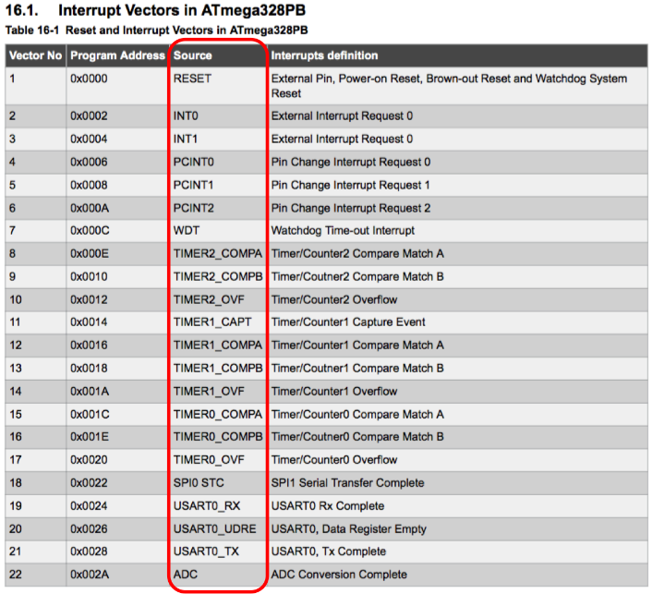

Misspelt vector_ids will still generate a function, however, it will not be wired into the interrupt vector table. The compiler will generate a warning if it detects a suspicious-looking name.

###### **Attributes**

ISR( ) attributes provide further instruction to the compiler regarding how to set up the interrupt function.

ISR_BLOCK

Global interrupts are initially disabled by the AVR hardware when entering the ISR. This setting does not modify this state.

This attribute is identical to an ISR( ) macro with no attribute specified.

ISR_NOBLOCK

ISR runs with global interrupts initially enabled. The interrupt enable flag is activated by the compiler as early as possible within the ISR to ensure minimal processing delay for nested interrupts.

This may be used to create nested ISRs, however, care should be taken to avoid stack overflows, or to avoid infinitely entering the ISR for those cases where the AVR hardware does not clear the respective interrupt flag before entering the ISR.

ISR_NAKED

ISR is created with no prologue or epilogue code. The user code is responsible for the preservation of the machine state including the SREG register, as well as placing a reti() at the end of the interrupt routine.

ISR_ALIASOF(vector_id)

This may be used to define additional vectors that share the same handler. The following example aliases the PCINT1 vector to the PCINT0 handler:

ISR(PCINT0_vect)  
{  
  ...  
  *// Code to handle the event.*}  
ISR(PCINT1_vect, ISR_ALIASOF(PCINT0_vect));

ISR( ) Example

In this code example, we highlight the required header files and correct ISR definition of a handler function for the Timer/Counter1 Clear-Timer-On-Compare (CTC) mode interrupt source. The handler toggles LED0 on the [ATmega328PB Xplained Mini](https://www.microchip.com/en-us/development-tool/atmega328pb-xmini) every 100 mS:

1  
2  
3  
4  
5  
6  
7  
8  
9  
10  
11  
12  
13  
14  
15  
16  
17  
18  
19  
20  
21  
22  
23  
24  
25  
26  
27  
28

#include *<avr/io.h>*  
#include *<avr/interrupt.h>*  
   
ISR(TIMER1_COMPA_vect, ISR_BLOCK)  
{  
    PORTB ^= (1 << PORTB5);   *// Toggle LED0*}  
   
int main(void)  
{  
    *// Initialization*   
    *// Set LED as output*    DDRB |= (1 << PORTB5);     *// Configure PB5 as digital output*    PORTB &= ~(1 << PORTB5);   *// Set initial level for PB5*   
    *// Set up Timer/Counter1*    TCCR1B |= (1 << WGM12 );   *// Configure timer 1 for CTC mode*    OCR1A = 25000;             *// Set CTC compare value to 10Hz (100mS)*                               *// at 16MHz AVR clock, with a prescaler of 64*    TIMSK1 |= (1 << OCIE1A );  *// Enable CTC interrupt*    TCCR1B |= ((1 << CS10 ) | (1 << CS11 )); *// Start Timer/Counter1 at F_CPU/64*   
    *// Enable all interrupts*    sei();   
   
    **while**(1);  
}

[Back to top](https://developerhelp.microchip.com/xwiki/bin/view/products/mcu-mpu/8-bit-avr/peripherals/interrupts/mega-configuration/)

##### **Configure the Peripheral**

Next, you must configure the peripheral to generate interrupt request events.

For example, the ATmega328PB contains several Timer/Counter peripherals modules. Each module has a mode called Clear Timer on Compare (CTC) that, when properly initialized, will periodically trigger a Timer1 Output Compare Match Flag signal in the TC1 interrupt flag register (TIFR1) register as shown in the accompanying image

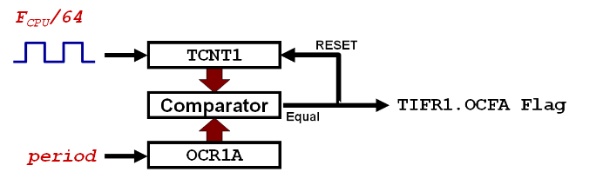

In this example, we will initialize Timer/Counter1 in CTC mode to generate interrupt requests every 100 mS, given a prescaled input of 250 kHz (16 MHz/64):

1  
2  
3  
4  
5  
6  
7  
8  
9  
10  
11  
12  
13  
14  
15  
16  
17  
18  
19  
20  
21  
22  
23  
24  
25  
26  
27  
28

#include *<avr/io.h>*  
#include *<avr/interrupt.h>*  
   
ISR(TIMER1_COMPA_vect, ISR_BLOCK)  
{  
    PORTB ^= (1 << PORTB5);   *// Toggle LED0*}  
   
int main(void)  
{  
    *// Initialization*   
    *// Set LED as output*    DDRB |= (1 << PORTB5);     *// Configure PB5 as digital output*    PORTB &= ~(1 << PORTB5);   *// Set initial level for PB5*   
    *// Set up Timer/Counter1*    TCCR1B |= (1 << WGM12 );   *// Configure timer 1 for CTC mode*    OCR1A = 25000;             *// Set CTC compare value to 10Hz (100mS)*                               *// at 16MHz AVR clock, with a prescaler of 64*    TIMSK1 |= (1 << OCIE1A );  *// Enable CTC interrupt*    TCCR1B |= ((1 << CS10 ) | (1 << CS11 )); *// Start Timer/Counter1 at F_CPU/64*   
    *// Enable all interrupts*    sei();   
   
    **while**(1);  
}

​This is an example of a [non-persistent interrupt](https://developerhelp.microchip.com/xwiki/bin/view/products/mcu-mpu/8-bit-avr/peripherals/interrupts/mega-overview/). The TIFR1.OCFA flag is automatically cleared by hardware on entry to the handler.

The TIFR1.OCFA flag can also be cleared manually by writing a logic 1 to the bit location.

[Back to top](https://developerhelp.microchip.com/xwiki/bin/view/products/mcu-mpu/8-bit-avr/peripherals/interrupts/mega-configuration/)

##### **Enable All Interrupts**

Finally, we need to globally enable all enabled peripheral interrupts by setting the Global Interrupt Enable I-bit in the Status Register (SREG).  
  
The AVR-LIBC interrupt library provides two handy macro functions for this:

* sei( ) to Enable interrupts globally
* cli( ) to Disable interrupts globally

​

1  
2  
3  
4  
5  
6  
7  
8  
9  
10  
11  
12  
13  
14  
15  
16  
17  
18  
19  
20  
21  
22  
23  
24  
25  
26  
27  
28

#include *<avr/io.h>*  
#include *<avr/interrupt.h>*  
   
ISR(TIMER1_COMPA_vect, ISR_BLOCK)  
{  
    PORTB ^= (1 << PORTB5);   *// Toggle LED0*}  
   
int main(void)  
{  
    *// Initialization*   
    *// Set LED as output*    DDRB |= (1 << PORTB5);     *// Configure PB5 as digital output*    PORTB &= ~(1 << PORTB5);   *// Set initial level for PB5*   
    *// Set up Timer/Counter1*    TCCR1B |= (1 << WGM12 );   *// Configure timer 1 for CTC mode*    OCR1A = 25000;             *// Set CTC compare value to 10Hz (100mS)*                               *// at 16MHz AVR clock, with a prescaler of 64*    TIMSK1 |= (1 << OCIE1A );  *// Enable CTC interrupt*    TCCR1B |= ((1 << CS10 ) | (1 << CS11 )); *// Start Timer/Counter1 at F_CPU/64*   
    *// Enable all interrupts*    sei();   
   
    **while**(1);  
}

## Learn More

* [megaAVR Interrupts Overview](https://developerhelp.microchip.com/xwiki/bin/view/products/mcu-mpu/8-bit-avr/peripherals/interrupts/mega-overview/)
* [Special Considerations](https://developerhelp.microchip.com/xwiki/bin/view/products/mcu-mpu/8-bit-avr/peripherals/interrupts/special-considerations/)
* [megaAVR Interrupt Example](https://developerhelp.microchip.com/xwiki/bin/view/products/mcu-mpu/8-bit-avr/peripherals/interrupts/8-bit-avr-interrupts-mega-example/)

[Back to top](https://developerhelp.microchip.com/xwiki/bin/view/products/mcu-mpu/8-bit-avr/peripherals/interrupts/mega-configuration/)

megaAVR® Interrupts Overview

Last modified by Microchip on 2023/11/10 11:09

**Contents**

* + [Reset & Interrupt Vector Locations](https://developerhelp.microchip.com/xwiki/bin/view/products/mcu-mpu/8-bit-avr/peripherals/interrupts/mega-overview/#HReset26InterruptVectorLocations)
  + [Vector Relocation](https://developerhelp.microchip.com/xwiki/bin/view/products/mcu-mpu/8-bit-avr/peripherals/interrupts/mega-overview/#HVectorRelocation)
  + [Priority Level](https://developerhelp.microchip.com/xwiki/bin/view/products/mcu-mpu/8-bit-avr/peripherals/interrupts/mega-overview/#HPriorityLevel)
  + [Interrupt Processing](https://developerhelp.microchip.com/xwiki/bin/view/products/mcu-mpu/8-bit-avr/peripherals/interrupts/mega-overview/#HInterruptProcessing)
  + [Persistent Interrupts](https://developerhelp.microchip.com/xwiki/bin/view/products/mcu-mpu/8-bit-avr/peripherals/interrupts/mega-overview/#HPersistentInterrupts)
    - [Example: USART Receive Complete Interrupt](https://developerhelp.microchip.com/xwiki/bin/view/products/mcu-mpu/8-bit-avr/peripherals/interrupts/mega-overview/#HExample:USARTReceiveCompleteInterrupt)
  + [Non-Persistent Interrupts](https://developerhelp.microchip.com/xwiki/bin/view/products/mcu-mpu/8-bit-avr/peripherals/interrupts/mega-overview/#HNon-PersistentInterrupts)
    - [Example: Timer/Counter0 Overflow Interrupt](https://developerhelp.microchip.com/xwiki/bin/view/products/mcu-mpu/8-bit-avr/peripherals/interrupts/mega-overview/#HExample:Timer2FCounter0OverflowInterrupt)
  + [Learn More](https://developerhelp.microchip.com/xwiki/bin/view/products/mcu-mpu/8-bit-avr/peripherals/interrupts/mega-overview/#HLearnMore)

The megaAVR® family provides several different interrupt sources, all of which are maskable and are divided into three categories:

* Internal Peripheral Interrupts
  + Associated with Timers, USART, SPI, ADC peripherals
* External Pin Interrupts
  + Associated with the INT0-INT7 external interrupt pins
* Pin Change Interrupts
  + Associated with PCINT0-PCINT2 external interrupts occurring on a port pin change

Peripherals are assigned individual interrupt enable bits in their respective interrupt mask register which must be written as a logic one together with the Global Interrupt Enable I-bit in the Status Register in order to enable the interrupt.

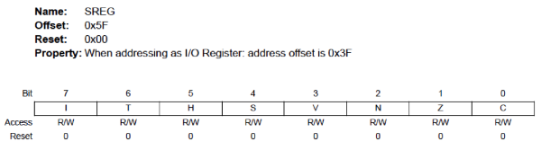

Reset & Interrupt Vector Locations

The Reset & Interrupt sources each have a separate program vector in the program memory space. The lowest addresses in the program memory space are by default defined as the Reset and Interrupt Vectors as follows:

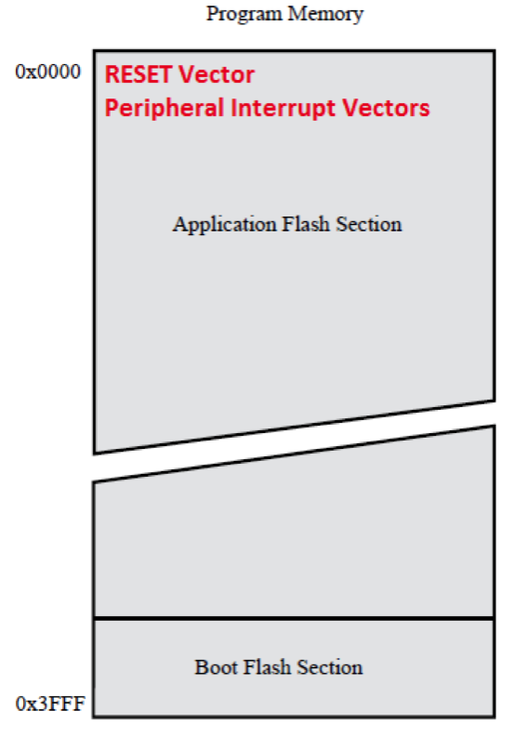

[Back to top](https://developerhelp.microchip.com/xwiki/bin/view/products/mcu-mpu/8-bit-avr/peripherals/interrupts/mega-overview/)

Vector Relocation

The user can relocate the RESET vector as well as the start location of the Interrupt vectors to the Boot Flash Section of program memory space by programming the BOOTRST fuse bit to 0 and setting the IVSEL bit of the Microcontroller Configuration Register (MCUCR) to 1. The possible RESET and interrupt vector placement are as follows:

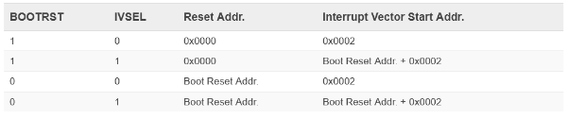

The Boot Reset Address is set by BOOTSZ0/BOOTSZ1 fuse bits as shown in Table 32-7 for ATmega328PB:

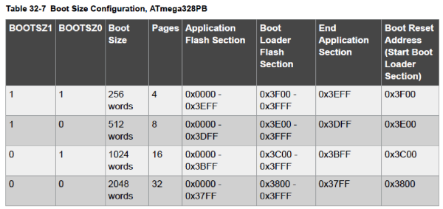

​

To avoid unintentional changes of Interrupt Vector tables, a special write procedure must be followed to change the IVSEL bit:

* Write the Interrupt Vector Change Enable (IVCE) bit to one.
* Within four cycles, write the desired value to IVSEL while writing a zero to IVCE.

Here is a code sample showing how to modify the IVSEL bit and relocate the interrupt vectors:

void move_interrupts(void)  
{  
  uchar temp;  
  */* GET MCUCR */*  
  temp = MCUCR;  
  */* Enable change of Interrupt Vectors */*  
  MCUCR = temp | (1 << IVCE);  
  */* Move interrupts to Boot Flash section */*  
  MCUCR = temp | (1 << IVSEL);  
}

[Back to top](https://developerhelp.microchip.com/xwiki/bin/view/products/mcu-mpu/8-bit-avr/peripherals/interrupts/mega-overview/)

Priority Level

Each vector has a pre-determined priority level; the *lower* the address, the *higher* the priority level. RESET has the highest priority, and next is INT0 – the External Interrupt Request 0. Table 16-1 depicts the partial vector listing for the ATmega328PB MCU:

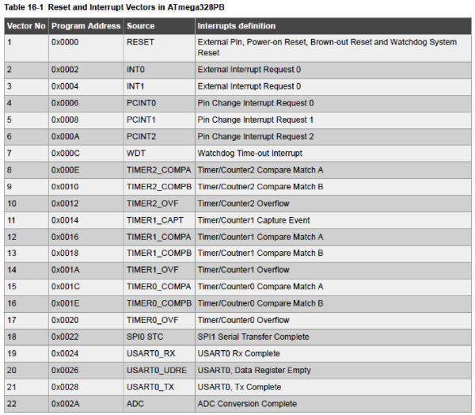

Interrupt Processing

When an interrupt occurs, the Global Interrupt Enable I-bit is cleared and all interrupts are disabled. The I-bit is automatically set when a Return from Interrupt instruction – RETI – is executed.

User software can write logic one to the I-bit to enable *nested interrupts*. All enabled interrupts can then interrupt the current interrupt routine.

There are basically two types of interrupts, persistent interrupts and non-persistent interrupts.

[Back to top](https://developerhelp.microchip.com/xwiki/bin/view/products/mcu-mpu/8-bit-avr/peripherals/interrupts/mega-overview/)

Persistent Interrupts

This type of interrupt will trigger as long as the interrupt condition is present. These interrupts do not necessarily have Interrupt Flags.

Example: USART Receive Complete Interrupt

The USART contains a Receive Complete Flag (RXC) which is set if there is unread data in the receive buffer. When the Receive Complete Interrupt Enable (RXCIE) in UCSRnB is set, the USART Receive Complete interrupt will be executed as long as the RXC Flag is set (provided that global interrupts are enabled). When interrupt-driven data reception is used, the receive complete routine must read the received data from UDR in order to clear the RXC Flag, otherwise a new interrupt will occur once the interrupt routine terminates.

[Back to top](https://developerhelp.microchip.com/xwiki/bin/view/products/mcu-mpu/8-bit-avr/peripherals/interrupts/mega-overview/)

Non-Persistent Interrupts

This type of interrupt is triggered by an event that sets an *Interrupt Flag*. For these interrupts, the Program Counter is vectored to the actual Interrupt Vector in order to execute the interrupt handling routine, and *hardware clears the corresponding Interrupt Flag*. Interrupt Flags can also be cleared by writing a logic one to the flag bit position(s) to be cleared. If an interrupt condition occurs while the corresponding interrupt enable bit is cleared, the Interrupt Flag will be set and remembered until the interrupt is enabled, or the flag is cleared by software. Similarly, if one or more interrupt conditions occur while the Global Interrupt Enable bit is cleared, the corresponding Interrupt Flag(s) will be set and remembered until the Global Interrupt Enable bit is set, and will then be executed by order of priority.

Example: Timer/Counter0 Overflow Interrupt

Bit-0 of the Timer0 Interrupt Flag Register (TIFR0) contains the TOV0 interrupt flag. This flag is set when an overflow occurs in Timer/Counter0. TOV0 is *cleared by hardware when executing the corresponding interrupt handling vector*. Alternatively, TOV0 is cleared by writing a logic one to the flag. When the SREG I-bit, TOIE0 (Timer/Counter0 Overflow Interrupt Enable), and TOV0 are set, the Timer/Counter0 Overflow interrupt is executed.

[Back to top](https://developerhelp.microchip.com/xwiki/bin/view/products/mcu-mpu/8-bit-avr/peripherals/interrupts/mega-overview/)

Learn More

* [Configuring megaAVR® Interrupts](https://developerhelp.microchip.com/xwiki/bin/view/products/mcu-mpu/8-bit-avr/peripherals/interrupts/mega-configuration/)
* [8-bit AVR® Interrupts Special Considerations](https://developerhelp.microchip.com/xwiki/bin/view/products/mcu-mpu/8-bit-avr/peripherals/interrupts/special-considerations/)
* [8-bit AVR Interrupts Example](https://developerhelp.microchip.com/xwiki/bin/view/products/mcu-mpu/8-bit-avr/peripherals/interrupts/8-bit-avr-interrupts-mega-example/)

[Back to top](https://developerhelp.microchip.com/xwiki/bin/view/products/mcu-mpu/8-bit-avr/peripherals/interrupts/mega-overview/)

# megaAVR® Oscillator Example Project

Last modified by Microchip on 2023/11/10 11:09

**Contents**

* [Objective](https://developerhelp.microchip.com/xwiki/bin/view/products/mcu-mpu/8-bit-avr/peripherals/oscillator/example/#HObjective)
* [Reference Material](https://developerhelp.microchip.com/xwiki/bin/view/products/mcu-mpu/8-bit-avr/peripherals/oscillator/example/#HReferenceMaterial)
* [Connection Diagram](https://developerhelp.microchip.com/xwiki/bin/view/products/mcu-mpu/8-bit-avr/peripherals/oscillator/example/#HConnectionDiagram)
* [​Procedure](https://developerhelp.microchip.com/xwiki/bin/view/products/mcu-mpu/8-bit-avr/peripherals/oscillator/example/#H200BProcedure)
* [Conclusions](https://developerhelp.microchip.com/xwiki/bin/view/products/mcu-mpu/8-bit-avr/peripherals/oscillator/example/#HConclusions)
* [Learn More](https://developerhelp.microchip.com/xwiki/bin/view/products/mcu-mpu/8-bit-avr/peripherals/oscillator/example/#HLearnMore)

## Objective

This page provides a simple project demonstrating dynamic adjustment of the System Clock Frequency via modification of the System Clock Prescaler Register (CLKPR) on megaAVR® devices. The code example runs on the [ATmega328PB](http://www.microchip.com/wwwproducts/en/ATmega328PB) MCU.  
  
TheSystem Clock Source is set via configuration fuse bits to be the external 16MHz clock provided by the mEDBG chip (see connection diagram below).  
  
The project configures the Timer/Counter1 module to operate in Clear-Timer-On-Compare (CTC) mode, and, on a period match, generates a tick interrupt every 100 mS. The timer clock source is configured to be SYS_CLK/64.  
  
The Timer/Counter1 ISR toggles LED0, and increments a Counter. The main program loop monitors the Counter value and updates CLKPR value every 10 seconds to dynamically change the SYS_CLK frequency.  
  
CLKPR is toggled between div/1 and div/4 setting, thereby changing the toggle (interrupt) interval from 100 ms to 400 mS respectively. This can be seen as the LED0 blink rate changes every 10 seconds.

Review the project's main.c file for further detailed comments and a description of the operation.

[Back to top](https://developerhelp.microchip.com/xwiki/bin/view/products/mcu-mpu/8-bit-avr/peripherals/oscillator/example/)

## Reference Material

[ATmega328PB Xplained Mini](https://www.microchipdirect.com/product/ATMEGA328PB-XMINI?productLoaded=true)  
[MPLAB® X IDE](https://developerhelp.microchip.com/xwiki/bin/view/software-tools/x/)  
[MPLAB® XC8](https://developerhelp.microchip.com/xwiki/bin/view/software-tools/xc8/)

[Back to top](https://developerhelp.microchip.com/xwiki/bin/view/products/mcu-mpu/8-bit-avr/peripherals/oscillator/example/)

## Connection Diagram

The mEDBG chip controls the programming/debug interface, as well as supplying a 16 MHz clock when the Xplained board is connected via USB cable to a PC.

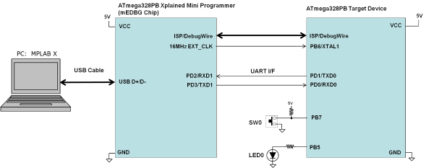​

[Back to top](https://developerhelp.microchip.com/xwiki/bin/view/products/mcu-mpu/8-bit-avr/peripherals/oscillator/example/)

## ​Procedure

##### **Attach the ATmega328PB Xplained Mini board**

Using a USB-A-male-to-Micro-B-male cable, attached the Xplained Mini to your computer. Start MPLAB X IDE®. If the board has been successfully enumerated, you should see the board image come up in Studio as shown in the accompanying image.

​

##### **Create a New Project**

In MPLAB X IDE, select **File > New Project.**

​

##### **Choose Project**

Select**Microchip Embedded**and then **Standalone Project**and then select **Next**.

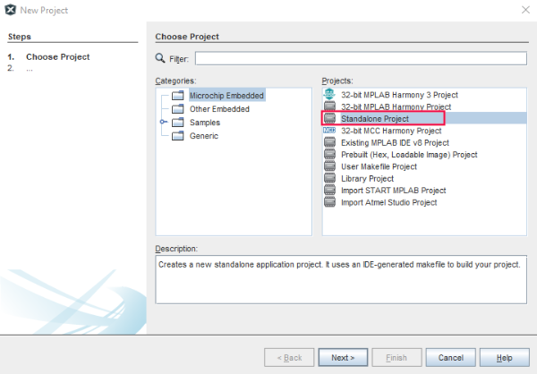

##### **Select Device**

Use the pulldown or type into the boxes to indicate the Family,  ATmega328PB, and Tool. Then Select **Next**.

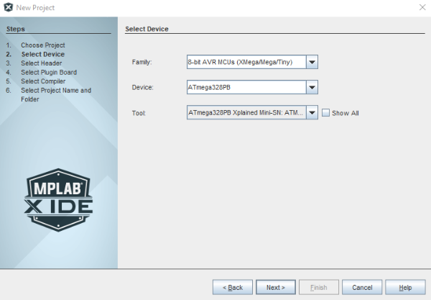

##### **Select Compiler**

Select the **XC8 Compiler**and then **Next.**

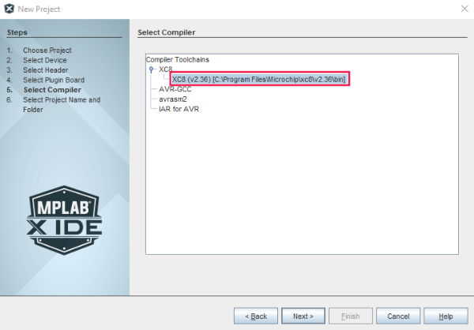

##### **Name the Project**

Choose a name for the project, browse to a location to save it, and select **Finish.**

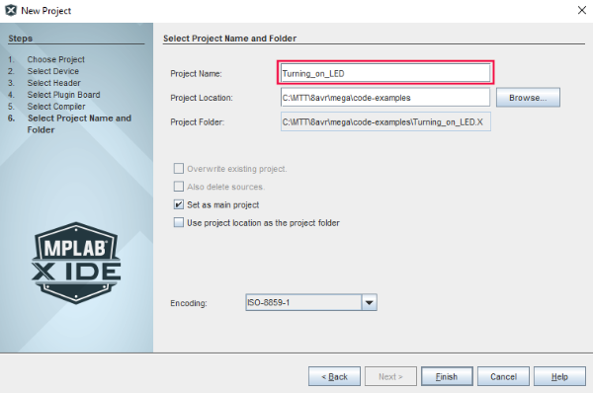

##### **Create a New main.c file**

Right-click on **Source Files** in the file explorer window and select **New > avr-main.c**and rename the File Name to **main.**Then select **Finish**.

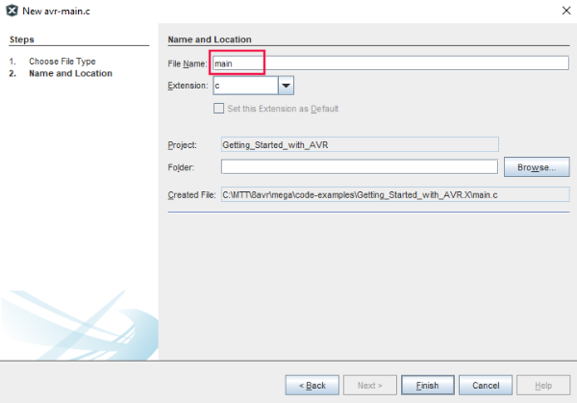

##### **Add the Code**

Delete the contents of the newly created main.c file. **Copy and Paste** the following code into it.

*/*******************************************************************************  
 * File:  main.c  
 *  
 * Project:  8avr-mega-oscillator-example  
 *  
 * Description: Timer/Counter1 ISR used to toggle LED0, and increment a Counter.  
 *      
 *    Main loop monitors the Counter. CLKPR is updated Every 10 sec  
 *    to dynamically change the SYS_CLK frequency.  
 *  
 *    CLKPR is toggled between div/1 and div/4 setting, which changes  
 *    the toggle from 100ms to 400mS respectively.   
 *   
 * Date:  22-Aug-2017   
 * Revision:  
 * Author:  
 *  
 * Hardware: ATmega328PB Xplained Mini PCB Rev 3  
 *  
 *    Clock:  16MHz (External - from EDBG IC)  
 *    LED0:  PB5  
 *    SW0:  PB7  
 *  
 * Fuses:  (Programmed in Atmel Studio)  
 *  
 *    NOTE: Target ATmega328PB CKSEL fuse bits are unchangeable on the  
 *    Xplained Mini board within Atmel Studio.  
 *  
 *    Ext:  0xFC  
 *    High:  0xDF  
 *    Low:  0xC0 (EXT CLK, Fast VDD rise, CLKDIV = 1)  
 *  
 ******************************************************************************/*  
  
#**include** <stdint.h>    // Std integral type definitions  
#**include** <avr/io.h>    // SFR definitions  
#**include** <avr/interrupt.h>  // ISR macros  
  
#define LONG_TOGGLE_DURATION 25 // 10 second delay @ 400mS tick  
#define SHORT_TOGGLE_DURATION 100 // 10 second delay @ 100mS tick  
  
#define CLKPR_DIV_1  0x00 // CLKPR values  
#define CLKPR_DIV_2  0x01  
#define CLKPR_DIV_4  0x02  
#define CLKPR_DIV_8  0x03  
#define CLKPR_DIV_16 0x04  
#define CLKPR_DIV_32 0x05  
#define CLKPR_DIV_64 0x06  
#define CLKPR_DIV_128 0x07  
#define CLKPR_DIV_256 0x08  
  
// variables used by main **loop** to track when to switch CLKPR value  
enum {SHORT, LONG} toggleDurationState = SHORT*;*  
volatile uint8_t toggleCounter = 0*;*  
uint8_t toggleDurationTripThreshold = SHORT_TOGGLE_DURATION*;*  
  
// CLKPR update function signature  
void clkPrescaleSet(uint8_t divisionFactor)*;*  
  
// Define An Interrupt Handler **for** TIMER1_COMPA Interrupt (Nesting Disabled)  
ISR(TIMER1_COMPA_vect, ISR_BLOCK){  
 PORTB ^= (1<<PORTB5)*;  // Toggle LED0 (PB5)*  
 toggleCounter++*;   // Increment counter*  
}  
   
int main(void)  
{  
    // Set up Timer/Counter1  
    TCCR1B |= (1 << WGM12)*;   // Configure timer 1 for CTC mode*  
    OCR1A = 25000*;     // Set CTC compare value to 10Hz (100mS) at*  
         // 16MHz AVR clock , with a prescaler of 64  
    TIMSK1 |= (1 << OCIE1A)*;  // Enable CTC interrupt*  
    TCCR1B |= ((1 << CS10) | (1 << CS11))*; // Start Timer/Counter1 at F_CPU/64*  
   
    // Set LED as output  
    DDRB |= (1<<PORTB5)*;   // Configure PB5 as digital output*  
    PORTB &= ~(1<<PORTB5)*;   // Set initial level for PB5*  
         
 // enable interrupts  
 sei()*;*  
   
 **while** (1)   
    {  
  switch(toggleDurationState){  
     
   case SHORT:  
     
   **if**(toggleCounter >= toggleDurationTripThreshold){  
    toggleCounter = 0*;*  
    clkPrescaleSet(CLKPR_DIV_4)*;*  
    toggleDurationTripThreshold = LONG_TOGGLE_DURATION*;*  
    toggleDurationState = LONG*;*  
   }  
   **break***;*  
     
   case LONG:  
     
   **if**(toggleCounter >= toggleDurationTripThreshold){  
    toggleCounter = 0*;*  
    clkPrescaleSet(CLKPR_DIV_1)*;*  
    toggleDurationTripThreshold = SHORT_TOGGLE_DURATION*;*  
    toggleDurationState = SHORT*;*  
   }  
   **break***;*  
     
   default:  
   **break***;*  
  }  
    }  
}  
  
void clkPrescaleSet(uint8_t divisionFactor){  
 cli()*;      // disable interrupts*  
 CLKPR = (1<<CLKPCE)*;  // enable change of the CLKPSx bits*  
 CLKPR = divisionFactor*;  // update the CLKPSx bits*  
 sei()*;      // re-enable interrupts*  
}

##### **Program the Device**

At the top of the MPLAB X IDE, select the **Make and Program** device button.

​

##### **Observe the Results**

LED0 will light at a fixed frequency which will change every 10 seconds.

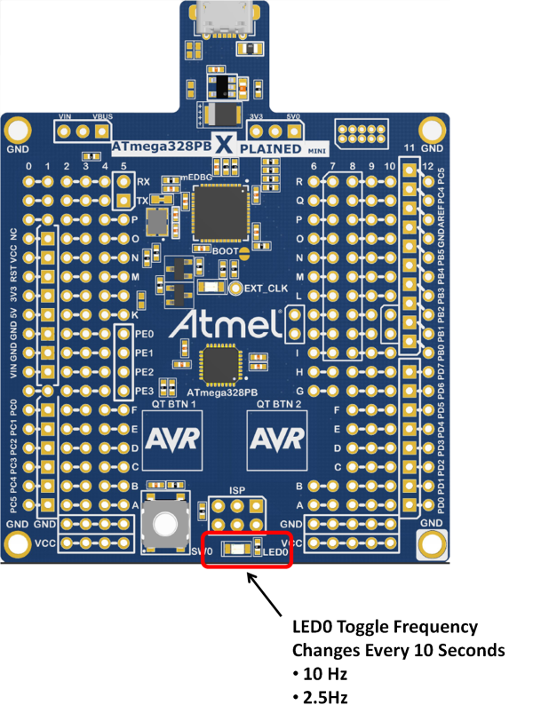​

## Conclusions

This project has provided an example of how to dynamically adjust the system clock frequency on the megaAVR® MCU.

[Back to top](https://developerhelp.microchip.com/xwiki/bin/view/products/mcu-mpu/8-bit-avr/peripherals/oscillator/example/)

## Learn More

* [megaAVR® Oscillator Overview](https://developerhelp.microchip.com/xwiki/bin/view/products/mcu-mpu/8-bit-avr/peripherals/oscillator/overview/)
* [megaAVR® Timer Overview](https://developerhelp.microchip.com/xwiki/bin/view/products/mcu-mpu/8-bit-avr/peripherals/timers-counters/8-bit-avr-avrtimerover/)
* [megaAVR® Interrupts Overview](https://developerhelp.microchip.com/xwiki/bin/view/products/mcu-mpu/8-bit-avr/peripherals/interrupts/mega-overview/)

[Back to top](https://developerhelp.microchip.com/xwiki/bin/view/products/mcu-mpu/8-bit-avr/peripherals/oscillator/example/)

MegaAVR® Oscillator Overview

Last modified by Microchip on 2023/11/14 18:33

**Contents**

* + [Overview](https://developerhelp.microchip.com/xwiki/bin/view/products/mcu-mpu/8-bit-avr/peripherals/oscillator/overview/#HOverview)
  + [Clock Sources](https://developerhelp.microchip.com/xwiki/bin/view/products/mcu-mpu/8-bit-avr/peripherals/oscillator/overview/#HClockSources)
    - [Default Clock Source](https://developerhelp.microchip.com/xwiki/bin/view/products/mcu-mpu/8-bit-avr/peripherals/oscillator/overview/#HDefaultClockSource)
    - [Clock Startup Sequence](https://developerhelp.microchip.com/xwiki/bin/view/products/mcu-mpu/8-bit-avr/peripherals/oscillator/overview/#HClockStartupSequence)
    - [Vcc Stability](https://developerhelp.microchip.com/xwiki/bin/view/products/mcu-mpu/8-bit-avr/peripherals/oscillator/overview/#HVccStability)
    - [Oscillator Stability](https://developerhelp.microchip.com/xwiki/bin/view/products/mcu-mpu/8-bit-avr/peripherals/oscillator/overview/#HOscillatorStability)
  + [Low Power Crystal Oscillator](https://developerhelp.microchip.com/xwiki/bin/view/products/mcu-mpu/8-bit-avr/peripherals/oscillator/overview/#HLowPowerCrystalOscillator)
  + [Low-Frequency Crystal Oscillator](https://developerhelp.microchip.com/xwiki/bin/view/products/mcu-mpu/8-bit-avr/peripherals/oscillator/overview/#HLow-FrequencyCrystalOscillator)
  + [Calibrated Internal RC Oscillator](https://developerhelp.microchip.com/xwiki/bin/view/products/mcu-mpu/8-bit-avr/peripherals/oscillator/overview/#HCalibratedInternalRCOscillator)
  + [128 kHz Internal Oscillator](https://developerhelp.microchip.com/xwiki/bin/view/products/mcu-mpu/8-bit-avr/peripherals/oscillator/overview/#H128A0kHzInternalOscillator)
  + [External Clock](https://developerhelp.microchip.com/xwiki/bin/view/products/mcu-mpu/8-bit-avr/peripherals/oscillator/overview/#HExternalClock)
  + [Clock Output Buffer](https://developerhelp.microchip.com/xwiki/bin/view/products/mcu-mpu/8-bit-avr/peripherals/oscillator/overview/#HClockOutputBuffer)
  + [Timer/Counter Oscillator](https://developerhelp.microchip.com/xwiki/bin/view/products/mcu-mpu/8-bit-avr/peripherals/oscillator/overview/#HTimer2FCounterOscillator)
  + [System Clock Prescaler](https://developerhelp.microchip.com/xwiki/bin/view/products/mcu-mpu/8-bit-avr/peripherals/oscillator/overview/#HSystemClockPrescaler)
  + [Writing to CLKPR](https://developerhelp.microchip.com/xwiki/bin/view/products/mcu-mpu/8-bit-avr/peripherals/oscillator/overview/#HWritingtoCLKPR)
    - [Code Sample](https://developerhelp.microchip.com/xwiki/bin/view/products/mcu-mpu/8-bit-avr/peripherals/oscillator/overview/#HCodeSample)
  + [CLKDIV8 Fuse & CLKPR](https://developerhelp.microchip.com/xwiki/bin/view/products/mcu-mpu/8-bit-avr/peripherals/oscillator/overview/#HCLKDIV8Fuse26CLKPR)
  + [Learn More](https://developerhelp.microchip.com/xwiki/bin/view/products/mcu-mpu/8-bit-avr/peripherals/oscillator/overview/#HLearnMore)

Microchip megaAVR® 8-bit microcontrollers have several clock source options, selectable via programming of the CKSEL[Flash fuse bits](https://developerhelp.microchip.com/xwiki/bin/view/products/mcu-mpu/8-bit-avr/structure/fuses/). This discussion is specific to the [ATmega328PB](http://www.microchip.com/wwwproducts/en/ATmega328PB) MCU.  
  
The fuse bits can select one of:

* Low-Power Crystal Oscillator
* Low-Frequency Crystal Oscillator
* Internal 128 kHz RC Oscillator
* Calibrated Internal RC Oscillator, and
* External Clock

The system clock source cannot be changed during run-time, as it is set via fuse programming.

The system clock frequency can be changed during run-time by writing to the System Clock Prescaler register (CLKPR).

Each clock source provides a delay option after the device reset or power-up to keep the device reset until it is supplied with minimum Vcc. The clock from the selected source is input to the AVR® clock generator and routed to the appropriate modules.

megaAVR® maximum operating frequency is dependent on VCC. Application software must ensure that the selected clock source frequency falls within the safe operating area (see section 33.4 in the [device data sheet](http://ww1.microchip.com/downloads/en/DeviceDoc/40001906A.pdf)).

Overview

The accompanying image illustrates the principal clock systems in the device and their distribution. All the clocks need not be active at a given time. In order to reduce power consumption, the clocks to modules not being used can be halted by using different [sleep modes](https://developerhelp.microchip.com/xwiki/bin/view/products/mcu-mpu/8-bit-avr/structure/sleep/). The clock systems are described in the following sections. The system clock frequency refers to the frequency generated from the System Clock Prescaler. All clock outputs from the AVR Clock Control Unit run at the same frequency.

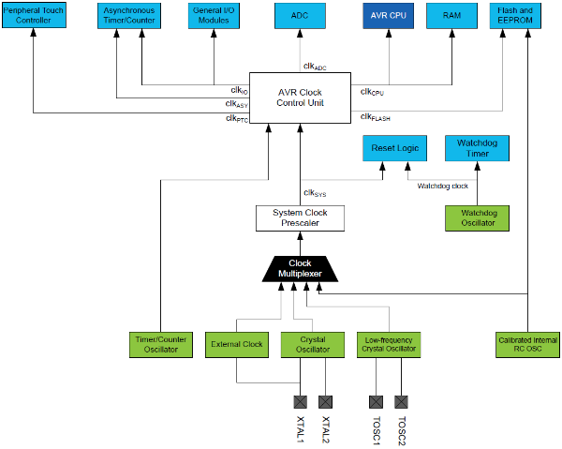  
[Back to top](https://developerhelp.microchip.com/xwiki/bin/view/products/mcu-mpu/8-bit-avr/peripherals/oscillator/overview/)

Clock Sources

The device has the following clock source options, selectable via CKSEL Flash Fuse bits as shown in the accompanying image. The clock from the selected source is input to the AVR® clock generator and routed to the appropriate modules.

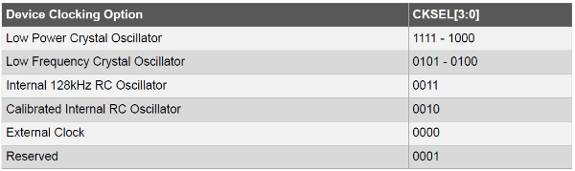

Default Clock Source

The device is shipped with the internal RC oscillator selected at 8.0 MHz and with the fuse CKDIV8 programmed, resulting in 1.0 MHz system clock. The start-up time is set to maximum, and the time-out period is enabled: CKSEL=0010, SUT=10, CKDIV8=0. This default setting ensures that all users can make their desired clock source setting using any available programming interface.

Clock Startup Sequence

Any clock source needs  a sufficient VCC to start oscillating and (ii) a minimum number of oscillating cycles before it can be considered stable.

Vcc Stability

To ensure sufficient VCC, the device issues an internal reset with a time-out delay (tTOUT) after the device reset is released by all other reset sources:

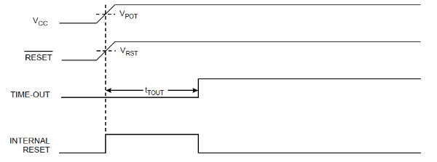

The delay (tTOUT) is timed from the Watchdog Oscillator and the delay time is set by the SUTx and CKSELx fuse bits. The selectable delays for tTOUT are shown in the table below. Note that the frequency of the Watchdog Oscillator is voltage dependent:

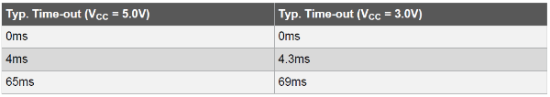

​

VCC is not monitored during the delay, so it is required to select a delay longer than the VCC rise time. If this is not possible, an internal or external Brown-Out Detection (BOD) circuit should be used. A BOD circuit will ensure sufficient VCC before it releases the reset, and the time-out delay can be disabled. Disabling the time-out delay without utilizing a BOD circuit is not recommended.

Oscillator Stability

The oscillator is required to oscillate for a minimum number of cycles before the clock is considered stable. An internal ripple counter monitors the oscillator output clock and keeps the internal reset active for a given number of clock cycles. The reset is then released and the device will start to execute. The recommended oscillator start-up time is dependent on the clock type and varies from 6 cycles for an externally applied clock to 32K cycles for a low-frequency crystal.

Refer to [section 11 in the device data sheet](http://ww1.microchip.com/downloads/en/DeviceDoc/40001906A.pdf) which specifies the number of CK delay cycles for each clock source type and SUTx fuse setting.

[Back to top](https://developerhelp.microchip.com/xwiki/bin/view/products/mcu-mpu/8-bit-avr/peripherals/oscillator/overview/)

Low Power Crystal Oscillator

Pins XTAL1 and XTAL2 are input and output, respectively, of an inverting amplifier that can be configured for use as an On-chip Oscillator, as shown in the accompanying image. Either a quartz crystal or a ceramic resonator may be used:

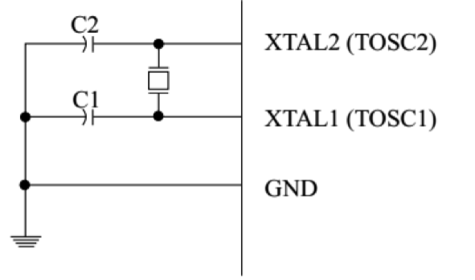

The Low Power Oscillator can operate in three different modes, each optimized for a specific frequency range. The operating mode is selected by the fuses CKSEL[3:1], as shown in the accompanying image:

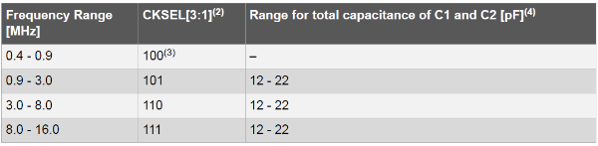

The CKSEL0 Fuse together with the SUT[1:0] Fuses select the start-up times (see section 11.3 in the [ATmega328PB datasheet](http://ww1.microchip.com/downloads/en/DeviceDoc/40001906A.pdf)).

[Back to top](https://developerhelp.microchip.com/xwiki/bin/view/products/mcu-mpu/8-bit-avr/peripherals/oscillator/overview/)

Low-Frequency Crystal Oscillator

The Low-frequency Crystal Oscillator is optimized for use with a 32.768 kHz watch crystal. The Low-frequency Crystal Oscillator must be selected by setting the CKSEL Fuses to '0110' or '0111', and Start-Up times are determined by the SUT Fuses.

[Back to top](https://developerhelp.microchip.com/xwiki/bin/view/products/mcu-mpu/8-bit-avr/peripherals/oscillator/overview/)

Calibrated Internal RC Oscillator

By default, the Internal RC Oscillator provides an 8.0 MHz clock. Though voltage and temperature dependent, this clock can be very accurately calibrated by the user. The device is shipped with the CKDIV8 Fuse programmed, providing a 1 MHz system clock frequency. This clock may be selected as the system clock by programming the CKSEL fuses to '0010':. If selected, it will operate with no external components. During reset, the hardware loads the pre-programmed calibration value into the OSCCAL Register and thereby automatically calibrates the RC Oscillator.

Refer to the [AVR053 Application Note](http://ww1.microchip.com/downloads/en/AppNotes/Atmel-2555-Internal-RC-Oscillator-Calibration-for-tinyAVR-and-megaAVR-Devices_ApplicationNote_AVR053.pdf) which outlines the procedure to re-calibrate the internal RC oscillator.

[Back to top](https://developerhelp.microchip.com/xwiki/bin/view/products/mcu-mpu/8-bit-avr/peripherals/oscillator/overview/)

128 kHz Internal Oscillator

The 128 kHz internal oscillator is a low-power oscillator providing a clock of 128 kHz. This clock may be selected as the system clock by programming the CKSEL fuses to '0011'.

[Back to top](https://developerhelp.microchip.com/xwiki/bin/view/products/mcu-mpu/8-bit-avr/peripherals/oscillator/overview/)

External Clock

To drive the device from an external clock source, EXTCLK should be driven as shown in the accompanying image. To run the device on an external clock, the CKSEL Fuses must be programmed to '0000'.

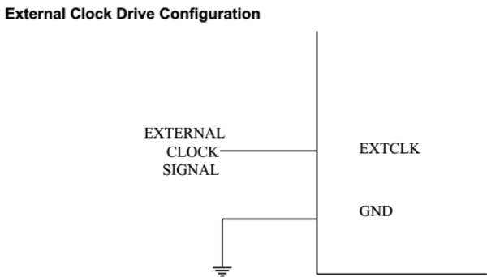

[Back to top](https://developerhelp.microchip.com/xwiki/bin/view/products/mcu-mpu/8-bit-avr/peripherals/oscillator/overview/)

Clock Output Buffer

The device can output the system clock on the CLKO pin. To enable the output, the CKOUT Fuse has to be programmed. This mode is suitable when the chip clock is used to drive other circuits on the system. The clock also will be output during reset, and the normal operation of I/O pin will be overridden when the fuse is programmed. Any clock source, including the internal RC Oscillator, can be selected when the clock is output on CLKO. If the System Clock Prescaler is used, it is the divided system clock that is output.

[Back to top](https://developerhelp.microchip.com/xwiki/bin/view/products/mcu-mpu/8-bit-avr/peripherals/oscillator/overview/)

Timer/Counter Oscillator

The device uses the same crystal oscillator for Low-frequency Oscillator and Timer/Counter Oscillator. See Low-Frequency Crystal Oscillator for details on the oscillator and crystal requirements.  
  
On this device, the Timer/Counter Oscillator Pins (TOSC1 and TOSC2) are shared with EXTCLK. When using the Timer/Counter Oscillator, the system clock needs to be four times the oscillator frequency. Due to this and the pin sharing, the Timer/Counter Oscillator can only be used when the Calibrated Internal RC Oscillator is selected as the system clock source. Applying an external clock source to TOSC1 can be done if the Enable External Clock Input bit in the Asynchronous Status Register (ASSR.EXCLK) is written to '1'. See the description of the Asynchronous Operation of Timer/Counter2 for further description on selecting an external clock as the input instead of a 32.768 kHz watch crystal.

[Back to top](https://developerhelp.microchip.com/xwiki/bin/view/products/mcu-mpu/8-bit-avr/peripherals/oscillator/overview/)

System Clock Prescaler

The device has a system clock prescaler, and the system clock can be divided by configuring the Clock Prescale Register (CLKPR). This feature can be used to decrease the system clock frequency and power consumption when the requirement for processing power is low. This can be used with all clock source options, and it will affect the clock frequency of the CPU and all synchronous peripherals. clkI/O,clkADC, clkCPU, and clkFLASH are divided by a factor as shown in the CLKPR description:

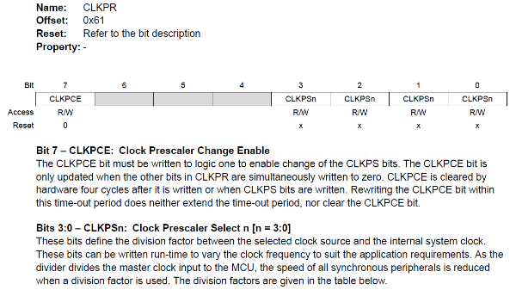

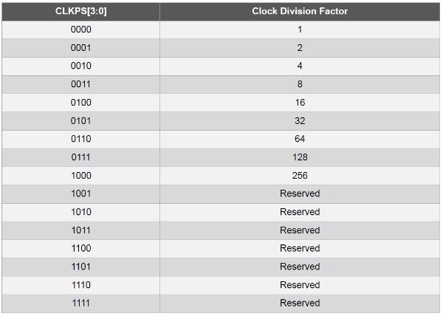

[Back to top](https://developerhelp.microchip.com/xwiki/bin/view/products/mcu-mpu/8-bit-avr/peripherals/oscillator/overview/)

Writing to CLKPR

When switching between prescaler settings, the System Clock Prescaler ensures that no glitches occur in the clock system. It also ensures that no intermediate frequency is higher than either the clock frequency corresponding to the previous setting or the clock frequency corresponding to the new setting. The ripple counter that implements the prescaler runs at the frequency of the undivided clock, which may be faster than the CPU's clock frequency. Hence, it is not possible to determine the state of the prescaler - even if it were readable, the exact time it takes to switch from one clock division to the other cannot be exactly predicted. From the time the Clock Prescaler Selection bits (CLKPS[3:0]) values are written, it takes between T1 + T2 and T1 + 2 * T2 before the new clock frequency is active. In this interval, two active clock edges are produced. Here, T1 is the previous clock period, and T2 is the period corresponding to the new prescaler setting. To avoid unintentional changes of clock frequency, a special write procedure must be followed to change the CLKPS bits:

1. Write the Clock Prescaler Change Enable (CLKPCE) bit to '1' and all other bits in CLKPR to zero: CLKPR=0x80.
2. Within four cycles, write the desired value to CLKPS[3:0] while writing a zero to CLKPCE: CLKPR=0x0N

Interrupts must be disabled when changing prescaler setting to make sure the write procedure is not interrupted.

Code Sample

The following function can be used to dynamically update CLKPR as required above. Note the usage of cli() and sei() functions to ensure that the CLKPR write procedure is uninterrupted.

#include *<stdint.h>  // Std integral type definitions*  
#include *<avr/io.h>  // SFR definitions*  
#include *<avr/interrupt.h> // ISR macros*  
   
void clkPrescaleSet(uint8_t divisionFactor){  
    cli();                        *// disable interrupts*    CLKPR = (1 << CLKPCE);        *// enable change of the CLKPSx bits*    CLKPR = divisionFactor;       *// update the CLKPSx bits*    sei();                        *// re-enable interrupts*}

To see this function in use, please visit the [megaAVR® Oscillator Example Project](https://developerhelp.microchip.com/xwiki/bin/view/products/mcu-mpu/8-bit-avr/peripherals/oscillator/example/).

[Back to top](https://developerhelp.microchip.com/xwiki/bin/view/products/mcu-mpu/8-bit-avr/peripherals/oscillator/overview/)

CLKDIV8 Fuse & CLKPR

The CKDIV8 Fuse determines the initial value of the CLKPS bits. If CKDIV8 is unprogrammed, the CLKPS bits will be reset to “0000”. If CKDIV8 is programmed, CLKPS bits are reset to “0011”, giving a division factor of 8 at start-up. This feature should be used if the selected clock source has a higher frequency than the maximum frequency of the device at the present operating conditions. Note that any value can be written to the CLKPS bits regardless of the CKDIV8 Fuse setting. The Application software must ensure that a sufficient division factor is chosen if the selected clock source has a higher frequency than the maximum frequency of the device at the present operating conditions. The device is shipped with the CKDIV8 Fuse programmed.

[Back to top](https://developerhelp.microchip.com/xwiki/bin/view/products/mcu-mpu/8-bit-avr/peripherals/oscillator/overview/)

8-bit AVR® Timers and Counters

Last modified by Microchip on 2023/11/09 09:02

The most common use of a timer peripheral is to trigger a specific action after a certain amount of time or clock cycles. Timer peripherals can be used to enhance your microcontroller (MCU) design in several ways:

Implementing timer functionality as a hardware peripheral ensures accuracy and reduces load on the CPU: although timing and counting is possible with software, this often causes inaccuracies due to latency and consumes valuable CPU instruction cycles.

A timer peripheral can also be used to generate waveforms, such as Pulse-Width Modulation (PWM) signals: this enables control over various output functions and is recommended for applications like controlling servo position or the brightness of an LED.

# 8-Bit AVR® MCU Timer Example Project

Last modified by Microchip on 2023/11/09 09:12

**Contents**

* [Resources](https://developerhelp.microchip.com/xwiki/bin/view/products/mcu-mpu/8-bit-avr/peripherals/timers-counters/example-project/#HResources)
* [Overview of Timers on 8-bit AVR MCUs](https://developerhelp.microchip.com/xwiki/bin/view/products/mcu-mpu/8-bit-avr/peripherals/timers-counters/example-project/#HOverviewofTimerson8-bitAVRMCUs)
* [Timer 0 - 8-bit Timer/Counter with PWM](https://developerhelp.microchip.com/xwiki/bin/view/products/mcu-mpu/8-bit-avr/peripherals/timers-counters/example-project/#HTimer0-8-bitTimer2FCounterwithPWM)
* [TC1, TC3, & TC4 - 16-bit Timer/Counters with PWM](https://developerhelp.microchip.com/xwiki/bin/view/products/mcu-mpu/8-bit-avr/peripherals/timers-counters/example-project/#HTC12CTC32C26TC4-16-bitTimer2FCounterswithPWM)
* [TC2 - 8-bit Timer/Counter2 with PWM and Asynchronous Operation](https://developerhelp.microchip.com/xwiki/bin/view/products/mcu-mpu/8-bit-avr/peripherals/timers-counters/example-project/#HTC2-8-bitTimer2FCounter2withPWMandAsynchronousOperation)
* [Connection Diagram](https://developerhelp.microchip.com/xwiki/bin/view/products/mcu-mpu/8-bit-avr/peripherals/timers-counters/example-project/#HConnectionDiagram)
* [​Procedure](https://developerhelp.microchip.com/xwiki/bin/view/products/mcu-mpu/8-bit-avr/peripherals/timers-counters/example-project/#H200BProcedure)

This page illustrates several methods of configuring the timers on an 8-bit AVR® MCU. An overview of the timers on an AVR is provided before the step-by-step example is presented.

## Resources

* [ATmega328PB Xplained Mini](https://www.microchipdirect.com/product/ATMEGA328PB-XMINI?productLoaded=true)
* [Xplained Board User Guide](http://www.atmel.com/Images/Atmel-42287-ATmega328P-Xplained-Mini-User-Guide_UserGuide.pdf)
* [MPLAB® X IDE](https://developerhelp.microchip.com/xwiki/bin/view/software-tools/x/)
* [MPLAB® XC8](https://developerhelp.microchip.com/xwiki/bin/view/software-tools/xc8/)

[Back to top](https://developerhelp.microchip.com/xwiki/bin/view/products/mcu-mpu/8-bit-avr/peripherals/timers-counters/example-project/)

## Overview of Timers on 8-bit AVR MCUs

ATmega328PB microcontroller has five Timer/Counters:

|  |  |  |
| --- | --- | --- |
| Timer 0 | TC0 | 8-bit Timer/counter with PWM |
| Timer 1 | TC1 | 16-bit Timer/counter with PWM and Asynchronous Operation. |
| Timer 2 | TC2 | 8-bit Timer/counter with PWM and Asynchronous Operation. |
| Timer 3 | TC3 | 16-bit Timer/counter with PWM and Asynchronous Operation. |
| Timer 4 | TC4 | 16-bit Timer/counter with PWM and Asynchronous Operation. |

[Back to top](https://developerhelp.microchip.com/xwiki/bin/view/products/mcu-mpu/8-bit-avr/peripherals/timers-counters/example-project/)

### Definitions:

|  |  |
| --- | --- |
| **Register Nomenclature** | |
| BOTTOM | The counter reaches the BOTTOM when it becomes zero (0x00 for 8-bit counters and 0x0000 for 16bit counters |
| MAX | The counter reaches its maximum value when it becomes 0x0F (15 decimal) for 8-bit counters and 0x00FF (255 decimal) for 16-bit counters |
| TOP | The counter reaches the TOP when its value becomes equal to the highest value possible. The TOP value can be assigned fixed value MAX or the value stored in the OCRxA register. This assignment is dependent upon the mode of operation |

[Back to top](https://developerhelp.microchip.com/xwiki/bin/view/products/mcu-mpu/8-bit-avr/peripherals/timers-counters/example-project/)

## Timer 0 - 8-bit Timer/Counter with PWM

Timer/Counter0 (TC0) is a general purpose 8-bit Timer/Counter module, with two independent Output Compare Units, and PWM support.

[Back to top](https://developerhelp.microchip.com/xwiki/bin/view/products/mcu-mpu/8-bit-avr/peripherals/timers-counters/example-project/)

### TC0 Registers

The Timer/Counter 0 register (TCNT0) and Output Compare TC0x registers (OCR0x) are 8-bit registers. Interrupt request signals are all visible in the Timer Interrupt Flag Register 0 (TIFR0). All interrupts are individually masked with the Timer Interrupt Mask Register 0 (TIMSK0).

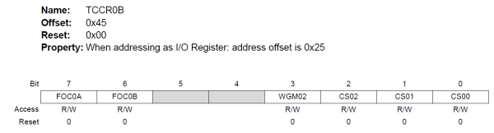

[Back to top](https://developerhelp.microchip.com/xwiki/bin/view/products/mcu-mpu/8-bit-avr/peripherals/timers-counters/example-project/)

### TC0 Timer/Counter Clock Sources

TC0 can be clocked by an internal or an external clock source. The clock source is selected by writing to the Clock Select (CS02:0) bits in the Timer/Counter Control Register (TCCR0B).

[Back to top](https://developerhelp.microchip.com/xwiki/bin/view/products/mcu-mpu/8-bit-avr/peripherals/timers-counters/example-project/)

### Bits 2:0 – CS0n: Clock Select [n = 0..2]

The three Clock Select bits select the clock source to be used by the Timer/Counter.

|  |  |  |  |
| --- | --- | --- | --- |
| **CS02** | **CS01** | **CS00** | **Description** |
| 0 | 0 | 0 | No Clock source (Timer stopped) |
| 0 | 0 | 1 | clkio/1 (No prescaling) |
| 0 | 1 | 0 | clkio/8 (From prescaler) |
| 0 | 1 | 1 | clkio/64 (From prescaler) |
| 1 | 0 | 0 | clkio/256 (From prescaler) |
| 1 | 0 | 1 | clkio/1012 (From prescaler) |
| 1 | 1 | 0 | External clock source on T0 pin (clock on falling edge) |
| 1 | 1 | 1 | External clock source on T0 pin (clock on rising edge) |

[Back to top](https://developerhelp.microchip.com/xwiki/bin/view/products/mcu-mpu/8-bit-avr/peripherals/timers-counters/example-project/)

### TC0 Counter Unit

Depending on the mode of operation used, T0 is cleared, incremented, or decremented at each timer clock (clkT0). clkT0 can be generated from an external or internal clock source, selected by the Clock Select bits (CS0[2:0]).

The counting sequence is determined by the setting of the WGM01 and WGM00 bits located in the T0 Control Register A (TCCR0A) and the WGM02 bit located in the Timer/Counter Control Register B (TCCR0B).

[Back to top](https://developerhelp.microchip.com/xwiki/bin/view/products/mcu-mpu/8-bit-avr/peripherals/timers-counters/example-project/)

### Bits 1:0 – WGM0n: Waveform Generation Mode [n = 1:0]

Combined with the WGM02 bit found in the TCCR0B Register, these bits control the counting sequence of the counter, the source for maximum (TOP) counter value, and what type of waveform generation to be used. Modes of operation supported by the Timer/Counter unit are: Normal mode (counter), Clear Timer on Compare Match (CTC) Mode, and two types of Pulse Width Modulation (PWM) modes.

[Back to top](https://developerhelp.microchip.com/xwiki/bin/view/products/mcu-mpu/8-bit-avr/peripherals/timers-counters/example-project/)

#### **Table 1-2 Waveform Generation Mode Bit Description**

|  |  |  |  |  |  |
| --- | --- | --- | --- | --- | --- |
| **Mode** | **WGM2:0** | **Mode of Operation** | **TOP** | **OCR0x Update** | **TOV flag set on** |
| 0 | 0 0 0 | Normal | 0xFF | Immediate | MAX |
| 1 | 0 0 1 | PWM Phase Correct | 0xFF | TOP | BOTTOM |
| 2 | 0 1 0 | CTC | OCRA | Immediate | MAX |
| 3 | 0 1 1 | Fast PWM | 0xFF | BOTTOM | MAX |
| 4 | 1 0 0 | Reserved | ~ | ~ | ~ |
| 5 | 1 0 1 | PWM Phase Correct | OCRA | TOP | BOTTOM |
| 6 | 1 1 0 | Reserved | ~ | ~ | ~ |
| 7 | 1 1 1 | Fast PWM | OCRA | BOTTOM | MAX |

​**Note:**  
1. MAX = 0xFF  
2. BOTTOM = 0x00

[Back to top](https://developerhelp.microchip.com/xwiki/bin/view/products/mcu-mpu/8-bit-avr/peripherals/timers-counters/example-project/)

### Modes of Operation for TC0

The mode of operation determines the behavior of TC0 and the Output Compare pins. It is defined by the combination of the Waveform Generation mode bits and Compare Output mode bits in the Timer/Counter control Registers A and B (TCCR0B.WGMn2, TCCR0A.WGM01, TCCR0A.WGM00, and TCCR0A.COM0x[1:0]).

Available modes of operation for TC0 are:

* Normal Mode
* Clear Timer on Compare Match (CTC) Mode
* Fast PWM Mode
* Phase Correct PWM Mode

[Back to top](https://developerhelp.microchip.com/xwiki/bin/view/products/mcu-mpu/8-bit-avr/peripherals/timers-counters/example-project/)

### Clear Timer on Compare Match Mode

In Clear Timer on Compare mode (WGM0[2:0]=0x2), the OCR0A Register is used to manipulate the counter resolution: the counter is cleared to ZERO when the counter value (TCNT0) matches the OCR0A. The OCR0A defines the top value for the counter, hence also its resolution.

The counter value (TCNT0) increases until a compare match occurs between TCNT0 and OCR0A, and then the counter (TCNT0) is cleared. An interrupt can be generated each time the counter value reaches the TOP value by setting the OCF0A Flag. If the interrupt is enabled, the interrupt handler routine can be used for updating the TOP value.

The waveform frequency is defined by the following equation:

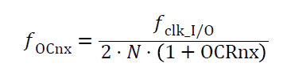​

N represents the prescaler factor (1, 8, 64, 256, or 1024).

[Back to top](https://developerhelp.microchip.com/xwiki/bin/view/products/mcu-mpu/8-bit-avr/peripherals/timers-counters/example-project/)

## TC1, TC3, & TC4 - 16-bit Timer/Counters with PWM

The 16-bit Timer/Counter units allow accurate program execution timing (event management), wave generation, and signal timing measurement.

[Back to top](https://developerhelp.microchip.com/xwiki/bin/view/products/mcu-mpu/8-bit-avr/peripherals/timers-counters/example-project/)

### Registers (TC1, TC3, TC4)

* The Timer/Counter (TCNTn), Output Compare Registers (OCRA/B), and Input Capture Register (ICRn) are all 16-bit registers.
* The Timer/Counter Control Registers (TCCRnA/B) are 8-bit registers and have no CPU access restrictions.
* Interrupt requests (abbreviated to Int.Req. in the block diagram) signals are all visible in the Timer Interrupt Flag Register (TIFRn). All interrupts are individually masked with the Timer Interrupt Mask Register (TIMSKn).

[Back to top](https://developerhelp.microchip.com/xwiki/bin/view/products/mcu-mpu/8-bit-avr/peripherals/timers-counters/example-project/)

### Timer/Counter Clock Sources (TC1, TC3, TC4)

The Timer/Counter can be clocked by an internal or an external clock source. The clock source is selected by the Clock Select logic which is controlled by the Clock Select bits in the timer/Counter control Register B (TCCRnB.CS[2:0]).

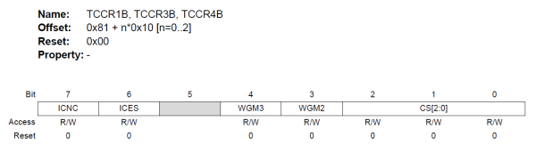​

Bits 2:0 – CS[2:0]: Clock Select [n = 0..2]  
The three Clock Select bits select the clock source to be used by the Timer/Counter.

|  |  |  |  |
| --- | --- | --- | --- |
| **CS02** | **CS01** | **CS00** | **Description** |
| 0 | 0 | 0 | No Clock source ( Timer stopped |
| 0 | 0 | 1 | clkio/1 (No prescaling) |
| 0 | 1 | 0 | clkio/8 (From prescaler) |
| 0 | 1 | 1 | clkio/64 (From prescaler) |
| 1 | 0 | 0 | clkio/256 (From prescaler) |
| 1 | 0 | 1 | clkio/1012 (From prescaler) |
| 1 | 1 | 0 | External clock source on T0 pin (clock on falling edge) |
| 1 | 1 | 1 | External clock source on T0 pin (clock on rising edge) |

[Back to top](https://developerhelp.microchip.com/xwiki/bin/view/products/mcu-mpu/8-bit-avr/peripherals/timers-counters/example-project/)

### Counter Unit (TC1, TC3, TC4)

TC1, TC3, and TC4 are programmable 16-bit bi-directional counters.

Each 16-bit counter is mapped into two 8-bit I/O memory locations: Counter High (TCNTnH) containing the upper eight bits of the counter, and Counter Low (TCNTnL) containing the lower eight bits.

Depending on the selected mode of operation, the counter is cleared, incremented, or decremented at each timer clock (clkTn). The clock clkTn can be generated from an external or internal clock source, as selected by the Clock Select bits in the Timer/Counter Control Register B (TCCRnB.CS[2:0]).

The counting sequence is determined by the setting of the Waveform Generation mode bits in the Timer/Counter Control Registers A and B (TCCRnB.WGM[3:2] and TCCRnA.WGM[1:0]).

[Back to top](https://developerhelp.microchip.com/xwiki/bin/view/products/mcu-mpu/8-bit-avr/peripherals/timers-counters/example-project/)

### Modes of Operation (TC1, TC3, TC4)

The mode of operation is determined by the combination of the Waveform Generation mode (WGM[3:0]) and Compare Output mode (TCCRnA.COMx[1:0]) bits.

Available modes of operation are:

* Normal Mode
* Clear Timer on Compare Match (CTC) Mode
* Fast PWM Mode
* Phase Correct PWM Mode
* Phase and Frequency Correct PWM Mode

[Back to top](https://developerhelp.microchip.com/xwiki/bin/view/products/mcu-mpu/8-bit-avr/peripherals/timers-counters/example-project/)

### Fast PWM Mode

The Fast Pulse Width Modulation or Fast PWM modes (modes 5, 6, 7, 14, and 15, WGM[3:0]= 0x5, 0x6, 0x7, 0xE, 0xF) provide a high frequency PWM waveform generation option. The Fast PWM differs from the other PWM options by its single-slope operation. The counter counts from BOTTOM to TOP then restarts from BOTTOM.

In Fast PWM mode the counter is incremented until the counter value matches either one of the fixed values 0x00FF, 0x01FF, or 0x03FF (WGM[3:0] = 0x5, 0x6, or 0x7), the value in ICRn (WGM[3:0]=0xE), or the value in OCRnA (WGM[3:0]=0xF). The counter is then cleared at the following timer clock cycle.

The PWM frequency for the output can be calculated by the following equation:

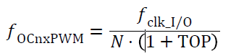​

​**Note:**  
• The “n” in the register and bit names indicates the device number (n = 0 for Timer/Counter 0), and the “x” indicates Output Compare unit (A/B).  
• N represents the prescale divider (1, 8, 64, 256, or 1024).

[Back to top](https://developerhelp.microchip.com/xwiki/bin/view/products/mcu-mpu/8-bit-avr/peripherals/timers-counters/example-project/)

## TC2 - 8-bit Timer/Counter2 with PWM and Asynchronous Operation

Timer/Counter2 (TC2) is a general purpose, dual channel, 8-bit Timer/Counter module.

[Back to top](https://developerhelp.microchip.com/xwiki/bin/view/products/mcu-mpu/8-bit-avr/peripherals/timers-counters/example-project/)

### TC2 Registers

The Timer/Counter (TCNT2) and Output Compare Register (OCR2A and OCR2B) are 8-bit registers. Interrupt request signals are all visible in the Timer Interrupt Flag Register (TIFR2). All interrupts are individually masked with the Timer Interrupt Mask Register (TIMSK2).

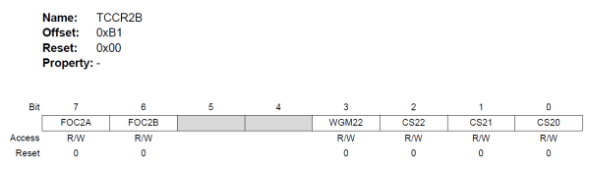  
[Back to top](https://developerhelp.microchip.com/xwiki/bin/view/products/mcu-mpu/8-bit-avr/peripherals/timers-counters/example-project/)

### TC2 Clock Sources

TC2 can be clocked by an internal synchronous or an external asynchronous clock source:  
The three Clock Select bits (CS2:CS0) select the clock source to be used by the Timer/Counter.

|  |  |  |  |
| --- | --- | --- | --- |
| **CS02** | **CS01** | **CS00** | **Description** |
| 0 | 0 | 0 | No Clock source (Timer stopped) |
| 0 | 0 | 1 | clkio/1 (No prescaling) |
| 0 | 1 | 0 | clkio/8 (From prescaler) |
| 0 | 1 | 1 | clkio/64 (From prescaler) |
| 1 | 0 | 0 | clkio/256 (From prescaler) |
| 1 | 0 | 1 | clkio/1012 (From prescaler) |
| 1 | 1 | 0 | External clock source on T0 pin ( clock on falling edge) |
| 1 | 1 | 1 | External clock source on T0 pin ( clock on rising edge) |

[Back to top](https://developerhelp.microchip.com/xwiki/bin/view/products/mcu-mpu/8-bit-avr/peripherals/timers-counters/example-project/)

### TC2 Counter Unit

Depending on the mode of operation used, the counter is cleared, incremented, or decremented at each timer clock (clkT2). clkT2 can be generated from an external or internal clock source, selected by the Clock Select bits (CS2[2:0]).  
The counting sequence is determined by the setting of the WGM21 and WGM20 bits located in the Timer/Counter Control Register (TCCR2A) and the WGM22 bit located in the Timer/Counter Control Register B (TCCR2B).

[Back to top](https://developerhelp.microchip.com/xwiki/bin/view/products/mcu-mpu/8-bit-avr/peripherals/timers-counters/example-project/)

### TC2 Modes of Operation

The mode of operation, i.e., the behavior of the Timer/Counter and the Output Compare pins, is defined by the combination of the Waveform Generation mode (WGM2[2:0]) and Compare Output mode (COM2x[1:0]) bits.  
Available modes of operation are:

* Normal Mode
* Clear Timer on Compare Match (CTC) Mode
* Fast PWM Mode
* Phase Correct PWM Mode

[Back to top](https://developerhelp.microchip.com/xwiki/bin/view/products/mcu-mpu/8-bit-avr/peripherals/timers-counters/example-project/)

### Normal Mode

In the Normal mode (WGM22:0 = 0) the counting direction is always up (incrementing), without having the counter cleared. The counter will roll over to 0c00 when it passes its maximum 8-bit value (TOP = 0xFF).

In normal operation, the Timer/Counter Overflow Flag (TOV2) will be set in the same timer clock cycle as the TCNT2 becomes zero. The TOV2 Flag, in this case, behaves like a ninth bit, except that it is only set, not cleared. However, combined with the timer overflow interrupt that automatically clears the TOV2 flag, the timer resolution can be increased by software. There are no special cases to consider in the Normal mode, a new counter value can be written any time.

Regardless of which mode is used the programmer needs to remember two things:

1. The timer has to be started by selecting the clock source.
2. If interrupts are used they must be enabled.

[Back to top](https://developerhelp.microchip.com/xwiki/bin/view/products/mcu-mpu/8-bit-avr/peripherals/timers-counters/example-project/)

## Connection Diagram

The mEDBG chip controls the programming/debug interface, as well as supplying a 16 MHz clock when the Xplained board is connected via USB cable to a PC.

  
[Back to top](https://developerhelp.microchip.com/xwiki/bin/view/products/mcu-mpu/8-bit-avr/peripherals/timers-counters/example-project/)

## ​Procedure

##### **Attach the ATmega328PB Xplained Mini board**

Using a USB-A-male-to-Micro-B-male cable, attached the Xplained Mini to your computer. Start MPLAB® X IDE. If the board has been successfully enumerated, you should see the board image come up in Studio as shown:

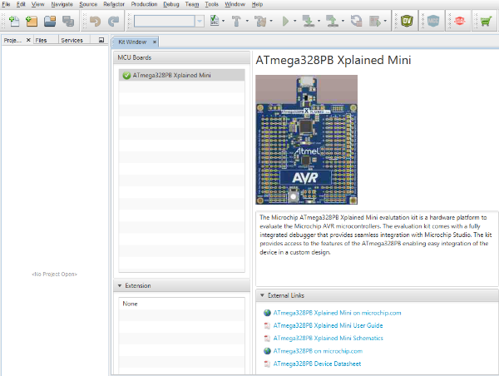​

[Back to top](https://developerhelp.microchip.com/xwiki/bin/view/products/mcu-mpu/8-bit-avr/peripherals/timers-counters/example-project/)

##### **Create a New Project**

In MPLAB X IDE, select **File > New Project**

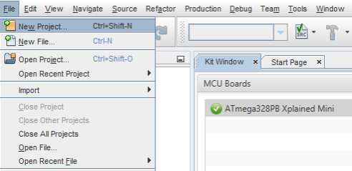​

##### **Choose Project**

Select**Microchip Embedded**and then **Standalone Project**and then select **Next**.

[Back to top](https://developerhelp.microchip.com/xwiki/bin/view/products/mcu-mpu/8-bit-avr/peripherals/timers-counters/example-project/)

##### **Select Device**

Use the pulldown or type into the boxes to indicate the Family,  ATmega328PB, and Tool. Then Select **Next**.



[Back to top](https://developerhelp.microchip.com/xwiki/bin/view/products/mcu-mpu/8-bit-avr/peripherals/timers-counters/example-project/)

##### **Select Compiler**

Select the **XC8 Compiler**and then **Next**



[Back to top](https://developerhelp.microchip.com/xwiki/bin/view/products/mcu-mpu/8-bit-avr/peripherals/timers-counters/example-project/)

##### **Name the Project**

Choose a name for the project, browse to a location to save it, and select **Finish**



[Back to top](https://developerhelp.microchip.com/xwiki/bin/view/products/mcu-mpu/8-bit-avr/peripherals/timers-counters/example-project/)

##### **Create a New main.c file**

Right-click on Source Files in the file explorer window and select **New>avr-main.c**and rename the File Name to **main.**Then select **Finish**



[Back to top](https://developerhelp.microchip.com/xwiki/bin/view/products/mcu-mpu/8-bit-avr/peripherals/timers-counters/example-project/)

##### **Add the Code**

Delete the contents of the newly created main.c file. **Copy and Paste** the following code into it.

*/*******************************************************************************  
* File:  main.c  
*  
* Project:  8avr-mega-timer-example  
*  
* Description: 8-abit AVR Timer Example  
*      
*    Main loop monitors the Counter. CLKPR is updated Every 10 sec  
*    to dynamically change the SYS_CLK frequency.  
*  
*    CLKPR is toggled between div/1 and div/4 setting, which changes  
*    the toggle from 100ms to 400mS respectively.   
*   
* Date:  19-Apr-2023   
* Revision:  
* Author:  
*  
* Hardware: ATmega328PB Xplained Mini   
*  
*    Clock:  16MHz (External - from EDBG IC)  
*    LED0:  PB5  
*      
*  
* Fuses:  Programmed in MPLAB X  
*  
*      
*    Ext:  0xFC  
*    High:  0xDF  
*    Low:  0xC0 (EXT CLK, Fast VDD rise, CLKDIV = 1)  
*  
******************************************************************************/*  
  
//Necessary #**include** files  
#**include** <avr/io.h>  
#**include** <avr/interrupt.h>  
  
//Set Fuses to configure the device  
FUSES = {  
 .low = 0xE0, // LOW {SUT_CKSEL=EXTCLK_6CK_14CK_65MS, CKOUT=CLEAR, CKDIV8=CLEAR}  
 .high = 0xDF, // HIGH {BOOTRST=CLEAR, BOOTSZ=256W_3F00, EESAVE=CLEAR, WDTON=CLEAR, SPIEN=SET, DWEN=CLEAR, RSTDISBL=CLEAR}  
 .extended = 0xFE, // EXTENDED {BODLEVEL=1V8, CFD=CFD_ENABLED}  
}*;*  
  
LOCKBITS = 0xFF*; // {LB=NO_LOCK, BLB0=NO_LOCK, BLB1=NO_LOCK}*  
  
//Initialize Variables  
int counter*;*  
int MyTimerConstant*;*  
int duty_cycle*;*  
int counterTimer2*;*  
int MyTimer2Constant*;*  
  
  
//Modification 1: Paste void init_TC0(void) code here  
  
  
//Modification 1: Paste ISR (TIMER0_COMPA_vect) code here  
  
  
//Paste void init_TC1_pwm(void) code here  
  
  
//Paste Copy ISR (TIMER1_COMPA_vector)code here     
  
  
  
//Main **loop**:  Both code modifications require pasting code to replace the main  
int main(void)  
   
{  
      
    **while** (1)  
    {  
        //main **loop**        
    }  
      
}  
  
//Modification 2:  Paste ISR (TIMER1_COMPA_vect) Here

[Back to top](https://developerhelp.microchip.com/xwiki/bin/view/products/mcu-mpu/8-bit-avr/peripherals/timers-counters/example-project/)

##### **Modification 1 - Blinking a LED using TC0**

In this example, Timer 0 blinks the LED connected to PB5 every 32 ms.

Modify the main function by adding the following code:

int main(void)  
  
{  
   set RB5 as output  
    DDRB |= 1 << DDRB5;  
  
    call TMR0 initialization function  
    init_TC0();  
  
   enable interrupt  
    sei();  
  
    **while** (1)  
    {  
        main loop  
    }  
}

Create the function init_TC0 () in main.c. Add the following code:

void init_TC0(void)  
{  
   
    *// Set the Timer Mode to CTC*    TCCR0A |= (1 << WGM01);  
   
    *// Set the value that you want to count to*    OCR0A = 0xF9; *//249*   
    *//Set the ISR COMPA vect*    TIMSK0 |= (1 << OCIE0A);      
   
    *// set prescaler to 1024 and start the timer*    TCCR0B |= (1 << CS00) | (1 << CS02);    
}

The preceding code does the following:

* Configures Timer 0 in CTC mode by setting the corresponding WGM bit in TCCR0A register;
* Sets the TOP value in the OCR0A register calculated using the equation 1 to blink the LED at 30 kHz;
* Enables the Timer Interrupt;
* Sets the pre-scaler to 1024 by configuring the CS00 and CS02 bits in TCCR0B register;]

[Back to top](https://developerhelp.microchip.com/xwiki/bin/view/products/mcu-mpu/8-bit-avr/peripherals/timers-counters/example-project/)

##### **Add the interrupt service routine to main.c:**

ISR (TIMER0_COMPA_vect)   
{  
    *//event to be executed every 32ms*MyTimerConstant*    counter++;  
  
    **if** (counter == MyTimerConstant) {  
        counter = 0;  
        PORTB ^= 1 << PORTB5; *//toggle LED on PORTB5*    }  
}

[Back to top](https://developerhelp.microchip.com/xwiki/bin/view/products/mcu-mpu/8-bit-avr/peripherals/timers-counters/example-project/)

##### **Program the Device**

At the top of the MPLAB X IDE, select the Make and Program device button



The use of the constant MyTimerConstant and the variable counter is optional. If used, changing the value of MyTimer Constant will alter the time it takes the LED to blink.

[Back to top](https://developerhelp.microchip.com/xwiki/bin/view/products/mcu-mpu/8-bit-avr/peripherals/timers-counters/example-project/)

##### **Modification 2 - Using TC1 in PWM mode to dim the LED**

This example uses TC1 to generate a PWM signal which is fed through an I/O pin to drive an LED. Changing the PWM duty-cycle will result in a change in the brightness of the LED.

Modify the main function by adding the following code:

int main(void)  
   
{  
    *//set direction of pin PB1 set as output*    DDRB |= 1 << DDRB1;  
   
    init_TC1_pwm();  
   
    *//enable global interrupts*    sei();   
   
    **while** (1)  
    {  
        *//main loop*    }  
}

For configuring the direction bit of pin PB1, write the DDB1 bit to logic 1 in the DDRB register. On the ATmega328PB Xplained Mini Board, LED is connected to PB5 and PWM is generated on PB1. To view the LED dimming, connect a wire from PB5 to PB1 on the ATmega328PB Xplained Mini Board, as shown below.

[Back to top](https://developerhelp.microchip.com/xwiki/bin/view/products/mcu-mpu/8-bit-avr/peripherals/timers-counters/example-project/)

##### **Modification 2 - Blinking an LED using TC2**

Create the init_TC1_pwm () function before the main loop with the following code:

void init_TC1_pwm(void)  
{  
    *//clear OCnA on compare match, BOTTOM (non-inverting mode)*    TCCR1A = (1 << COM1A1);  
   
    *//the counting sequence is determined by the setting of the waveform generation mode bits in Timer*    TCCR1A |= (1 << WGM10);  
    TCCR1B |= (1 << WGM12);  
   
    *//256 presclaer clock select bits*    TCCR1B |= (0 << CS10) | (1 << CS12);  
   
    *//enable interrupts*    TIMSK0 |= (1 << OCIE1A);  
}  
​

init_TC!_PWM() performs the following

* Sets the bits COMA1=1 and COMA0=0 (non-inverting mode from datasheet table Compare Output Mode, Fast PWM in the TCCR1A register;
* Configures Bits 1:0 – WGM[1:0]:Waveform Generation Mode accordingly for Fast PWM, 8-bit mode;
* Verifies the configuration for the clock source and prescaler to be used by the Timer/Counter, which decides the frequency of the PWM. Internal clock source divided by 256 is configured by writing to the CS10 and CS12 bits in TCCR1B register;
* Enables the Timer Interrupt;

[Back to top](https://developerhelp.microchip.com/xwiki/bin/view/products/mcu-mpu/8-bit-avr/peripherals/timers-counters/example-project/)

##### **Modification 2**

Add the ISR function after the main loop to execute dimming LED event:

ISR (TIMER1_COMPA_vect)  *// timer1 interrupt*{  
    duty_cycle--;  
    **if** (duty_cycle == 0) {  
        duty_cycle = 0xFF;  
    }  
    OCR1A = duty_cycle;  
   
}

The register OC1RA decides the duty cycle of the PWM. To dim the LED gradually decrease the duty cycle.

[Back to top](https://developerhelp.microchip.com/xwiki/bin/view/products/mcu-mpu/8-bit-avr/peripherals/timers-counters/example-project/)

##### **Program the Device**

At the top of the MPLAB X IDE, select the Make and Program device button



[Back to top](https://developerhelp.microchip.com/xwiki/bin/view/products/mcu-mpu/8-bit-avr/peripherals/timers-counters/example-project/)

##### **Modification 2 Blinking an LED using TC2**

For this example, Timer 2 (TC2) is configured to blink the LED connected to PB5 at a period of 3 seconds.

Modify the main function by adding the following code:

int main(void)  
{  
    *//set direction of PB5 as output*    DDRB |= 1 << DDRB5;  
   
    */* Timer clock = I/O clock / 1024 */*  
    TCCR2B = (1 << CS22) | (1 << CS20) | (1 << CS21);  
   
    */* Clear overflow flag */*  
    TIFR2 = 1 << TOV2;  
   
    */* Enable Overflow Interrupt */*  
    TIMSK2 = 1 << TOIE2;  
   
    *// enable global interrupts*    sei();  
   
    **while** (1)  
    {  
        *// Main loop*    }  
}

* Configures the direction bit of pin PB5, write the DDB5 bit to logic 1 in the DDRB register;
* Sets the prescaler to 1024 by configuring the CS20, CS21 and CS22 bits in TCCR2B register;
* Clears Overflow flag - TOV2 is cleared by writing a logic one to the flag.
* Enables global interrupts by calling sei();

[Back to top](https://developerhelp.microchip.com/xwiki/bin/view/products/mcu-mpu/8-bit-avr/peripherals/timers-counters/example-project/)

##### **Add the interrupt service routine to main.c**

Enable the Overflow Timer Interrupt;

Add the ISR function after the main loop to execute blinking LED event:

ISR (TIMER0_COMPA_vect)   
{  
    *//event to be executed every 32ms*MyTimerConstant*    counter++;  
  
    **if** (counter == MyTimerConstant) {  
        counter = 0;  
        PORTB ^= 1 << PORTB5; *//toggle LED on PORTB5*    }  
}

Set the PORTB register to blink the LED

The use of the constant MyTimerConstant and the variable counter is optional. If used, changing the value of MyTimer Constant will alter the time it takes the LED to blink.

[Back to top](https://developerhelp.microchip.com/xwiki/bin/view/products/mcu-mpu/8-bit-avr/peripherals/timers-counters/example-project/)

Timers are a very useful feature of a microcontroller for counting pulses on an input pin. When driven by the instruction clock, they can become an accurate time base. AVR® devices have 8-bit-wide and 16-bit-wide timers and they offer different features based on the device. A very typical set of timers can be found in the AVR ATmega328PB microcontroller. This device has five Timer/Counters as described here:

|  |  |  |
| --- | --- | --- |
| Timer 0 | TC0 | 8-bit Timer/counter with Pulse Width Modulation (PWM) |
| Timer 1 | TC1 | 16-bit Timer/counter with PWM and Asynchronous Operation |
| Timer 2 | TC2 | 8-bit Timer/counter with PWM and Asynchronous Operation |
| Timer 3 | TC3 | 16-bit Timer/counter with PWM and Asynchronous Operation |
| Timer 4 | TC4 | 16-bit Timer/counter with PWM and Asynchronous Operation |

### Definitions

|  |  |
| --- | --- |
| **Register Nomenclature** | |
| BOTTOM | The counter reaches the BOTTOM when it becomes zero (0x00 for 8-bit counters and 0x0000 for 16-bit counters) |
| MAX | The counter reaches its maximum value when it becomes 0x0F (15 decimal) for 8-bit counters and 0x00FF (255 decimal) for 16-bit counters |
| TOP | The counter reaches the TOP when its value becomes equal to the highest value possible. The TOP value can be assigned a fixed value MAX or the value stored in the OCRxA register. This assignment is dependent upon the mode of operation |

[Back to top](https://developerhelp.microchip.com/xwiki/bin/view/products/mcu-mpu/8-bit-avr/peripherals/timers-counters/8-bit-avr-avrtimerover/)

### TC0 - 8-bit Timer/Counter with PWM

Timer/Counter0 (TC0) is a general-purpose 8-bit Timer/Counter module, with two independent Output Compare Units and PWM support.

[Back to top](https://developerhelp.microchip.com/xwiki/bin/view/products/mcu-mpu/8-bit-avr/peripherals/timers-counters/8-bit-avr-avrtimerover/)

#### **TC0 Registers**

The Timer/Counter 0 register (TCNT0) and Output Compare TC0x registers (OCR0x) are 8-bit registers. Interrupt request signals are all visible in the Timer Interrupt Flag Register 0 (TIFR0). All interrupts are individually masked with the Timer Interrupt Mask Register 0 (TIMSK0).

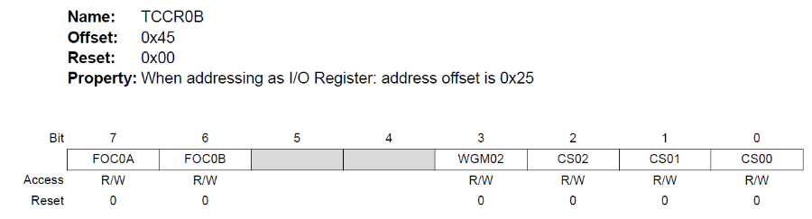

#### **TC0 Timer/Counter Clock Sources**

TC0 can be clocked by an internal or an external clock source. The clock source is selected by writing to the Clock Select (CS02:0) bits in the Timer/Counter Control Register (TCCR0B).

#### **Bits 2:0 – CS0n: Clock Select [n = 0..2]**

The three Clock Select bits select the clock source to be used by the Timer/Counter.

|  |  |  |  |
| --- | --- | --- | --- |
| **CS02** | **CS01** | **CS00** | **Description** |
| 0 | 0 | 0 | No Clock source (Timer stopped) |
| 0 | 0 | 1 | clkio/1 (No prescaling) |
| 0 | 1 | 0 | clkio/8 (From prescaler) |
| 0 | 1 | 1 | clkio/64 (From prescaler) |
| 1 | 0 | 0 | clkio/256 (From prescaler) |
| 1 | 0 | 1 | clkio/1012 (From prescaler) |
| 1 | 1 | 0 | External clock source on T0 pin (clock on falling edge) |
| 1 | 1 | 1 | External clock source on T0 pin (clock on rising edge) |

#### **TC0 Counter Unit**

Depending on the mode of operation used, T0 is cleared, incremented, or decremented at each timer clock (clkT0). clkT0 can be generated from an external or internal clock source, selected by the Clock Select bits (CS0[2:0]).

The counting sequence is determined by the setting of the WGM01 and WGM00 bits located in the T0 Control Register A (TCCR0A) and the WGM02 bit located in the Timer/Counter Control Register B (TCCR0B).

#### **Bits 1:0 – WGM0n: Waveform Generation Mode [n = 1:0]**

Combined with the WGM02 bit found in the TCCR0B Register, these bits control the counting sequence of the counter, the source for maximum (TOP) counter value and what type of waveform generation to be used. Modes of operation supported by the Timer/Counter unit are: Normal mode (counter), Clear Timer on Compare Match (CTC) Mode and two types of Pulse Width Modulation (PWM) modes.

#### **Table 1-2 Waveform Generation Mode Bit Description**

|  |  |  |  |  |  |
| --- | --- | --- | --- | --- | --- |
| **Mode** | **WGM2:0** | **Mode of Operation** | **TOP** | **OCR0x Update** | **TOV flag set on** |
| 0 | 0 0 0 | Normal | 0xFF | Immediate | MAX |
| 1 | 0 0 1 | PWM Phase Correct | 0xFF | TOP | BOTTOM |
| 2 | 0 1 0 | CTC | OCRA | Immediate | MAX |
| 3 | 0 1 1 | Fast PWM | 0xFF | BOTTOM | MAX |
| 4 | 1 0 0 | Reserved | ~ | ~ | ~ |
| 5 | 1 0 1 | PWM Phase Correct | OCRA | TOP | BOTTOM |
| 6 | 1 1 0 | Reserved | ~ | ~ | ~ |
| 7 | 1 1 1 | Fast PWM | OCRA | BOTTOM | MAX |

1. MAX = 0xFF  
2. BOTTOM = 0x00

#### **Modes of Operation for TC0**

The mode of operation determines the behavior of TC0 and the Output Compare pins. It is defined by the combination of the Waveform Generation mode bits and Compare Output mode bits in the Timer/Counter control Registers A and B (TCCR0B.WGMn2, TCCR0A.WGM01, TCCR0A.WGM00 and TCCR0A.COM0x[1:0]).

Available modes of operation for TC0 are:

* Normal Mode
* Clear Timer on Compare Match (CTC) Mode
* Fast PWM Mode
* Phase Correct PWM Mode

#### **Clear Timer on Compare Match Mode**

In Clear Timer on Compare or CTC mode (WGM0[2:0]=0x2), the OCR0A Register is used to manipulate the counter resolution: the counter is cleared to ZERO when the counter value (TCNT0) matches the OCR0A. The OCR0A defines the top value for the counter, hence also its resolution.

The counter value (TCNT0) increases until a compare match occurs between TCNT0 and OCR0A and then counter (TCNT0) is cleared. An interrupt can be generated each time the counter value reaches the TOP value by setting the OCF0A Flag. If the interrupt is enabled, the interrupt handler routine can be used for updating the TOP value.

The waveform frequency is defined by the following equation:



N represents the prescaler factor (1, 8, 64, 256, or 1024).

[Back to top](https://developerhelp.microchip.com/xwiki/bin/view/products/mcu-mpu/8-bit-avr/peripherals/timers-counters/8-bit-avr-avrtimerover/)

### TC1, TC3, & TC4 - 16-bit Timer/Counters with PWM

The 16-bit Timer/Counter units allow accurate program execution timing (event management), wave generation and signal timing measurement.

#### **Registers (TC1, TC3, TC4)**

* The Timer/Counter (TCNTn), Output Compare Registers (OCRA/B) and Input Capture Register (ICRn) are all 16-bit registers.
* The Timer/Counter Control Registers (TCCRnA/B) are 8-bit registers and have no CPU access restrictions.
* Interrupt requests (abbreviated to Int.Req. in the block diagram) signals are all visible in the Timer Interrupt Flag Register (TIFRn). All interrupts are individually masked with the Timer Interrupt Mask Register (TIMSKn).

#### **Timer/Counter Clock Sources (TC1, TC3, TC4)**

The Timer/Counter can be clocked by an internal or an external clock source. The clock source is selected by the Clock Select logic which is controlled by the Clock Select bits in the timer/Counter control Register B (TCCRnB.CS[2:0]).

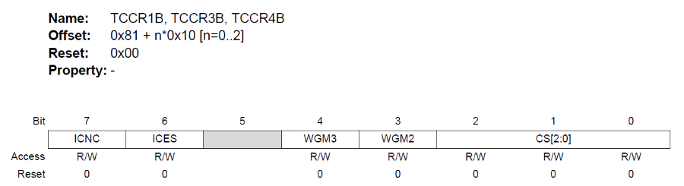

Bits 2:0 – CS[2:0]: Clock Select [n = 0..2]  
The three Clock Select bits select the clock source to be used by the Timer/Counter.

|  |  |  |  |
| --- | --- | --- | --- |
| **CS02** | **CS01** | **CS00** | **Description** |
| 0 | 0 | 0 | No Clock source (Timer stopped) |
| 0 | 0 | 1 | clkio/1 (No prescaling) |
| 0 | 1 | 0 | clkio/8 (From prescaler) |
| 0 | 1 | 1 | clkio/64 (From prescaler) |
| 1 | 0 | 0 | clkio/256 (From prescaler) |
| 1 | 0 | 1 | clkio/1012 (From prescaler) |
| 1 | 1 | 0 | External clock source on T0 pin (clock on falling edge) |
| 1 | 1 | 1 | External clock source on T0 pin (clock on rising edge) |

#### **Counter Unit (TC1, TC3, TC4)**

TC1, TC3 and TC4 are programmable 16-bit bi-directional counters.

Each 16-bit counter is mapped into two 8-bit I/O memory locations, Counter High (TCNTnH) containing the upper eight bits of the counter, and **Counter**Low (TCNTnL) containing the lower eight bits.

Depending on the selected mode of operation, the counter is cleared, incremented, or decremented at each timer clock (clkTn). The clock clkTn can be generated from an external or internal clock source, as selected by the Clock Select bits in the Timer/Counter Control Register B (TCCRnB.CS[2:0]).

The counting sequence is determined by the setting of the Waveform Generation mode bits in the Timer/Counter Control Registers A and B (TCCRnB.WGM[3:2] and TCCRnA.WGM[1:0]).

#### **Modes of Operation (TC1, TC3, TC4)**

The mode of operation is determined by the combination of the Waveform Generation mode (WGM[3:0]) and Compare Output mode (TCCRnA.COMx[1:0]) bits.

Available modes of operation are:

* Normal Mode
* Clear Timer on Compare Match (CTC) Mode
* Fast PWM Mode
* Phase Correct PWM Mode
* Phase and Frequency Correct PWM Mode

#### **Fast PWM Mode**

The Fast Pulse Width Modulation or Fast PWM modes (modes 5, 6, 7, 14, and 15, WGM[3:0]= 0x5, 0x6, 0x7, 0xE, 0xF) provide a high-frequency PWM waveform generation option. The Fast PWM differs from the other PWM options by its single-slope operation. The counter counts from BOTTOM to TOP then restarts from BOTTOM.

In Fast PWM mode the counter is incremented until the counter value matches either one of the fixed values 0x00FF, 0x01FF, or 0x03FF (WGM[3:0] = 0x5, 0x6, or 0x7), the value in ICRn (WGM[3:0]=0xE), or the value in OCRnA (WGM[3:0]=0xF). The counter is then cleared at the following timer clock cycle.

The PWM frequency for the output can be calculated by the following equation:



**Note:**  
• The “n” in the register and bit names indicates the device number (n = 0 for Timer/Counter 0) and the “x” indicates Output Compare unit (A/B).  
• N represents the prescale divider (1, 8, 64, 256, or 1024).

[Back to top](https://developerhelp.microchip.com/xwiki/bin/view/products/mcu-mpu/8-bit-avr/peripherals/timers-counters/8-bit-avr-avrtimerover/)

### TC2 - 8-bit Timer/Counter2 with PWM and Asynchronous Operation

Timer/Counter2 (TC2) is a general-purpose, dual-channel, 8-bit Timer/Counter module.

#### **TC2 Registers**

The Timer/Counter (TCNT2) and Output Compare Register (OCR2A and OCR2B) are 8-bit registers. Interrupt request signals are all visible in the Timer Interrupt Flag Register (TIFR2). All interrupts are individually masked with the Timer Interrupt Mask Register (TIMSK2).

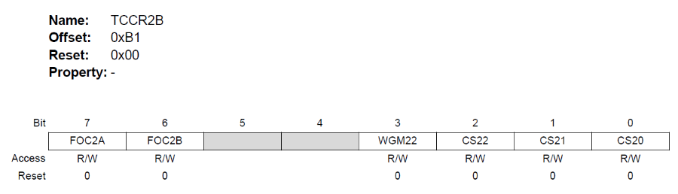

#### **TC2 Clock Sources**

TC2 can be clocked by an internal synchronous or an external asynchronous clock source.

The three Clock Select bits (CS2:CS0) select the clock source to be used by the Timer/Counter.

|  |  |  |  |
| --- | --- | --- | --- |
| **CS02** | **CS01** | **CS00** | **Description** |
| 0 | 0 | 0 | No Clock source (Timer stopped) |
| 0 | 0 | 1 | clkio/1 (No prescaling) |
| 0 | 1 | 0 | clkio/8 (From prescaler) |
| 0 | 1 | 1 | clkio/64 (From prescaler) |
| 1 | 0 | 0 | clkio/256 (From prescaler) |
| 1 | 0 | 1 | clkio/1012 (From prescaler) |
| 1 | 1 | 0 | External clock source on T0 pin (clock on falling edge) |
| 1 | 1 | 1 | External clock source on T0 pin (clock on rising edge) |

#### **TC2 Counter Unit**

Depending on the mode of operation used, the counter is cleared, incremented, or decremented at each timer clock (clkT2). clkT2 can be generated from an external or internal clock source, selected by the Clock Select bits (CS2[2:0]).

The counting sequence is determined by the setting of the WGM21 and WGM20 bits located in the Timer/Counter Control Register (TCCR2A) and the WGM22 bit located in the Timer/Counter Control Register B (TCCR2B).

#### **TC2 Modes of Operation**

The mode of operation, i.e., the behavior of the Timer/Counter and the Output Compare pins, is defined by the combination of the Waveform Generation mode (WGM2[2:0]) and Compare Output mode (COM2x[1:0]) bits.

Available modes of operation are:

* Normal Mode
* Clear Timer on Compare Match (CTC) Mode
* Fast PWM Mode
* Phase Correct PWM Mode

#### **Normal Mode**

In the Normal mode (WGM22:0 = 0) the counting direction is always up (incrementing) without having the counter cleared. The counter will roll over to 0c00 when it passes its maximum 8-bit value (TOP = 0xFF).

In normal operation, the Timer/Counter Overflow Flag (TOV2) will be set in the same timer clock cycle as the TCNT2 becomes zero. The TOV2 Flag, in this case, behaves like a ninth bit, except that it is only set, not cleared. However, combined with the timer overflow interrupt that automatically clears the TOV2 flag, the timer resolution can be increased by software. There are no special cases to consider in the Normal mode, a new counter value can be written at any time.

Regardless of which mode is used the programmer needs to remember two things:

1. The timer has to be started by selecting the clock source.
2. If interrupts are used, they must be enabled.

[Back to top](https://developerhelp.microchip.com/xwiki/bin/view/products/mcu-mpu/8-bit-avr/peripherals/timers-counters/8-bit-avr-avrtimerover/)

8-bit AVR® Universal Synchronous and Asynchronous Receiver and Transmitter (USART)

Last modified by Microchip on 2023/11/09 09:02

8-bit AVR®microcontrollers contain a highly flexible communication peripheral known as a Universal Synchronous and Asynchronous Receiver and Transmitter (USART). This peripheral can be used to communicate with a wide variety of other components, including other microcontrollers, wireless modules, LCD displays, GPS modules, etc. The USART peripheral can operate in one of two main modes: Synchronous or Asynchronous. AVR devices include at least one and sometimes more Universal Synchronous and Asynchronous serial Receiver and Transmitter (USART) blocks.

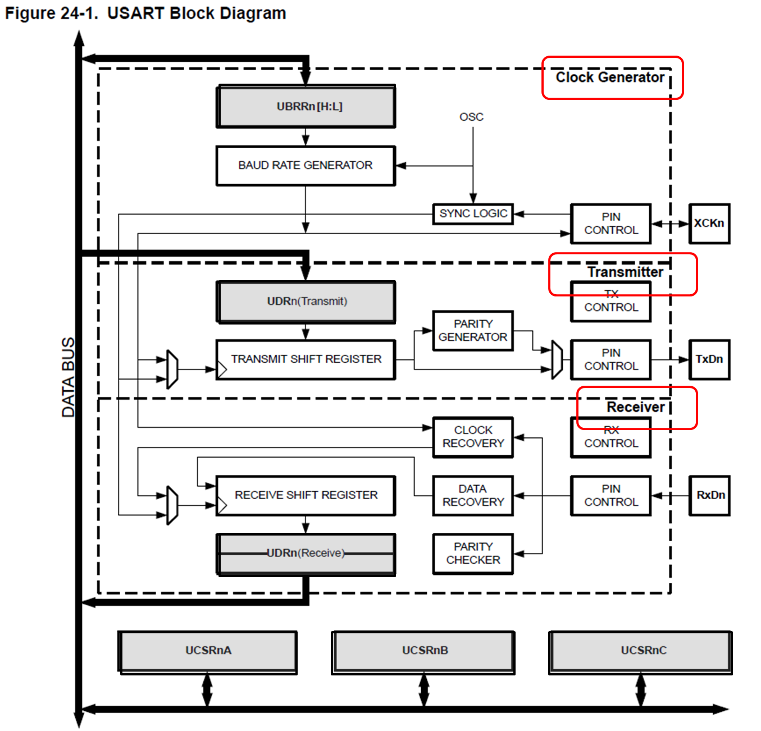

 0

AVR® USART Overview

Last modified by Microchip on 2023/11/09 09:02

Microchip AVR® 8-bit microcontrollers contain a highly flexible communication peripheral known as a Universal Synchronous and Asynchronous Serial Receiver and Transmitter (USART).  
  
This peripheral can be used to communicate with a wide variety of other components, including other microcontrollers, wireless modules, LCD displays, GPS modules, etc. The USART peripheral can operate in one of two main modes: Synchronous or Asynchronous.  
  
This module focuses on the [Asynchronous Mode](https://en.wikipedia.org/wiki/Universal_asynchronous_receiver/transmitter) of operation.

Learn More

* [megaAVR® USART Configuration](https://developerhelp.microchip.com/xwiki/bin/view/products/mcu-mpu/8-bit-avr/peripherals/usart/8-bit-avr-usart-mega-configuration/)
* [megaAVR® USART Example (Polled)](https://developerhelp.microchip.com/xwiki/bin/view/products/mcu-mpu/8-bit-avr/peripherals/usart/mega-example-polled/)

# megaAVR® USART Configuration

Last modified by Microchip on 2023/11/10 11:09

**Contents**

* [Overview](https://developerhelp.microchip.com/xwiki/bin/view/products/mcu-mpu/8-bit-avr/peripherals/usart/8-bit-avr-usart-mega-configuration/#HOverview)
  + [Using the USART (Summary)](https://developerhelp.microchip.com/xwiki/bin/view/products/mcu-mpu/8-bit-avr/peripherals/usart/8-bit-avr-usart-mega-configuration/#HUsingtheUSART28Summary29)
* [Initialization](https://developerhelp.microchip.com/xwiki/bin/view/products/mcu-mpu/8-bit-avr/peripherals/usart/8-bit-avr-usart-mega-configuration/#HInitialization)
  + [Setting the Baud Rate](https://developerhelp.microchip.com/xwiki/bin/view/products/mcu-mpu/8-bit-avr/peripherals/usart/8-bit-avr-usart-mega-configuration/#HSettingtheBaudRate)
  + [Setting the Frame Format](https://developerhelp.microchip.com/xwiki/bin/view/products/mcu-mpu/8-bit-avr/peripherals/usart/8-bit-avr-usart-mega-configuration/#HSettingtheFrameFormat)
  + [Enabling the Transmitter](https://developerhelp.microchip.com/xwiki/bin/view/products/mcu-mpu/8-bit-avr/peripherals/usart/8-bit-avr-usart-mega-configuration/#HEnablingtheTransmitter)
  + [Enabling the Receiver](https://developerhelp.microchip.com/xwiki/bin/view/products/mcu-mpu/8-bit-avr/peripherals/usart/8-bit-avr-usart-mega-configuration/#HEnablingtheReceiver)
  + [Code Example](https://developerhelp.microchip.com/xwiki/bin/view/products/mcu-mpu/8-bit-avr/peripherals/usart/8-bit-avr-usart-mega-configuration/#HCodeExample)
* [Data Communications](https://developerhelp.microchip.com/xwiki/bin/view/products/mcu-mpu/8-bit-avr/peripherals/usart/8-bit-avr-usart-mega-configuration/#HDataCommunications)
  + [Transmit](https://developerhelp.microchip.com/xwiki/bin/view/products/mcu-mpu/8-bit-avr/peripherals/usart/8-bit-avr-usart-mega-configuration/#HTransmit)
  + [Receive](https://developerhelp.microchip.com/xwiki/bin/view/products/mcu-mpu/8-bit-avr/peripherals/usart/8-bit-avr-usart-mega-configuration/#HReceive)
  + [Code Example](https://developerhelp.microchip.com/xwiki/bin/view/products/mcu-mpu/8-bit-avr/peripherals/usart/8-bit-avr-usart-mega-configuration/#HCodeExample-1)
* [Learn More](https://developerhelp.microchip.com/xwiki/bin/view/products/mcu-mpu/8-bit-avr/peripherals/usart/8-bit-avr-usart-mega-configuration/#HLearnMore)

## Overview

In this section, we will cover the basic coding steps required to configure/use the USART module in a megaAVR® MCU, with a focus on the [ATmega328PB](http://www.microchip.com/wwwproducts/en/ATmega328PB) device.

The USART module consists of three main sections, Clock Generator, Transmitter, and Receiver, as shown in the following diagram:

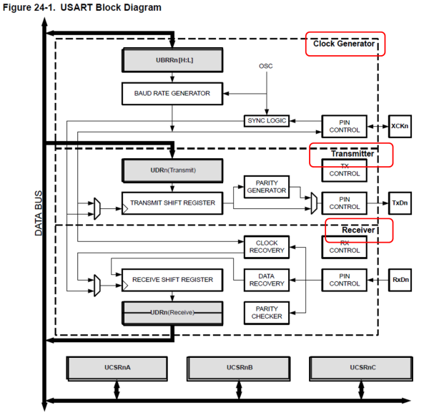

​

Key registers (highlighted in grey) include:

* Control-and-Status Registers (UCSRnA, UCSRnB, UCSRnC) shared by all three sections.
* Data register UDRn shared by both Transmitter and Receiver sections.
* Baud rate control registers UBRRn[H:L] used by the Clock Generator.

The "n" in the register/bit name identifies the specific USART hardware instance (0, 1, 2) the register/bit is associated with. For example, UCSR0A refers to USART0 Control & Status Register A.

[Back to top](https://developerhelp.microchip.com/xwiki/bin/view/products/mcu-mpu/8-bit-avr/peripherals/usart/8-bit-avr-usart-mega-configuration/)

### Using the USART (Summary)

For basic polled operation, the following minimum steps need to be performed:

1. Choose a baud rate and program the UBRRn[H:L] registers accordingly.
2. Enable the USART serial transmit and receive sections.
3. If transmitting, wait until the transmit shift register is empty (poll on UCSRnA.UDREn), then load your data byte into UDRn.
4. If receiving, wait until the receiver data-received bit is set (poll on UCSRnA.RXCn), then read the data out of UDRn. Reading UDRn auto-clears the bit, and prepares the hardware to receive the next byte.

[Back to top](https://developerhelp.microchip.com/xwiki/bin/view/products/mcu-mpu/8-bit-avr/peripherals/usart/8-bit-avr-usart-mega-configuration/)

## Initialization

The USART has to be initialized before any communication can take place. The initialization process normally consists of:

* Setting the baud rate,
* Setting frame format and
* Enabling the Transmitter or the Receiver depending on the usage.

[Back to top](https://developerhelp.microchip.com/xwiki/bin/view/products/mcu-mpu/8-bit-avr/peripherals/usart/8-bit-avr-usart-mega-configuration/)

### Setting the Baud Rate

Internal clock generation is used for the Asynchronous mode of operation. The Clock Generation logic generates the base clock for the Transmitter and Receiver (key registers and control bits are highlighted):

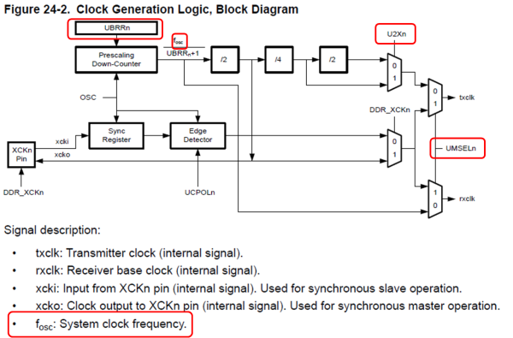

[Back to top](https://developerhelp.microchip.com/xwiki/bin/view/products/mcu-mpu/8-bit-avr/peripherals/usart/8-bit-avr-usart-mega-configuration/)

#### **USART Mode Select (UMSELn)**

The baud rate equation used by the module is set based on the operating mode. For asynchronous mode operation, the USART Mode Select bits in the USART Control and Status Register C (UCSRnC.UMSELn[1:0]) are used to select asynchronous operation (UMSEL[1:0] = 00) as shown:

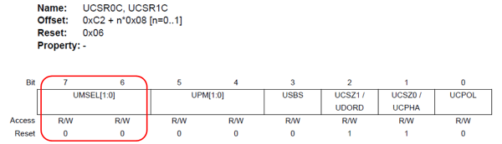

[Back to top](https://developerhelp.microchip.com/xwiki/bin/view/products/mcu-mpu/8-bit-avr/peripherals/usart/8-bit-avr-usart-mega-configuration/)

#### **Double-Speed Mode (U2Xn)**

For asynchronous mode, the USART TX rate can be doubled by setting the U2Xn bit in the UCSRnA register (UCSRnA.U2Xn = 1).

With double-speed mode set, the Receiver will only use half the number of samples (reduced from 16 to 8) for data sampling and clock recovery, and therefore a more accurate baud rate setting and system clock are required when this mode is used.

[Back to top](https://developerhelp.microchip.com/xwiki/bin/view/products/mcu-mpu/8-bit-avr/peripherals/usart/8-bit-avr-usart-mega-configuration/)

#### **Baud Rate Register (UBRRn)**

The USART Baud Rate Register (UBRRn) and the down-counter connected to it function as a programmable prescaler or baud rate generator. The down-counter, running at system clock (fosc), is loaded with the UBRRn value each time the counter has counted down to zero or when the UBRRnL Register is written. A clock is generated each time the counter reaches zero. This clock is the baud rate generator clock output (= fosc/(UBRRn+1)). The Transmitter divides the baud rate generator clock output by 2, 8, or 16 depending on the mode. The baud rate generator output is used directly by the Receiver’s clock and data recovery units. However, the recovery units use a state machine that uses 2, 8, or 16 states depending on the mode set by the state of the UMSEL, U2Xn, and DDR_XCK bits.  
  
Table 24-1 contains equations for calculating the baud rate (in bits per second) and for calculating the UBRRn value for each mode of operation using an internally generated clock source.

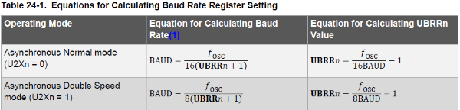

* **BAUD**: Baud rate (in bits per second, bps)
* **fOSC** : System oscillator clock frequency
* **UBRRn**: Contents of the UBRRnH and UBRRnL Registers, (0-4095).

​

Tables are also provided in the device data sheet containing UBRRn values for common Baud rates, given several oscillator frequencies:

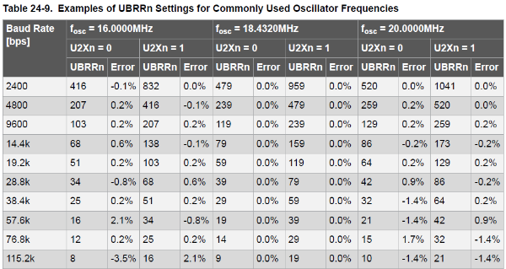

​

For baud frequency calculations, it is generally accepted that error percentages of less than ± 2% are acceptable.

[Back to top](https://developerhelp.microchip.com/xwiki/bin/view/products/mcu-mpu/8-bit-avr/peripherals/usart/8-bit-avr-usart-mega-configuration/)

### Setting the Frame Format

USART Control and Status Register C (UCSRnC) is used to configure the UART communication frame format—parity, number of stop bits, and number of data bits. Settings for the typical “8N1” frame format are as follows:

* **UPM[1:0] = 00** for No Parity
* **USBS = 0** for 1 Stop Bit
* **UCSZ1[1:0]** = 11 for 8 Bits

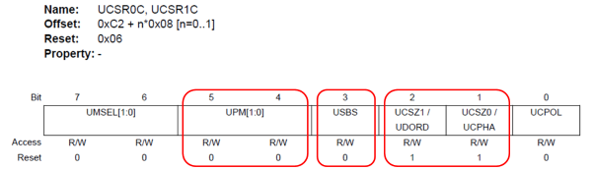

[Back to top](https://developerhelp.microchip.com/xwiki/bin/view/products/mcu-mpu/8-bit-avr/peripherals/usart/8-bit-avr-usart-mega-configuration/)

### Enabling the Transmitter

The USART Transmitter is enabled by setting the Transmit Enable (TXEN) bit in the UCSRnB register:

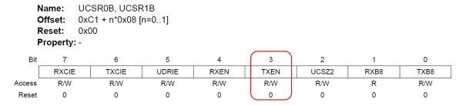

When the Transmitter is enabled, the normal port operation of the TxDn pin is overridden by the USART and given the function as the Transmitter’s serial output.

​

The baud rate, mode of operation, and frame format must be set up once before doing any transmissions.

[Back to top](https://developerhelp.microchip.com/xwiki/bin/view/products/mcu-mpu/8-bit-avr/peripherals/usart/8-bit-avr-usart-mega-configuration/)

### Enabling the Receiver

The USART Receiver is enabled by writing the Receive Enable (RXEN) bit in the UCSRnB Register to ‘1':

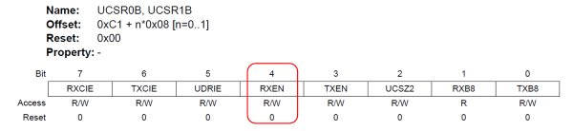

When the Receiver is enabled, the normal port operation of the RxDn pin is overridden by the USART and given the function as the Receiver's serial input.

​

The baud rate, mode of operation, and frame format must be set up once before doing any transmissions.

[Back to top](https://developerhelp.microchip.com/xwiki/bin/view/products/mcu-mpu/8-bit-avr/peripherals/usart/8-bit-avr-usart-mega-configuration/)

### Code Example

The following USART initialization code example uses the [setbaud utility](http://www.nongnu.org/avr-libc/user-manual/group__util__setbaud.html) library in AVR-LIBC. This library provides macros that use the c-preprocessor to calculate appropriate values for UBBRn.

#### **Inputs**

This header file requires that on-entry values are already defined for F_CPU and BAUD. In addition, the macro BAUD_TOL will define the baud rate tolerance (in percent) that is acceptable during the calculations. The value of BAUD_TOL will default to +/- 2%.

#### **Outputs**

Assuming that the requested BAUD is valid for the given F_CPU then the UBRR_VALUE macro is set to the required prescaler value. Two additional macros are provided for the low and high bytes of the prescaler, respectively; UBRRL_VALUE is set to the lower byte of the UBRR_VALUE, and UBRRH_VALUE is set to the upper byte. An additional macro, USE_2X, will be defined. Its value is set to 1 if the desired BAUD rate within the given tolerance could only be achieved by setting the U2Xn bit in the UART configuration. It will be defined as 0 if U2Xn is not needed.

1  
2  
3  
4  
5  
6  
7  
8  
9  
10  
11  
12  
13  
14  
15  
16  
17  
18  
19  
20  
21  
22  
23  
24  
25  
26  
27  
28

#define F_CPU 16000000UL             required for setbaud & other libraries  
#define BAUD 38400UL                 desired baud  
#define BAUD_TOL 2                   desired baud rate tolerance (+/- %)  
  
#include *<avr/io.h>*  
#include *<util/setbaud.h>*  
  
void USART0_Init(void){  
  
     Set the BAUD rate  
  
    UBRR0H = UBRRH_VALUE;  
    UBRR0L = UBRRL_VALUE;  
    #**if** USE_2X                        USE_2X defined by setbaud.h based on inputs  
    UCSR0A |= (1 << U2X0);  
    #**else**  
    UCSR0A &= (1 << U2X0);  
    #endif  
  
     Set the Mode & Frame Parameters  
  
    UCSR0C = 0x06;                    Asynchronous, 8-data, No parity, 1-stop  
  
     Enable USART0 Transmitter and Receiver  
  
    UCSR0B = (1 << TXEN0) | (1 << RXEN0);  
  
}

The setbaud library generates warning messages during compilation if the input parameters generate a BAUD rate setting which will produce a baud rate outside of the desired BAUD_TOL.

[Back to top](https://developerhelp.microchip.com/xwiki/bin/view/products/mcu-mpu/8-bit-avr/peripherals/usart/8-bit-avr-usart-mega-configuration/)

## Data Communications

### Transmit

Data transmission is initiated by loading the transmit buffer with the data to be transmitted. The CPU can load the transmit buffer by writing to the UDRn register. For polled operation, firmware should monitor the data-register-empty flag (UCSRnA.UDREn) before loading UDRn.  
  
The buffered data in the transmit buffer will be moved to the Shift Register when the Shift Register is ready to send a new frame. The Shift Register is loaded with new data if it is in an  Idle state (no ongoing transmission) or immediately after the last stop bit of the previous frame is transmitted. When the Shift Register is loaded with new data, it will transfer one complete frame at the rate given by the Baud Register.

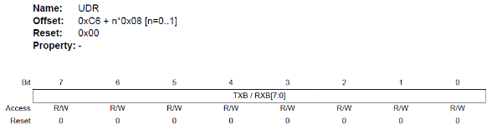

​

The transmit complete interrupt flag (USCRnA.TXCn) is set and an optional TX interrupt may be generated (if enabled) when the entire frame in the shift register has been shifted out. The UCSRnA.TXCn Flag bit is automatically cleared when a transmit complete interrupt is executed, or it can be cleared by writing a one to its bit location.

[Back to top](https://developerhelp.microchip.com/xwiki/bin/view/products/mcu-mpu/8-bit-avr/peripherals/usart/8-bit-avr-usart-mega-configuration/)

### Receive

The Receiver starts data reception when it detects a valid start bit. Each bit that follows the start bit will be sampled at the baud rate or XCKn clock, and shifted into the Receive Shift Register until the first stop bit of a frame is received. The receive buffer can then be read by reading the UDRn register. The complete reception of a byte can be checked by polling the RXCn bit in UCSRnA register.

The receive complete interrupt flag (RXCn) is set and an optional RX interrupt may be generated (if enabled) when the entire frame in the shift register has been copied to the UDRn register. This is a persistent interrupt, i.e., firmware must read the received data from UDRn in order to clear the RXCn Flag

### Code Example

The following simple blocking APIs send and receive a byte of data via USART0.

1  
2  
3  
4  
5  
6  
7  
8  
9  
10  
11  
12  
13  
14  
15  
16  
17  
18  
19

void USART0_Transmit(unsigned char data){  
  
    Wait **for** empty transmit buffer  
    **while**(!(UCSR0A & (1 << UDRE0)));  
  
     Put data into buffer, sends the data  
    UDR0 = data;  
  
}  
  
unsigned char USART0_Receive(void){  
  
    Wait **for** data to be received  
    **while**(!(UCSR0A & (1 << RXC0)));  
  
     Get and **return** received data from buffer  
    **return** UDR0;  
  
}

[Back to top](https://developerhelp.microchip.com/xwiki/bin/view/products/mcu-mpu/8-bit-avr/peripherals/usart/8-bit-avr-usart-mega-configuration/)

## Learn More

* [megaAVR® Interrupt Configuration](https://developerhelp.microchip.com/xwiki/bin/view/products/mcu-mpu/8-bit-avr/peripherals/interrupts/)
* [megaAVR® USART Example (Polled)](https://developerhelp.microchip.com/xwiki/bin/view/products/mcu-mpu/8-bit-avr/peripherals/usart/mega-example-polled/)

[Back to top](https://developerhelp.microchip.com/xwiki/bin/view/products/mcu-mpu/8-bit-avr/peripherals/usart/8-bit-avr-usart-mega-configuration/)

megaAVR® USART Example (Polled)

Last modified by Microchip on 2023/11/10 11:09

**Contents**

* + [Objective](https://developerhelp.microchip.com/xwiki/bin/view/products/mcu-mpu/8-bit-avr/peripherals/usart/mega-example-polled/#HObjective)
  + [Reference Materials](https://developerhelp.microchip.com/xwiki/bin/view/products/mcu-mpu/8-bit-avr/peripherals/usart/mega-example-polled/#HReferenceMaterials)
  + [Connection Diagram](https://developerhelp.microchip.com/xwiki/bin/view/products/mcu-mpu/8-bit-avr/peripherals/usart/mega-example-polled/#HConnectionDiagram)
  + [Procedure](https://developerhelp.microchip.com/xwiki/bin/view/products/mcu-mpu/8-bit-avr/peripherals/usart/mega-example-polled/#HProcedure)
* [Conclusions](https://developerhelp.microchip.com/xwiki/bin/view/products/mcu-mpu/8-bit-avr/peripherals/usart/mega-example-polled/#HConclusions)
* [Learn More](https://developerhelp.microchip.com/xwiki/bin/view/products/mcu-mpu/8-bit-avr/peripherals/usart/mega-example-polled/#HLearnMore)

Objective

This page provides a simple project demonstrating polled operation of the Universal Synchronous Asynchronous Receiver Transmitter (USART) peripheral on megaAVR® devices. The code example runs on the [ATmega328PB](http://www.microchip.com/wwwproducts/en/ATmega328PB) MCU.  
  
The project configures the Timer/Counter1 module to operate in Clear-Timer-On-Compare (CTC) mode, and, on a period match, generates a tick interrupt every 100 mS. The main loop monitors these tick signals to implement a time-of-day clock (HH:MM:SS format). LED0 is also toggled at every tick event.  
  
The clock display is sent out USART0 TX every second and is controlled by user input 'control' characters received on USART0 RX:

* 'u' enables updates to the clock display every second
* 'f' freezes updates to the display

The clock interface is displayed using a Terminal Emulator program, such as [Tera Term](https://ttssh2.osdn.jp/index.html.en).

Reference Materials

[ATMEGA328PB Xplained Mini](https://www.microchip.com/en-us/development-tool/ATMEGA328PB-XMINI)

[Microchip Studio](https://www.microchip.com/studio)

[Tera Term](https://ttssh2.osdn.jp/index.html.en)

[Project Files](https://github.com/MicrochipTech/dh-8bit-megaavr-usart-example-polled)

We recommend extracting the .zip file to your C:\ folder.  
  
You should see the folder C:\MTT\8avr\mega\code-examples\usart-example-polled\8avr-mega-usart-example-polled containing the solution 8avr-mega-usart-example-polled.atsln here.

Connection Diagram

The USART0 module on the target ATmega328PB device is connected to the USART interface on the mEDBG chip. The mEDBG chip performs USB-serial conversion by enumerating as a CDC-class virtual COM port on the PC and presenting the target USART data on this interface. Note that the mEDBG also controls the programming/debug interface, as well as supplying a 16 MHz clock when the Xplained board is connected via USB cable to a PC.

​

[Back to Top](https://developerhelp.microchip.com/xwiki/bin/view/products/mcu-mpu/8-bit-avr/peripherals/usart/mega-example-polled/#top)

Procedure

Attach the ATmega328PB Xplained Mini board:

Using a USB-A-male-to-Micro-B-male cable, attached the Xplained Mini to your computer. Start MPLAB X IDE. If the board has been successfully enumerated, you should see the board image come up in Studio as shown in the accompanying image:

​​

[Back to Top](https://developerhelp.microchip.com/xwiki/bin/view/products/mcu-mpu/8-bit-avr/peripherals/usart/mega-example-polled/#top)

Create a New Project

In MPLAB X IDE, select **File > New Project**.

​

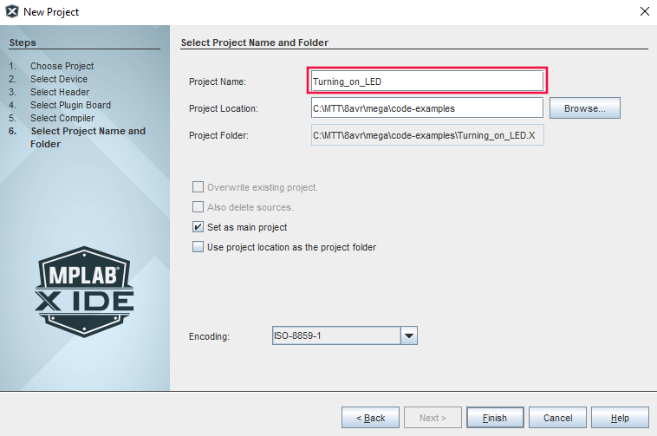​

[Back to Top](https://developerhelp.microchip.com/xwiki/bin/view/products/mcu-mpu/8-bit-avr/peripherals/usart/mega-example-polled/#top)

Choose Project

Select**Microchip Embedded**and then **Standalone Project**and then select **Next**.



[Back to Top](https://developerhelp.microchip.com/xwiki/bin/view/products/mcu-mpu/8-bit-avr/peripherals/usart/mega-example-polled/#top)

Select Device

Use the pulldown or type into the boxes to indicate the Family,  ATmega328PB, and Tool. Then Select **Next**.



[Back to Top](https://developerhelp.microchip.com/xwiki/bin/view/products/mcu-mpu/8-bit-avr/peripherals/usart/mega-example-polled/#top)

Select Compiler

Select the **XC8 Compiler**and then **Next**.



[Back to Top](https://developerhelp.microchip.com/xwiki/bin/view/products/mcu-mpu/8-bit-avr/peripherals/usart/mega-example-polled/#top)

Name the Project

Choose a name for the project, browse to a location to save it, and select **Finish**.



[Back to Top](https://developerhelp.microchip.com/xwiki/bin/view/products/mcu-mpu/8-bit-avr/peripherals/usart/mega-example-polled/#top)

Create a New main.c file

Right-click on **Source Files** in the file explorer window and select **New>avr-main.c**and rename the File Name to **main.**Then select **Finish.**



[Back to Top](https://developerhelp.microchip.com/xwiki/bin/view/products/mcu-mpu/8-bit-avr/peripherals/usart/mega-example-polled/#top)

Add the Code

Delete the contents of the newly created **main.c** file. Copy and Paste the following code into it.

*/*******************************************************************************  
 * File:  main.c  
 *  
 * Project:  8avr-mega-usart-example-polled  
 *  
 * Description: Demonstrate basic polled usart configuration/usage  
 *      
 *    100mS Timer1 ISR is used to create tick events.  
 *  
 *    Main loop monitors tick events to toggle the LED and track time.  
 *      
 *    Elapsed time (HH:MM:SS) is output to a terminal via USART0 once  
 *    every second. "u" command updates the clock display, "f" command  
 *    freezes the clock display (time is still incremented).  
 *   
 * Date:  08-June-2017   
 * Revision:  
 * Author:  
 *  
 * Hardware: ATmega328PB Xplained Mini PCB Rev 3  
 *  
 *    Clock:  16MHz (External - from EDBG IC)  
 *    LED0:  PB5  
 *    SW0:  PB7  
 *    UART_TX: TXD/PD1 (Connected to EDBG IC RXD)  
 *    UART_RX: RXD/PD0 (Connected to EDBG IC TXD)  
 *  
 * Fuses:  High:  0xDF  
 *    Low:  0xC0  
 *    Ext:  0xFC  
 ******************************************************************************/*   
  
*/*** MACROS *******************************************************************/*  
  
#define F_CPU 16000000UL   // required **for** **setbaud** & other libraries  
#define BAUD 38400UL    // desired baud  
#define BAUD_TOL 2     // desired baud rate tolerance (+/- %)  
  
*/*** INCLUDES *****************************************************************/*  
  
#**include** <stdint.h>  
#**include** <stdio.h>  
#**include** <avr/io.h>     // SFR/Bit identifiers  
#**include** <avr/interrupt.h>   // ISR macro  
#**include** <util/**setbaud**.h>   // Baud rate calculation macro helpers  
  
*/*** GLOBAL VARIABLES *********************************************************/*  
  
char g_OutString[80]*;    // output buffer used with sprintf*  
volatile uint8_t g_TickSignal = 0*; // define shared variable used for signaling*  
uint8_t g_Hours, g_Minutes, g_Seconds, g_Tenths*; // time variables*  
enum TIMEOUTPUT {DISABLED, ENABLED} g_TimeControl*; // control for time output*  
char g_Command*;      // control character to enable/disable output*  
  
*/*** LOCAL FUNCTION PROTOTYPES ************************************************/*  
  
void SYSTEM_Init(void)*;    // Initialize HW and variables*  
void TIMER1_Init(void)*;    // Timer/Counter1 initialization*  
void USART0_Init(void)*;    // USART0 initialization*  
void USART0_Put(uint8_t data)*;  // Transmit a byte*  
void USART0_PutString(char *ptr)*; // Transmit a string*  
char USART0_GetChar(void)*;   // Receive a character (if available)*  
  
*/*** main() *******************************************************************/*  
  
int main(void)  
{  
    // Initialization  
 SYSTEM_Init()*;*  
   
 // Enable global interrupts   
 sei()*;*  
   
    USART0_PutString("megaAVR USART0 Example (Polled)\r**\n**\r**\n**")*;*  
 USART0_PutString("Press 'u' to update the clock display,\r**\n**")*;*  
 USART0_PutString("Press 'f' to freeze the clock display.\r**\n**\r**\n**")*;*  
 **sprintf**(g_OutString, "%02d:%02d:%02d\r", g_Hours, g_Minutes, g_Seconds)*;*  
 USART0_PutString(g_OutString)*;*  
   
 **while**(1){  
    
  // Look **for** 100mS event signal  
  **if**(g_TickSignal){  
     
   // Toggle LED0  
   PORTB ^= (1 << PORTB5)*;*  
     
   // Update the clock  
   g_Tenths++*;*  
   **if**(g_Tenths == 10){  
    g_Tenths = 0*;*  
    **if**(g_TimeControl == ENABLED){  
     **sprintf**(g_OutString, "%02d:%02d:%02d\r", g_Hours, g_Minutes, g_Seconds)*;*  
     USART0_PutString(g_OutString)*;*  
    }  
    g_Seconds++*;*  
    **if**(g_Seconds == 60){  
     g_Seconds = 0*;*  
     g_Minutes++*;*  
    }  
    **if**(g_Minutes == 60){  
     g_Minutes = 0*;*  
     g_Hours++*;*  
    }    
   }  
     
   // Acknowledge event signal  
   g_TickSignal = 0*;*  
  }  
    
  // Look to enable/disable the updating of the clock output  
  g_Command = USART0_GetChar()*;*  
  switch(g_Command){  
   case 'u':  
    g_TimeControl = ENABLED*;*  
    **break***;*  
     
   case 'f':  
    g_TimeControl = DISABLED*;*  
    **break***;*  
     
   default:  
    **break***;*  
  }  
 }  
} // main()  
  
*/*** SYSTEM_Init() ****************************************************************/*  
  
void SYSTEM_Init(void){  
   
 // Set LED as output  
 DDRB |= (1<<PORTB5)*;   // Configure PB5 as digital output*  
 PORTB &= ~(1<<PORTB5)*;   // Set initial level for PB5*  
   
 // Timer1  
 TIMER1_Init()*;*  
   
 // USART0  
 USART0_Init()*;*  
   
 // Initialize global variables  
 g_Hours = 0*;*  
 g_Minutes = 0*;*  
 g_Seconds = 0*;*  
 g_Tenths = 0*;*  
   
} // SYSTEM_Init()  
  
*/*** TIMER1_Init() *************************************************************/*  
  
void TIMER1_Init(void){  
   
 // Set up Timer/Counter1  
 TCCR1B |= (1 << WGM12)*;   // Configure timer 1 for CTC mode*  
 OCR1A = 25000*;     // Set CTC compare value to 10Hz (100mS) at*  
         // 16MHz AVR clock , with a prescaler of 64  
 TIMSK1 |= (1 << OCIE1A)*;  // Enable CTC interrupt*  
 TCCR1B |= ((1 << CS10) | (1 << CS11))*; // Start Timer/Counter1 at F_CPU/64*  
  
} // TIMER1_Init()  
  
*/*** USART0_Init() *************************************************************/*  
  
void USART0_Init(void){  
   
 // Set the BAUD rate  
 UBRR0H = UBRRH_VALUE*;*  
 UBRR0L = UBRRL_VALUE*;*  
 #**if** USE_2X     // USE_2X defined by **setbaud**.h based on inputs  
 UCSR0A |= (1 << U2X0)*;*  
 #**else**  
 UCSR0A &= ~(1 << U2X0)*;*  
 #**endif**  
   
 // Set the Mode & Frame Parameters  
 // Asynchronous, 8-data, No parity, 1 stop  
 UCSR0C = 0x06*;*  
   
 // Enable USART0 Transmitter and Receiver  
 UCSR0B = (1 << TXEN0) | (1 << RXEN0)*;*  
  
} // USART0_Init()  
  
*/*** USART0_Put() **************************************************************/*  
  
void USART0_Put(uint8_t data){  
   
 //Checking to see **if** USART TX buffer is empty **for** new data  
 **while**(!(UCSR0A & (1<<UDRE0)))*;*  
   
 //Initiating transfer  
 UDR0 = data*;*  
  
} // USART0_Put()  
  
*/*** USART0_PutString() ********************************************************/*  
  
void USART0_PutString(char *ptr){  
   
 **while**(*ptr){   // **Loop** **until** **end** of string (*s = '\0')  
  USART0_Put(*ptr++)*; // Send the character and point to the next one*  
 }  
   
} // USART0_PutString()  
  
*/*** USART0_GetChar() **************************************************************/*  
  
char USART0_GetChar(void){  
   
 char rxdata*;*  
   
 **if**(UCSR0A & (1<<RXC0)){  // checking **if** USART RX data is available  
  rxdata = UDR0*;   // reading the received byte (clears RXC0)*  
  **return** rxdata*;   // return the data*  
 }  
   
 **return** 0x00*;    // return NUL char ('/0') if no data available*  
  
} // USART0_GetChar()  
  
*/*** Interrupt Handler for TIMER1_COMPA Interrupt (Nesting Disabled) **********/*  
  
ISR(TIMER1_COMPA_vect, ISR_BLOCK)  
{  
 g_TickSignal++*;     // signal "tick" event*  
         // Timer1 CTC flag auto-cleared by hardware  
}  
  
*/*******************************************************************************  
  
SOFTWARE AND DOCUMENTATION ARE PROVIDED "AS IS" WITHOUT WARRANTY OF ANY KIND,  
EITHER EXPRESS OR IMPLIED, INCLUDING WITHOUT LIMITATION, ANY WARRANTY OF  
MERCHANTABILITY, TITLE, NON-INFRINGEMENT AND FITNESS FOR A PARTICULAR PURPOSE.  
IN NO EVENT SHALL MICROCHIP TECHNOLOGY INC OR ITS LICENSORS BE LIABLE OR  
OBLIGATED UNDER CONTRACT, NEGLIGENCE, STRICT LIABILITY, CONTRIBUTION, BREACH OF  
WARRANTY, OR OTHER LEGAL EQUITABLE THEORY ANY DIRECT OR INDIRECT DAMAGES OR  
EXPENSES INCLUDING BUT NOT LIMITED TO ANY INCIDENTAL, SPECIAL, INDIRECT,  
PUNITIVE OR CONSEQUENTIAL DAMAGES, LOST PROFITS OR LOST DATA, COST OF  
PROCUREMENT OF SUBSTITUTE GOODS, TECHNOLOGY, SERVICES, OR ANY CLAIMS BY THIRD  
PARTIES (INCLUDING BUT NOT LIMITED TO ANY DEFENSE THEREOF), OR OTHER SIMILAR  
COSTS.  
  
*******************************************************************************/*

[Back to Top](https://developerhelp.microchip.com/xwiki/bin/view/products/mcu-mpu/8-bit-avr/peripherals/usart/mega-example-polled/#top)

Program the Device

At the top of the MPLAB X IDE, select the Make and Program device button

​​​

There are several key hardware configuration settings that need to be configured. The following [**fuse settings**](https://developerhelp.microchip.com/xwiki/bin/view/products/mcu-mpu/8-bit-avr/structure/fuses/) need to be programmed into the device:

* HIGH: 0xDF
* LOW: 0xC0
* EXT: 0xFC

While still in the Device Programming dialog box, select the **Memories** sub-section as shown. The path to the solution's hex file should already be listed in the dialog. Press **Program** as shown.

[Back to Top](https://developerhelp.microchip.com/xwiki/bin/view/products/mcu-mpu/8-bit-avr/peripherals/usart/mega-example-polled/#top)

Start the Tera Term application

Select the correct mEDBG COM port in the dialog box that appears:

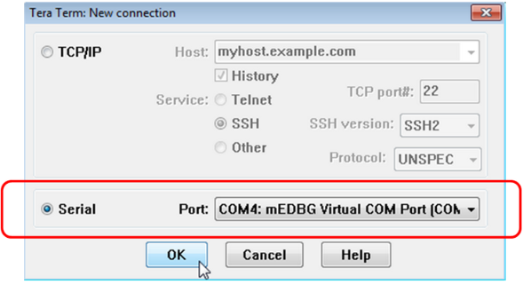​​​​

[Back to Top](https://developerhelp.microchip.com/xwiki/bin/view/products/mcu-mpu/8-bit-avr/peripherals/usart/mega-example-polled/#top)

Set the serial port parameters to match the project defaults

38400 baud, 8-data, no parity, 1-stop, no flow-control as shown:

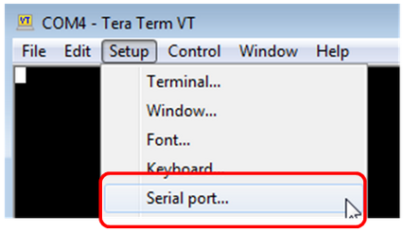​​​​

[Back to Top](https://developerhelp.microchip.com/xwiki/bin/view/products/mcu-mpu/8-bit-avr/peripherals/usart/mega-example-polled/#top)

Observe the Results

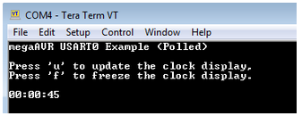​​​​

​You may see gibberish on the display after resetting the communication parameters. Simply perform a board reset by shorting RST to GND, or by re-programming the hex file into the board again (see step 4 above).

[Back to Top](https://developerhelp.microchip.com/xwiki/bin/view/products/mcu-mpu/8-bit-avr/peripherals/usart/mega-example-polled/#top)

Conclusions

This project has provided an example of how to setup and use the USART module on the megaAVR® MCU.

[Back to Top](https://developerhelp.microchip.com/xwiki/bin/view/products/mcu-mpu/8-bit-avr/peripherals/usart/mega-example-polled/#top)

## 8-bit AVR® Analog and Comparator Voltage Reference

A voltage reference is a circuit that produces a known output voltage from a varying input. Voltage references are crucial for providing a stable reference for Analog-to-Digital Converters (ADCs) and Digital-to-Analog Converters (DACs). The Fixed Voltage Reference (FVR) or the Voltage Reference (VREF) peripherals in PIC® and AVR® microcontrollers (MCUs) are embedded in the device, allowing you to improve the performance of the integrated ADC and DAC peripherals without increasing your Bill of Materials (BOM).

Analog Comparator Voltage Reference Overview

Last modified by Microchip on 2023/11/09 09:02

The Analog Comparator compares the input values on the positive pin AIN0 and negative pin AIN1. When the voltage on the positive pin, AIN0, is higher than the voltage on the negative pin, AIN1, the Analog Comparator Output, ACO (on Port E[0]), is set. The comparator’s output can be set to trigger the Timer/Counter1 Input Capture function. In addition, the comparator can trigger a separate interrupt, exclusive to the Analog Comparator. The user can select Interrupt triggering on comparator output rise, fall, or toggle.

A block diagram of the comparator and its surrounding logic is shown.

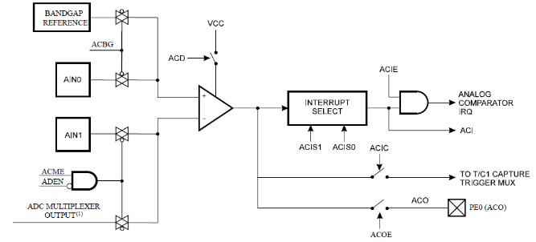

The Power Reduction Analog-to-Digital Converter (ADC) bit in the Power Reduction Register (PRR.PRADC) must be written to 0 in order to be able to use the ADC input MUX.

Analog Comparator Multiplexed Input

It is possible to select any of the ADC[7..0] pins to replace the negative input to the Analog Comparator. The ADC multiplexer is used to select this input, and consequently, the ADC must be switched off to utilize this feature. If the Analog Comparator Multiplexer Enable bit in the ADC Control and Status Register B (ADCSRB.ACME) is one and the ADC is switched off (ADCSRA.ADEN=0), the three least significant Analog Channel Selection bits in the ADC Multiplexer Selection Register (ADMUX.MUX[2..0]) select the input pin to replace the negative input to the Analog Comparator, as shown in the table below. When ADCSRB.ACME=0 or ADCSRA.ADEN=1, AIN1 is applied to the negative input of the Analog Comparator.

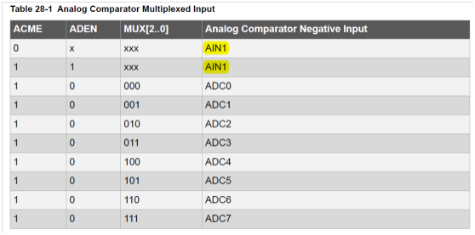

Analog Comparator Control and Status Register B

The Store Program Memory Control and Status Register contain the control bits needed to control the Boot Loader operations. When addressing I/O Registers as data space using LD and ST instructions, the provided offset must be used. When using the I/O specific commands IN and OUT, the offset is reduced by 0x20, resulting in an I/O address offset within *0x00 - 0x3F*.  
Name: ACSRB Offset: 0x4F Reset: 0x00  
Property:  
When addressing as I/O Register: address offset is *0x2F*

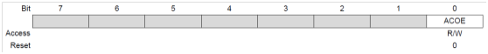

* Bit 0 – ACOE: Analog Comparator Output Enable

When this bit is set, the analog comparator output is connected to the ACO pin.

Analog Comparator Control and Status Register

When addressing I/O Registers as data space using LD and ST instructions, the provided offset must be used. When using the I/O specific commands IN and OUT, the offset is reduced by *0x20*, resulting in an I/O address offset within *0x00 - 0x3F*.  
Name: ACSR Offset: *0x50* Reset: N/A  
Property:  
When addressing as I/O Register: address offset is *0x30*

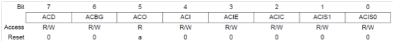

* Bit 7 – ACD: Analog Comparator Disable

When this bit is written as logic one, the power to the Analog Comparator is switched off. This bit can be set at any time to turn off the Analog Comparator. This will reduce power consumption in Active and Idle mode. When changing the ACD bit, the Analog Comparator Interrupt must be disabled by clearing the ACIE bit in ACSR. Otherwise, an interrupt can occur when the bit is changed.

* Bit 6 – ACBG: Analog Comparator Bandgap Select

When this bit is set, a fixed bandgap reference voltage replaces the positive input to the Analog Comparator. When this bit is cleared, AIN0 is applied to the positive input of the Analog Comparator. When the bandgap reference is used as input to the Analog Comparator, it will take a certain time for the voltage to stabilize. If not stabilized, the first conversion may give the wrong value.

* Bit 5 – ACO: Analog Comparator Output

The output of the Analog Comparator is synchronized and then directly connected to ACO. The synchronization introduces a delay of one to two clock cycles.

* Bit 4 – ACI: Analog Comparator Interrupt Flag

This bit is set by hardware when a comparator output event triggers the interrupt mode defined by ACIS1 and ACIS0. The ACI routine is executed if the ACIE bit is set and the I-bit in SREG is set. ACI is cleared by hardware when executing the corresponding interrupt handling vector. Alternatively, ACI is cleared by writing a logic one to the flag.

* Bit 3 – ACIE: Analog Comparator Interrupt Enable

When the ACIE bit is written logic one and the I-bit in the Status Register is set, the Analog Comparator interrupt is activated. When written logic zero, the interrupt is disabled.

* Bit 2 – ACIC: Analog Comparator Input Capture Enable

When written as logic one, this bit enables the input capture function in Timer/Counter1 to be triggered by the Analog Comparator. The comparator output is in this case directly connected to the input capture front-end logic, making the comparator utilize the noise canceler and edge select features of the Timer/Counter1 Input Capture interrupt. When written logic zero, no connection between the Analog Comparator and the input capture function exists. To make the comparator trigger the Timer/Counter1 Input Capture interrupt, the ICIE1 bit in the Timer Interrupt Mask Register (TIMSK1) must be set.

* Bits 1:0 – ACISn: Analog Comparator Interrupt Mode Select [n = 1:0]

These bits determine which comparator events that trigger the Analog Comparator interrupt.

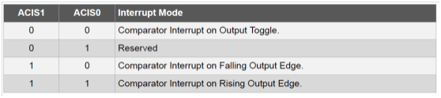

When changing the ACIS1/ACIS0 bits, the Analog Comparator Interrupt must be disabled by clearing its Interrupt Enable bit in the ACSR Register. Otherwise, an interrupt can occur when the bits are changed.

Digital Input Disable Register 1

Name: DIDR1 Offset: *0x7F*; Reset: *0x00*  
Property:

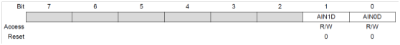

* Bit 1 – AIN1D: AIN1 Digital Input Disable
* Bit 0 – AIN0D: AIN0 Digital Input Disable

When this bit is written logic one, the digital input buffer on the AIN1/0 pin is disabled. The corresponding PIN Register bit will always read as zero when this bit is set. When an analog signal is applied to the AIN1/0 pin and the digital input from this pin is not needed, this bit should be written logic one to reduce power consumption in the digital input buffer.

Selectable 1.1 V ADC Reference Voltage specification:

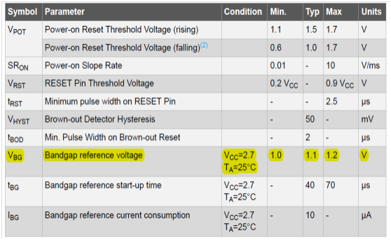

Example Project

A project example for the Analog Comparator is available here: [Example Project](https://developerhelp.microchip.com/xwiki/bin/view/products/mcu-mpu/8-bit-avr/peripherals/voltage-reference/8-bit-avr-analog-comparator-voltage-reference/)

# Comparator Example Project

Last modified by Microchip on 2023/11/09 09:02

## Analog Comparator and Voltage Reference Example

This hands-on project demonstrates a simple example of an analog comparator and reference voltage:  
Bandgap reference as positive input (1.1V) and AIN1 as negative input. By wiring AIN1 (PD7) to Switch (SW0, PB7), which turns on to high (5 V) and off to GND, and wiring ACO (PE0) to PB5 (LED0), the output of the comparator (ACO, PE0) can be observed by checking the LED’s status.

* Wiring: PD7 (AIN1) | PB7 (SW0; PE0 (ACO) | PB5 (LED0)

Xplained Board:

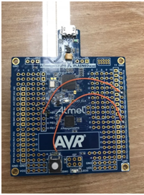​

##### **Select File > New > Atmel Start Project.**

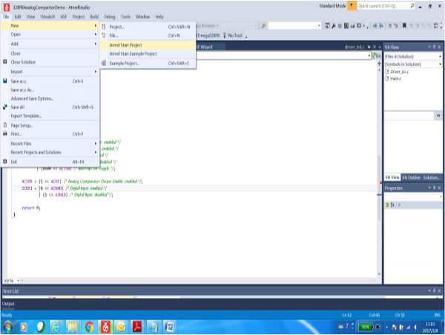​​

##### **Create new project.**

​​

##### **Select**[**ATmega328PB Xplained Mini**](https://www.microchip.com/en-us/development-tool/ATMEGA328PB-XMINI)**.**

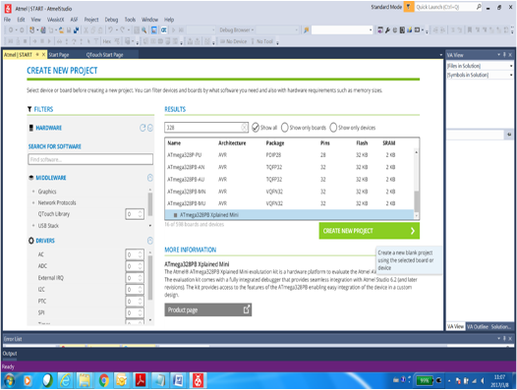​​

##### **Add Software Components and select AC.**

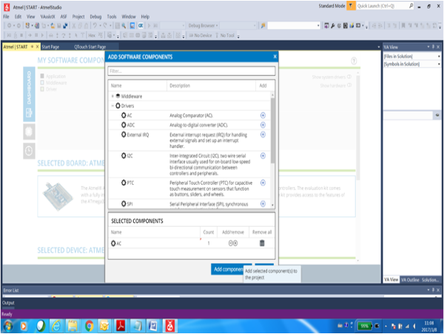​​

##### **Setup AC.**

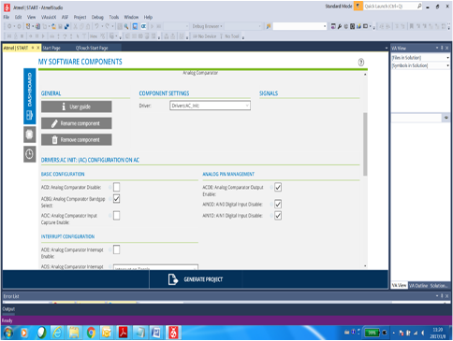​​

##### **Pin Configurator view.**

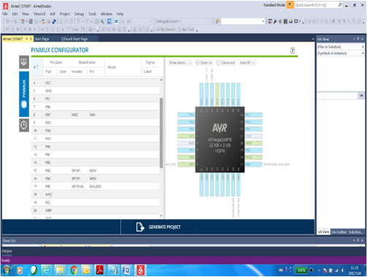​​

##### **Setup Clock Configurator.**

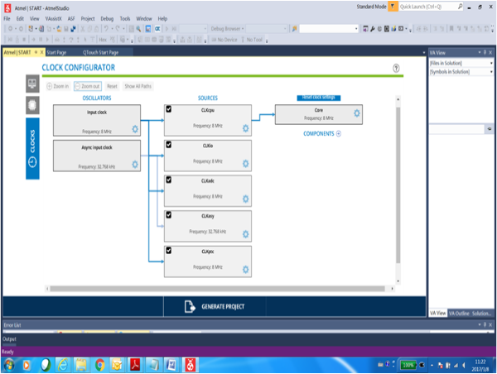​​

##### **Generate Project.**

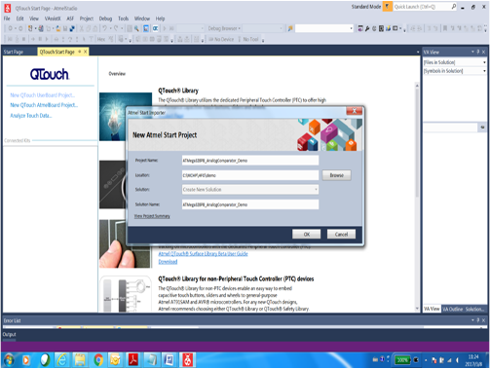​​

##### **View Project.**

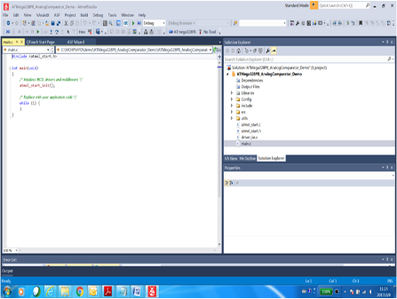​​

##### **In Main.c, add keyboard scan and LED driver.**

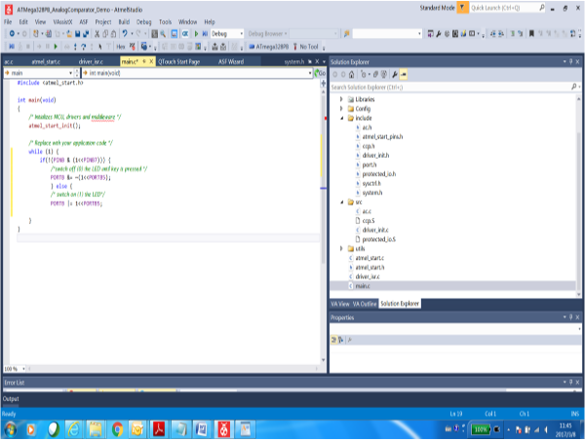​​

##### **Build and run.**

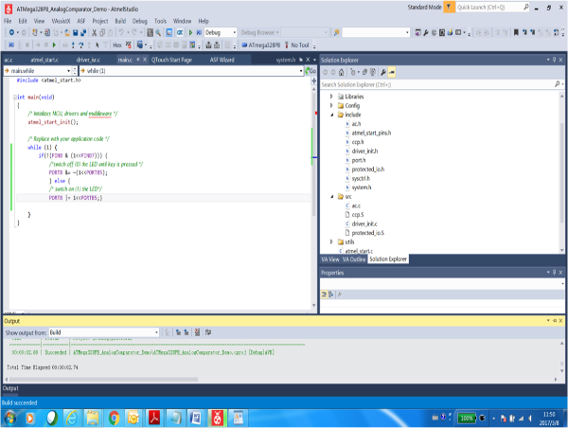​​

# 8-bit AVR® Microcontrollers ADC Setup for Internal Temperature Sensor

Last modified by Microchip on 2023/11/09 09:12

## 8-bit AVR® Analog to Digital Converter (ADC) Internal Temp Sensor Example

### Objective

This hands-on project helps you through a simple example of reading the on-chip temperature sensor. Reading the temperature sensor can be a rewarding project in itself. It confirms that you have completed the software build and the ADC hardware setup, and were able to program the microcontroller successfully. Finally, the debugger is used to view the temperature using the MPLAB® X Integrated Development Environment (IDE) output window.

The on-chip temperature sensor is coupled to a single-ended ADC8 channel. Selecting the ADC8 channel by writing ADMUX.MUX[3:0] to '1000' enables the temperature sensor. The internal 1.1 V voltage reference must also be selected for the ADC voltage reference source in the temperature sensor measurement. When the temperature sensor is enabled, the ADC converter can be used in a single conversion mode to measure the voltage over the temperature sensor.

The voltage sensitivity is approximately 1 mV/°C and the accuracy of the temperature measurement is ±10°C.

### Resources

[ATmega328PB Xplained Mini](https://www.microchipdirect.com/product/ATMEGA328PB-XMINI?productLoaded=true)  
[MPLAB® X IDE](https://developerhelp.microchip.com/xwiki/bin/view/software-tools/x/)  
[MPLAB® X XC8](https://developerhelp.microchip.com/xwiki/bin/view/software-tools/xc8/)

### Procedure

##### **1. Project Creation**

* Open MPLAB X IDE.
* Select **File > New > Project**.
* Select **Microchip Embedded > Standalone Project**.
* Select the device**Family > 8-bit AVR MCUs (XMega/Mega/Tiny)**.
* Select **Device > ATmega328PB**.
* Select **Tool>ATmega328PB Xplained Mini-Sn: ATMLxxxxxxxx...**

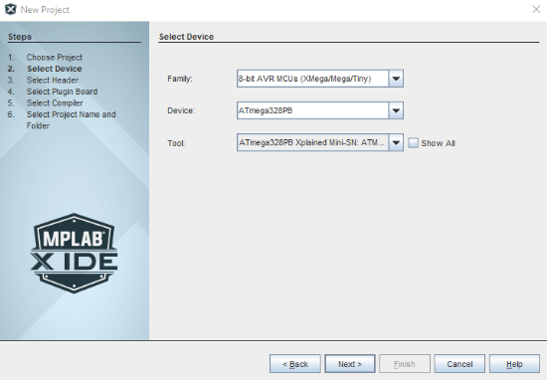

* Select**Next**.
* Select **XC8 compiler**.

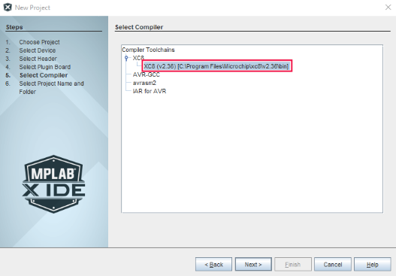

* Select **Next**.
* Enter **Project Name**.  We will use Temp_Sensor_Example as the file name.
* Choose a location to save the project on your computer.
* Select **Finish**.

​

##### **2. Create a main.c File**

This project reads the internal temperature sensor, converts the result to degrees centigrade, then stores the result in ADC Temperature Result.

##### **) A main.c file is need so we will add one to our project.**

Right click on **Source Files** in the **Project Explorer** window and navigate to **New > avr-main.c**.

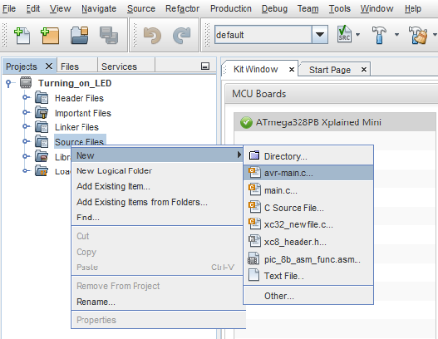

* Rename the File Name to **main**.

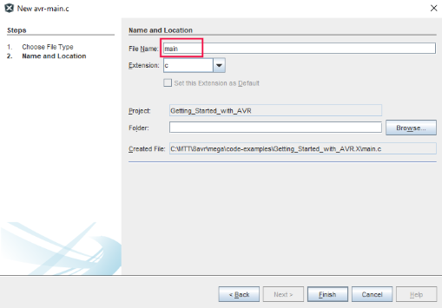

* Select **Finish**.

Modify main.c by entering copy/pasting the lines in the gray code block below just after the #include <avr/io.h> line.

​

#include <avr/io.h> is automatically added to the main.c file when it is generated. This should always be placed before the main(void) loop.

unsigned int Ctemp;  
unsigned int Ftemp;  
  
int main(void)  
{  
  
    */* Setup ADC to use int 1.1V reference   
    and select temp sensor channel */*  
    ADMUX = (1<<REFS1) | (1<<REFS0) | (0<<ADLAR) | (1<<MUX3) | (0<<MUX2) | (0<<MUX1) | (0<<MUX0);  
  
    */* Set conversion time to   
    112usec = [(1/(8Mhz / 64)) * (14 ADC clocks  per conversion)]  
     and enable the ADC*/*  
    ADCSRA = (1<<ADPS2) | (1<<ADPS1) | (1<<ADEN);  
  
    */* Perform Dummy Conversion to complete ADC init */*  
    ADCSRA |= (1<<ADSC);  
  
    */* wait for conversion to complete */*  
    **while** ((ADCSRA & (1<<ADSC)) != 0);  
  
    */* Scan for changes on A/D input pin in an infinite loop */*  
    **while**(1)  
    {  
        */* start a new conversion on channel 8 */*  
        ADCSRA |= (1<<ADSC);  
  
        */* wait for conversion to complete */*  
        **while** ((ADCSRA & (1<<ADSC)) != 0)  
        ;  
  
        */* Calculate the temperature in C */*  
        Ctemp = (ADC - 273);  
        Ftemp = (Ctemp * 1.8) + 32;  
    }  
  
    **return** 0;  
  
}

##### **3. Build Project and Program the Device**

Select the **Make and Program Device Main Project** button at the top of the MPLAB X IDE GUI.



​If the project builds correctly with no errors, we will enter debugging mode to get our temperature.

##### **4. Debugging**

Debugging a device is essential for determining how a program may be running.

* Select the line number next to the Ftemp = (Ctemp * 1.8) + 32; line  to create a breakpoint.
* Select the **Debug Project** button at the top of the MPLAB X GUI.

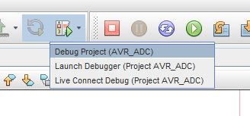

* The project will build and the program will be loaded into the Xplained board
* The program will halt when it hits the breakpoint and the breakpoint will turn green and in the Variables window at the bottom of the screen the first variable, Ctemp will have a value.  Notice that Ftemp does not yet have a value because the program has not reached the point where the conversion has been made.

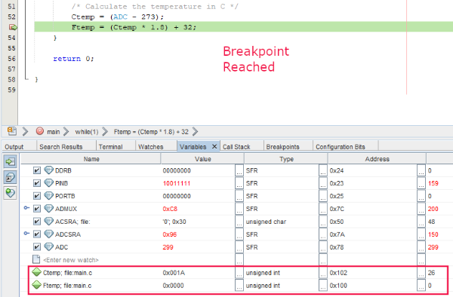

​If the program is continued by selecting the PLAY button at the top of the MPLAB X GUI, it will continue and the value for Ftemp is now calculated.  Notice that the value is in RED.  This is because it changed since the last time the program was halted.

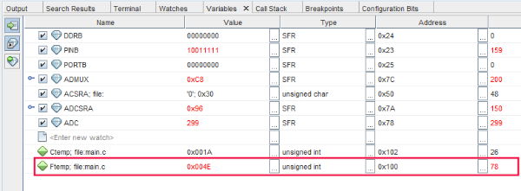

##### **5. Disable debugWIRE and Close**

It is a good practice to disable the debugWIRE after running in Debug mode. This will allow MPLAB X to program the Xplained board in the future.

Select **Debug > Disconnect from Debug** Tool from the top menu.

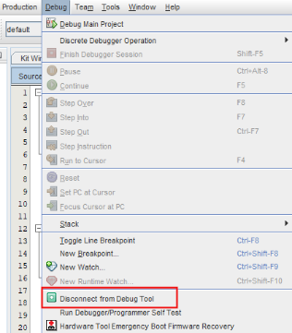

## Analysis

Using the ADC is quite easy and the debug feature makes it easy to monitor the results.

## Conclusions

This project can become the basis for future ADC-related projects.

AVR® Internal Temperature Sensor

Last modified by Microchip on 2023/11/09 09:02

Some AVR® devices have an internal temperature sensor. It can be used to measure the core temperature of the device (not the ambient temperature around the device). The measured voltage has a linear relationship to the temperature. The voltage sensitivity is approximately 1 mV/°C, the accuracy of the temperature measurement is ±10°C.

The temperature measurement is based on the on-chip temperature sensor that is coupled to a single-ended Analog-to-Digital Converter (ADC) channel. Selecting ADC channel 8 by writing '1000' to ADMUX.MUX[3:0] enables the temperature sensor. The internal 1.1V voltage reference must also be selected for the ADC voltage reference source. When the temperature sensor is enabled, the ADC converter can be used in single-conversion mode to measure the voltage over the temperature sensor.

Sample Measurement Data



Calibration

The results from temperature measurements have offset and gain errors. The internal temperature reference can be corrected for these errors by making calibration measurements at one or two known temperatures and adjusting the output values. This can result in very precise temperature measurements, sometimes as accurate as ±2°C.  
More detail can be found in this [application note.](http://www.atmel.com/Images/Atmel-8108-Calibration-of-the-AVR's-Internal-Temperature-Reference_ApplicationNote_AVR122.pdf)

Configuring the ADC

The internal 1.1V voltage reference must be selected for the ADC voltage reference source when using the internal temperature sensor. Writing “11” to the REFS1 and REFS0 bits of the ADMUX register selects the internal 1.1V voltage reference.

The ADC has multiple input channels and modes of operation. The Single Conversion mode can be used to convert the temperature sensor signal connected to channel 8. To select channel 8, writing “1000” to the MUX3 thru MUX0 bits selects channel 8 or the temperature sensor.

Once the conversion is complete, the result is stored in two 8-bit ADC data registers ADCH (higher 8-bits) and ADCL (lower 8-bits). The 10-bit result can be either left-justified or right-justified. If ADLAR bit is set to a "1", then the result is left adjusted to the upper 10-bits of the two registers. If set to "0" then the result occupies the lower 10 bits of the two registers. By default, each bit is cleared and the word is right justified.

This code statement will set the bits as described.  
ADMUX = (1«REFS1) | (1«REFS0) | (0«ADLR) | (1«MUX3) | (0«MUX2) | (0«MUX1) | (0«MUX0);

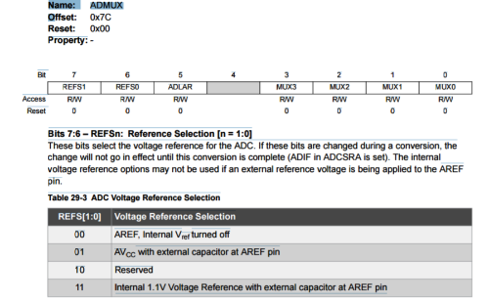

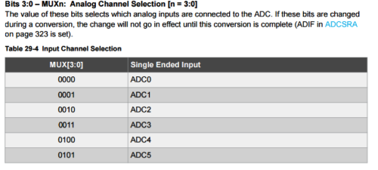

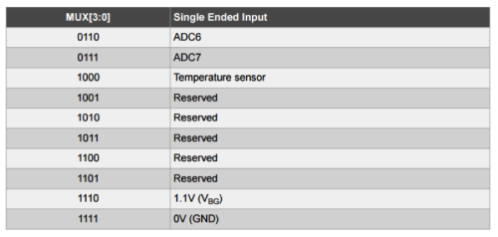

Configuring the ADC Clock and Conversion Timing

The ADC can prescale the system clock to provide an ADC clock that is between 50 kHz and 200 kHz to get maximum resolution. If an ADC resolution of less than 10-bits is required, then the ADC clock frequency can be higher than 200 kHz. At 1 MHz it is possible to achieve up to 8 bits of resolution.

The prescaler value is selected with ADPS bits in ADCSRA Register. For example; writing “110” to the ADCSRA register selects the divide by 64 pre-scaler resulting in a 125 KHz ADC clock when an 8 MHz oscillator clock is used.

ADC Control and Status Register A

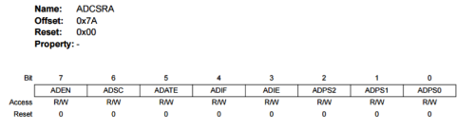

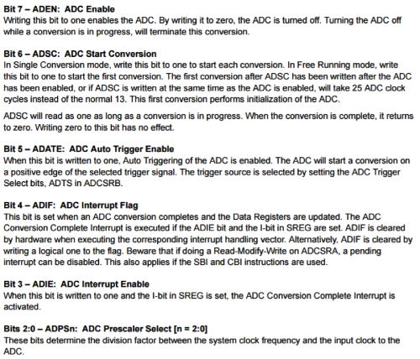

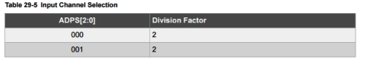

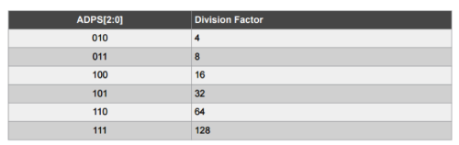

Starting a Conversion

In single conversion mode, the ADSC bit in the ADCSRA register must be set to a logical one state to start the ADC conversion. This bit remains at logic high while the conversion is in progress and is cleared by the hardware, once the conversion is complete.

The first conversion after the ADC is switched on takes 25 ADC clock cycles in order to initialize the analog circuitry. Then, for further conversions, it takes 13 ADC clock cycles (13.5 for auto-triggered conversions).